Date: February 2016

Precise Semantics of UML State Machines (PSSM)

Initial Submission
In response to the Precise Semantics of UML State Machines RFP (ad/2015-03-02)
__________________________________________________
OMG Document Number: ad/2016-02-xx
Machine Readable File(s):

_________________________________________________
Submitted by:
BAE Systems
Model Driven Solutions
No Magic, Inc.
Supported by:
Airbus Group
Commissariat á l'Energie Atomique et Alternatives (CEA)
LieberLieber Software
Simula Research Laboratory

Copyright © 2016 Airbus Group
Copyright © 2016 BAE Systems
Copyright © 2016 Commissariat á l'Energie Atomique et Alternatives (CEA)
Copyright © 2016 Data Access Technologies, Inc. (Model Driven Solutions)
Copyright © 2016 LeiberLeiber Software
Copyright © 2016 No Magic, Inc.
Copyright © 2016 Simula Research Laboratory

COPYRIGHT WAIVER
Each of the entities listed above: (i) grants to the Object Management Group, Inc. (OMG) a nonexclusive, royalty-free, paid up, worldwide license to copy and distribute this document and to modify this document and distribute copies of the modified version, and (ii) grants to each member of the OMG a nonexclusive, royalty-free, paid up, worldwide license to make up to fifty (50) copies of this document for internal review purposes only and not for distribution, and (iii) has agreed that no person shall be deemed to have infringed the copyright in the included material of any such copyright holder by reason of having used any OMG specification that may be based hereon or having conformed any computer software to such specification.

Table of Contents

0 Submission Introduction vi
0.1 Overview vi
0.2 Submitters vi
0.3 Mandatory Requirements vi
0.4 Non-Mandatory Features ix
0.5 Issues To Be Discussed x
1 Scope 1
2 Conformance 1
2.1 General 1
2.2 Conformance Levels 1
2.2.1 PSSM-only Conformance 1
2.2.2 Joint PSSM and PSCS Conformance 2
2.3 Genericity of the Execution Model 2
3 Normative References 3
4 Terms and Definitions 3
5 Symbols 4
6 Additional Information 5
6.1 Changes to Adopted OMG Specifications 5
6.2 Acknowledgments 5
7 Abstract Syntax 6
7.1 Overview 6
7.2 Common Structure 9
7.2.1 Overview 9
7.2.2 Constraints 9
7.3 Values 9
7.3.1 Overview 9
7.3.2 Constraints 10
7.4 Classification 10
7.4.1 Overview 10
7.4.2 Constraints 11
7.5 Common Behavior 11
7.5.1 Overview 11
7.5.2 Constraints 12
7.6 State Machines 12
7.6.1 Overview 12
7.6.2 Behavior State Machines 12
7.6.2.1 Overview 12
7.6.2.2 Constraints 14
7.6.3 State Machine Redefinition 15
7.6.3.1 Overview 15
7.6.3.2 Constraints 16
8 Execution Model 17
8.1 Overview 17
8.2 Loci 17
8.2.1 Overview 17
8.2.2 Class Descriptions 17
8.3 Values 17
8.3.1 Overview 17
8.3.2 Expressions 17
8.3.2.1 Overview 17
8.3.2.2 Class Descriptions 17
8.4 Structured Classifiers 17
8.4.1 Overview 17
8.4.2 Classes 17
8.5 State Machines 17
8.5.1 Overview 17
8.5.2 Behavior State Machines 17
8.5.3 State Machine Redefinition 17
9 Test Suite 18
9.1 Overview 18
9.1.1 UML Semantics Requirements 18
9.1.2 Test Suite Organization 18
9.1.3 Test Coverage and Limits 18
9.1.4 Constraint on Vendors implementing the Semantic Model 18
9.2 Utilities 19
9.2.1 Architecture 19
9.2.1.1 Relation with UML testing profile 19
9.2.1.2 Base Semantic Test 19
9.2.1.2.1 Tester 20
9.2.1.2.2 Target 21
9.2.1.2.3 SemanticTest 21
9.2.1.3 Semantic Test and Test Suite 23
9.2.1.3.1 SemanticTestSuite 23
9.2.2 Protocol 25
9.2.2.1 Synchronization 26
9.2.2.1.1 Start 26
9.2.2.1.2 End 26
9.2.2.1.3 TestEnd 27
9.2.2.2 Stimulation sequence 27
9.2.3 Tracing 27
9.3 Tests 28
9.3.1 Behaviors 28
9.3.1.1 Overview 28
9.3.1.2 Test Behavior 001 28
9.3.1.3 Test Behavior 002 30
9.3.1.4 Test Behavior 003 31
9.3.1.5 Test Behavior 003-bis 33
9.3.1.6 Test Behavior 003-ter 34
9.3.1.7 Test Behavior 004 34
9.3.2 Transitions 35
9.3.2.1 Transition 001 35
9.3.2.2 Transition 007 36
9.3.2.3 Transition 010 38
9.3.2.4 Transition 011 39
9.3.2.5 Transition 011-bis 40
9.3.2.6 Transition 011-ter 42
9.3.2.7 Transition 011-quater 43
9.3.2.8 Transition 011-quinquies 44
9.3.2.9 Transition 015 46
9.3.2.10 Transition 016 47
9.3.2.11 Transition 017 48
9.3.2.12 Transition 019 49
9.3.2.13 Transition 020 51
9.3.2.14 Transition 022 52
9.3.3 Event 53
9.3.3.1 Overview 53
9.3.3.2 Event 001 53
9.3.3.3 Event 002 54
9.3.3.4 Event 008 56
9.3.3.5 Event 009 57
9.3.3.6 Event 010 58
9.3.3.7 Event 015 59
9.3.3.8 Event 016 61
9.3.3.9 Event 016-bis 62
9.3.3.10 Event 018 64
9.3.4 Entering 65
9.3.4.1 Overview 65
9.3.4.2 Entering 004 65
9.3.4.3 Entering 005 67
9.3.4.4 Entering 009 68
9.3.4.5 Entering 010 69
9.3.4.6 Entering 011 70
9.3.5 Exiting 71
9.3.5.1 Overview 71
9.3.5.2 Exiting 001 71
9.3.5.3 Exiting 002 72
9.3.5.4 Exiting 003 75
9.3.5.5 Exiting 004 76
9.3.5.6 Exiting 005 76
9.3.6 Exit 77
9.3.6.1 Overview 77
9.3.6.2 Exit 001 78
9.3.6.3 Exit 002 78
9.3.6.4 Exit 003 80
9.3.7 Entry 81
9.3.7.1 Overview 81
9.3.7.2 Entry 002 - A 81
9.3.7.3 Entry 002 – B 82
9.3.7.4 Entry 002 – C 83
9.3.7.5 Entry 002 – D 84
9.3.7.6 Entry 002 – E 85
9.3.8 Choice 86
9.3.8.1 Overview 86
9.3.8.2 Choice 001 86
9.3.8.3 Choice 002 87
9.3.8.4 Choice 003 88
9.3.9 Standalone 89
9.3.9.1 Overview 89
9.3.9.2 Standalone 001 89
9.3.10 Fork 90
9.3.10.1 Overview 90
9.3.10.2 Fork 001 90
9.3.10.3 Fork 002 92
9.3.11 Join 92
9.3.11.1 Overview 92
9.3.11.2 Join 001 93
9.3.11.3 Join 002 94
9.3.12 Terminate 94
9.3.12.1 Overview 94
9.3.12.2 Terminate 001 95
9.3.12.3 Terminate 002 96
9.3.12.4 Terminate 003 97
9.3.13 Final 98
9.3.13.1 Overview 98
9.3.13.2 Final 001 98
9.3.14 Deferred 100
9.3.14.1 Overview 100
9.3.14.2 Deferred 001 100
9.3.14.3 Deferred 002 101
9.3.14.4 Deferred 003 103
9.3.14.5 Deferred 004 – A 104
9.3.14.6 Deferred 004 – B 106
9.3.15 Other Tests 107
9.3.15.1 Overview 107
9.3.15.2 Transition Execution Algorithm Test 107
9.4 Test Coverage and Limits 108
9.4.1 Overview 108
9.4.2 Tests Report 109
9.4.2.1 Test Failures 109
9.4.2.2 Valid (but still discussed) 109
9.4.3 Coverage 109
9.4.4 Execution Model Limitations 109
9.4.4.1 Syntactic Elements 109
9.4.4.2 Limitations 110
A Protocol State Machines 111
A.1 Overview 111
A.2 Abstract Syntax 111
A.3 Semantics 112
A.3.1 Controlled Events 112
A.3.2 Protocol States Configuration 112
A.3.3 Protocol Violation 113

Submission Introduction

Overview
This is OMG document ad/2016-92-xx, entitled Precise Semantics of UML State Machines, which may be abbreviated “PSSM”. It is submitted in response to the RFP for Precise Semantics of UML State Machines (PSSM) (ad/2015-03-02). Similarly to previous Executable UML specifications on the Semantics of a Foundational Subset for Executable UML Models (fUML) and the Precise Semantics of UML Composite Structures (PSCS), the proposed PSSM specification defines the subset of the UML abstract syntax relevant to UML state machines, as an extension of the fUML abstract syntax subset (see Clause 7), and an operational semantics for that subset, as an extension to the fUML/PSCS execution model (see Clause 8). In addition, as required in the RFP, the proposed specification includes a suite of tests that may be used to validate the conformance of an execution tool to the specification (see Clause 9).

Submitters
The following OMG member organizations (with the given contact individuals) are jointly submitting this proposed specification.
- BAE Systems (Jeffery Smith, jeffrey.smith5@baesystems.com)
- Model Driven Solutions (Ed Seidewitz, ed-s@modeldriven.com)
- No Magic, Inc. (Nerijus Jankevicius, nerijus@nomagic.com)
The following OMG members organizations are supporters of and contributors to this proposed specification, but not formal submitters. All have licensed any contributed material as necessary to one of the formally submitting organizations.
- Airbus
- Simula Research Laboratory
- LieberLieber
- CEA

Mandatory Requirements
The table below describes how this proposed specification responds to each of the mandatory requirements of the PSSM RFP.
Requirement | Response
6.5.1a Proposals shall provide precise semantics for UML behavior state machines, including the following underlying metaclasses:
- FinalState
- Pseudostate (all kinds)
- Region (except for redefinition)
- State (except for redefinition and submachine states)
- StateMachine (except state machine extension)
- Transition (except for redefinition), including completion transitions (with no triggers) and transitions with triggers for the following kinds of events:
- Call Event
- Signal Event
- Vertex
6.5.1b Proposals shall define how data associated with event occurrences shall be accessed by transition guards and passed to transition effect behaviors and state behaviors during the process of event dispatching and transition triggering.
6.5.1c The precise semantics shall cover at least the cases of the standalone execution of state machines (i.e., with no other behaviored classifier as context) and state machines used as classifier behaviors of active classes.
6.5.1d The precise semantics for state machines shall include the meaning of specifying a port on a trigger in a state machine. The proposed semantics for this (and any other potential touch points with UML composite structure as identified by submitters) shall be consistent with the semantics of composite structures as defined in the Precise Semantics of UML Composite Structures (PSCS) specification. This consistency shall be such that there would be no conflict in a tool conforming to both the proposed state machine semantics and PSCS. However, proposals shall not require that a tool necessarily formally conform to the entire PSCS specification in order to conform to the precise semantics for state machines.
6.5.1e The semantic description shall establish explicit relationships with fUML, for example by specifying a precise formal model transformation from the metaclasses listed above to metaclasses which are part of the fUML subset and/or by extending the fUML execution model, for example with appropriate visitor classes. Whatever the way the execution semantics are actually specified, proposals shall be readable as if they are additions to fUML semantics, rather than separate specifications.
6.5.1f Proposals shall extend the base semantics of fUML with specific axioms for UML state machines only if necessary. These new axioms shall have explicit relationships with existing axioms of fUML base semantics. These axioms shall be expressed in Common Logic Interchange Format (as was done for fUML). Submitters shall demonstrate, through manual or automated means, that the new axioms are consistent with fUML axioms.
6.5.2a Proposals shall precisely identify any allowed semantic variabilities. These semantic variabilities shall be in the scope of semantic variabilities allowed by UML state machines (potentially including only a subset of allowed UML semantic variabilities, as was the case for fUML).
6.5.2b Proposals shall define rules for defining semantic variants, where a semantic variant is an internally consistent set of values for the different semantic variabilities allowed from requirement 6.5.2.a.
6.5.3a Proposals shall conform to the current version of the UML 2 metamodel and notation.
6.5.3b Proposals shall use the current version of the fUML specification.
6.5.3c Proposals shall use the current version of the PSCS specification.
6.5.3d For any extension to the fUML base semantics using CLIF, proposals shall conform to the current version of the ISO Common Logic standard.
6.5.4a Proposals shall provide a suite of test cases that can demonstrate conformance to this specification, as described in section 6.2.
6.5.4b Proposals shall demonstrate the coverage by the test suite of all proposed state machine semantic functionality and the traceability of each test case to specific required functionality.

Non-Mandatory Features
The following table describes whether and how this proposed specification provides the non-mandatory features listed in the PSSM RFP.
Feature | Response
6.6.1 Proposals may provide precise semantics of submachine states, as represented by the A_submachineState_submachine meta-association and including the ConnectionPointReference metaclass.
6.6.2 Proposals may provide precise semantics of UML protocol state machines, including the following underlying metaclasses:
- ProtocolConformance
- ProtocolStateMachine
- ProtocolTransition
6.6.3 Proposals may provide precise semantics for state machine redefinition, as represented by the following meta-associations:
- A_extendedRegion_region
- A_extendedStateMachine_stateMachine
- A_redefinedState_state
- A_redefinedTransition_transition
- A_redefinitionContext_region
- A_redefinitionContext_state
- A_redefinitionContext_transition
6.6.4 Proposals may provide precise semantics for asynchronous operation calls (which are not currently allowed in fUML). If provided, such semantics should include the handling of asynchronous calls both by call event triggers in state machines and by operation methods. Proposals may additionally provide semantics for accepting call events in activities, as covered by the AcceptCallAction and ReplyAction metaclasses.
6.6.5 Proposals may provide precise semantics for triggers with ChangeEvents.
6.6.6 Proposals may use the Action language for Foundational UML (Alf) as a concrete syntax for specifying the execution semantics of state machines.

Issues To Be Discussed

Proposals shall discuss how state machines may be used to specify the behavior of passive classes.

Background and Rationale
The use of state machines for describing the behavior of instances of passive object classes can be found in several UML tools, notably in Rhapsody and RSA RTE (both from IBM). In fact, the original 1.x series of UML specifications explicitly discusses the case of passive state machines (e.g., section 2.12.4.7 in the UML 1.3 specification [1]). In particular, it mentions a possible means for ensuring preservation of run-to-completion semantics for passive classes whose behavior is specified via state machines.
To help us understand how the behavior of passive classes can be described using state machines, it is useful to recall that an essential characteristic of state machine behaviors is that a response to a particular stimulus (e.g., a call event occurrence) depends on the object’s history; that is, the nature and order of preceding stimuli received by that object. In active class state machines, this information is captured concisely by the current state of an object’s classifier behavior. However, when dealing with passive objects, which do not have a classifier behavior, this means that, in the general case, each method of the class needs to include a conditional branch to handle the different responses based on some internal value that, in effect, represents the history of the object.
Consider, for example, the simplest case of a Stack class shown in Figure 0.1. Note that the response to a “pop” operation will depend on whether the stack is empty or not. Similarly, assuming that the stack is of limited capacity, the response to a “push” operation will differ when the stack is full compared to when it is not full.
Of course, this can be coded explicitly by defining a suitable local variable of the object (e.g., “stack size”) and using appropriate action language conditional statements. But, this not only obscures the true nature of the behavior in question, but, because it relies on relatively low-level (i.e., “manual”) coding it, is also more error prone and requires more effort by the modeler. This approach becomes increasingly more problematic as the complexity of the behavior grows.
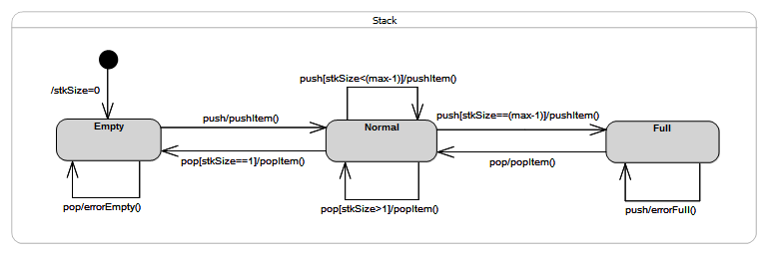Figure 0.1 - Stack Example
Hence, the motivations behind supporting state machine specifications of passive class behaviors are to reduce the burden on the modeler, to more clearly describe an object’s behavior using a higher-level formalisms, and to increase both reliability and productivity.

Proposed Approach
To avoid gratuitous differences from the familiar semantics of active state machines, the general strategy taken is to be fully consistent with those semantics wherever possible. Note that this proposal covers both passive classes as well as stand-alone passive state machines (which are, after all, classes as well).
The core idea behind the approach is straightforward: map the state machine specification into an equivalent set of behavioral fragments and conditional statements distributed across the appropriate methods. For example, all three transitions triggered by the “pop” call event in the Stack example above, would be mapped to appropriate conditional statement cases of a single “pop” operation method. The control variable of such a statement would correspond to the current state of the state machine. This is illustrated by the following pseudocode for the method of the “pop” operation:
operation pop(): Item {
case (state) {
'Empty': errorEmpty();
'Normal': if (stkSize == 1) then
{popItem();
nextState('Empty');}
else
popItem();
'Full': {popItem();
nextState('Normal');}
};
}
Furthermore, any action associated with the initial transition would be mapped to the method of the class constructor.
Of course, in addition to the lack of a classifier behavior, one key difference between active and passive class semantics is in how the transition triggering mechanism works. For active classes, triggering is realized by a dedicated scheduling and dispatch mechanism, which is external to the state machine instance. Among other responsibilities, this mechanism also ensures that run-to-completion semantics are enforced. In contrast, no such mechanism exists for passive classes; the methods of a passive class are executed synchronously when some calling behavior invokes the corresponding operation. Consequently, if two or more concurrently executing behaviors make overlapping calls to the same passive object, there is a possibility of concurrency conflicts that would violate the run-to-completion semantics. (Note that this can occur even if all of the operations of the passive class are declared as “guarded”, since that only prevents a given operation being invoked concurrently. However, it would still be possible to concurrently invoke two or more different operations of the passive class.)
Therefore, to ensure run-to-completion semantics of a passive class state machine, it is proposed that for any passive class whose behavior is defined by a state machine, at most one operation call can be executed (to completion) at a time. Alternatively, this could be made a configurable option. However, that would lead to unsafe and error prone designs, and would violate one of the core semantic tenets of UML state machines.

Proposals shall address issues with the UML abstract syntax involved in the specification of the accessing and passing of data from event occurrences, as required in 6.5.1b.
TBD

Proposals shall discuss the relationship of the proposed precise semantics for UML state machines to the causality model defined for the UML Profile for MARTE.

TBD

Proposals shall discuss the relationship of the proposed precise semantics for UML state machines to the specification of a state machine ontology and, particularly, to the integration approach of OntoIOP.

TBD

Proposals shall discuss the relationship of the proposed precise semantics for UML state machines to the semantics defined for state machines in the W3C State Chart XML (SCXML) specification.
The general environment of SCXML state machines is completely different from that of UML state machines. In SCXML, a state machine is an independent self-contained entity that can interact with other, or external, entities located in a Web-based environment (e.g., external entities are accessed via URIs). External entities can be other SCXML state machines or any other kind of Web-based application. This interaction can be either synchronous or asynchronous. In other words, unlike UML, in SCXML there is no explicit structural context defined in which a state machine is defined; i.e., the (single) state machine is the top-level concept.
The data model, event model, and action language of SCXML are all specific to it and not equivalent to those of UML, although most action language (executable content) elements can be mapped to standard programming language equivalents.
It is fairly clear that SCXML was inspired in great part by UML. There is a significant conceptual, semantic, and even terminological overlap. However, there are also some important differences.

Syntax
SCXML only supports three kinds of pseudostates: initial, deep history, and shallow history. This means that it does not support exit and entry points, fork and join points, or terminate pseudostates. Also, there is no support for submachine states or state machine redefinition. Finally, protocol state machines are also not supported.
An SCXML document defines a single state machine as a set of states and a set of associated data (i.e., its “extended” state). States own their outgoing transitions and can be either atomic or compound. The latter own other states (substates). A special kind of state is a parallel state, which is the conceptual equivalent of a UML region. Any state, whether atomic or compound, can have entry and exit actions. Transitions can have zero or more triggering events and an optional guard condition. States of any kind can optionally own local sets of data, something that has no equivalent in UML. Finally, the UML concept of “do” behaviors associated with states is not supported in SCXML.
Like UML, SCXML supports completion event, but, in contrast to UML, these events are named and used to explicitly trigger completion transitions. However, their effect is the same, although it appears that SCXML gives the modeler more control over the triggering because individual completion events can be differentiated. For example, it is possible to define a trigger that refers explicitly to the completion of a particular state. This cannot be done in UML since completions event triggers are implicit.

Semantics
From an initial cursory analysis, it seems that the semantics of those SCXML concepts that have UML equivalents are compatible with UML semantics. If we set aside the major differences in the structural context mentioned above, it is fair to say that the semantics of SCXML state machines are a subset of those found in UML.

Summary of differences
- No structural context
- SCXML specific action language
- Event model is different
- Does not support all pseudostates (join, fork, terminate, exit/entry points not supported)
- No support for submachines
- States can own local extended data variables
- No support for “do” behaviors
- More refined model of completion events

Proposals shall describe a proof of concept implementation that can successfully execute tests from the conformance test suite, without violating any tests from the PSCS conformance test suite.
CEA has developed a prototype proof of concept implementation of the execution model defined in Clause 8 of this specification. It is integrated to the Papyrus model execution framework Moka as a specific execution engine. Papyrus and Moka tooling are based on the Eclipse implementation of the UML 2.5 metamodel. Therefore, models that can be interpreted by the prototype must conform to this metamodel implementation.
The execution model implemented by the prototype is built on top of the one defined to capture the PSCS semantics. The prototype is able to execute any model conforming to subset that is covered both by fUML and PSCS. In addition it also able to execute models including syntax elements that are covered by the subset of behavior state machines identified in this specification (see 7.6.2).
PSSM execution model is delivered with a test suite. This test suite is an executable model that conforms to the subset covered by fUML and PSSM. It enables us to validate the semantics encoded within the execution model. The test suite is composed of 64 tests. Among theses tests, 63 are executed successfully by the proof of concept implementation.
PSSM execution model does not conflict with PSCS execution model. Both execution model can be used jointly. To demonstrate the absence of conflicts, the PSCS test suite was executed using the PSSM execution model. No regressions were detected. Execution traces generated by PSCS and PSSM during test suite execution are the same.

Scope
This specification is an extension of the Semantics of a Foundational Subset for Executable UML Models standard (known as “Foundational UML” or “fUML”) [fUML] that defines the execution semantics for UML state machines. Syntactically, this specification extends fUML by with a (large) subset of the abstract syntax of state machines as given in the OMG Unified Modeling Language specification [UML] (Clause 14, for UML 2.5 and later). Semantically, this specification extends the fUML execution model in order to specify the operational execution semantics of the state machine abstract syntax subset.
The semantic model defined in this specification is actually an extension of the model from the Precise Semantics of UML Composite Structures (PSCS) standard [PSCS], which is itself an extension of fUML. This is done in order to ensure that the semantics given in this specification are compatible with the extensions defined in PSCS and to allow for the definition of the semantics of triggers with an “onPort” reference. However, this latter feature is the only point for which the semantics of state machines presented here depends in any way on the PSCS semantic extensions, and it is possible for an execution tool to conform to this specification without also conforming to the PSCS specification (see Clause 1).

Conformance

General
This specification defines a precise semantics for a subset of UML 2 concepts associated with the notion of a state machine. This definition is based on the Foundational UML Subset (henceforth referred to as “fUML” in the remainder of this clause), which is specified in [fUML]. Hence, except where explicitly noted in this clause, the definitions, interpretations (meaning), and types of conformance and related terms in this specification fully match their corresponding definitions, interpretations, and types in fUML. Thus, as in fUML, conformance to this specification has two aspects:
- Syntactic Conformance – A conforming model must be restricted to the abstract syntax subset defined in Clause 7 of this specification.
- Semantic Conformance – A conforming execution tool must provide execution semantics for a conforming model consistent with the semantics specified in Clause 8 of this document.

Conformance Levels
The semantic model in Clause 8 is specified as an extension to the semantic model given in [PSCS]. However, the only point at which the semantics given in this specification actually depend on the PSCS semantics is for triggers with an “onPort” reference (see TBD). There are two levels of conformance defined for this specification, depending on whether an execution tool conforms only to PSSM or conforms to PSSM and PSCS, including the semantics for triggers with “onPort”. Both of these have syntactic and semantic aspects, as specified in the following subclauses.

PSSM-only Conformance
- Syntactic Conformance – A conforming model must be restricted to the abstract syntax subset defined in Clause 7 of this specification, with the further restriction that triggers must not have onPort references.
Note. The abstract syntax subset defined in Clause 7 is a superset of the subset defined in [fUML]. Thus, every syntactically conforming fUML model is also a syntactically conforming PSSM model.
- Semantic Conformance – A conforming execution tool must provide execution semantics for a conforming model consistent with the semantics specified in Clause 8 of this specification. Demonstrating semantic conformance to fUML (as defined in Clause 2 of [fUML] and passing all the tests of the test suite in Clause 9 of this specification, except for this related to onPort (see TBD), is sufficient to demonstrate semantic conformance at this level.

Joint PSSM and PSCS Conformance
- Syntactic Conformance – A conforming model must be restricted to the abstract syntax subset defined by the union of the subset defined Clause 7 of this specification and the subset defined in Clause 7 of [PSCS]. The model shall satisfy all constraints as specified in this specification and in [PSCS].
- Semantic Conformance – A conforming execution tool must provide execution semantics for a conforming model consistent with the semantics specified in Clause 8 of this specification and the semantics specified in Clause 8 of [PSCS]. Demonstrating semantic conformance to fUML (as defined in Clause 2 of [fUML]) and passing all the tests of the test suite in Clause 9 of this specification and all the tests in Clause 9 of [PSCS] is sufficient to demonstrate semantic conformance at this level.

Genericity of the Execution Model
To support a variety of different execution paradigms and environments, the specification of the execution model incorporates a degree of genericity. This is achieved in two ways: (1) by leaving some key semantic elements unconstrained, and (2) by defining explicit semantic variation points. A particular execution tool can then realize specific semantics by suitably constraining the unconstrained semantic aspects and providing specifications for any desired variation at semantic variation points.
The semantic areas that are not explicitly constrained by the execution model in this specification are the same as the ones defined in subclause 2.3 of [fUML]. Different execution tools may semantically vary in these areas in executing the same model, while still being conformant to the semantics specified by the execution model in this specification. Additional semantic specifications or constraints may be provided for a specific execution tool in these areas, so long as it remains, overall, conformant to the execution model. For instance, a particular tool may be limited to a single centralized time source such that all time measurements can be fully ordered.
In contrast to the above areas, the items below are explicit semantic variation points. That is, the execution model as given in this specification by default fully specifies the semantics of these items. However, it is allowable for a conforming execution tool to define alternate semantics for them, so long as this alternative is fully specified as part of the conformance statement for the tool.
- The semantic variation points defined in subclause 2.3 of [fUML]. Note, however, that the default event dispatching strategy defined for fUML is replaced by the default strategy given in subclause 8.4.1.2.1 of [PSCS].
- In addition, this specification introduces one new semantic variation point and a corresponding default strategies for it: the method for selecting which transitions of a state machine (if any) will fire in response to a given event occurrence.
If a conforming execution tool wishes to implement a semantic variation in one of the above areas, then a specification most be provided for this variation via a specialization of the appropriate execution model class as identified above. This specification must be provided as a fUML model in the “base UML” subset interpretable by the base semantics of Clause 10 of [fUML]. Further, it must be defined in what cases the variation is used and, if different variants may be used in different cases, when each variant applies, and/or how what variant to use, is to be specified in a conforming model accepted by the execution tool.

Normative References
The following normative documents contain provisions which, through reference in this text, constitute provisions of this specification. For versioned references, subsequent amendments to, or revisions of, any of these publications do not apply.
[fUML] Semantics of a Foundational Subset for Executable UML Models (fUML), Version 1.2.1, http://www.omg.org/spec/FUML
[PSCS] Precise Semantics of UML Composite Structures (PSCS), Version 1.0, http://www.omg.org/spec/PSCS
[UML] OMG Unified Modeling Language (OMG UML), Version 2.5, http://www.omg.org/spec/UML
Note. The semantics of state machines given in this specification are intended to be consistent with the syntax and semantics given in UML 2.5. However, fUML and PSCS are currently formally based on UML 2.4.1 (though PSCS incorporates UML 2.5 clarifications of the semantics of composite structures). For consistency, it is expected that the normative references given here for fUML and PSCS will be updated to versions consistent with UML 2.5, as soon as these become available.
[UTP] UML Testing Profile (UTP), Version 2, Initial Submission, OMG document ad/2014-05-01
Note. UTP v2 is expected to be adopted and finalized before the finalization of PSSM.

Terms and Definitions
For the purposes of this specification, the following terms and definitions apply.

Base Semantics
A definition of the execution semantics of those UML constructs used in the execution model, using some formalism other than the execution model itself. Since the execution model is a UML model, the base semantics are necessary in order to provide non-circular grounding for the execution semantics defined by the execution model. The base semantics provide the “meaning” for the execution of just those UML constructs used in the execution model. The execution model then defines the “meaning” of executing any UML model based on the full foundational subset. Any execution tool that executes the execution model should reproduce the execution behavior specified for it by the base semantics. (The base semantics for this specification are as specified in [fUML].)

Behavioral Semantics
The denotational mapping of appropriate language elements to a specification of a dynamic behavior resulting in changes over time to instances in the semantic domain about which the language is making statements.

Execution Model
A model that provides a complete, abstract specification to which a valid execution tool must conform. Such a model defines the required behavior of a valid execution tool in carrying out its function of executing a UML model and therefore provides a definition of the semantics of such execution.

Execution Semantics
The behavioral semantics of UML constructs that specify operational action over time, describing or constraining allowable behavior in the domain being modeled.

Execution Tool
Any tool that is capable of executing any valid UML model that is based on the abstract syntax subset defined in this specification and expressed as an instantiation of the UML 2 abstract syntax metamodel. This may involve direct interpretation of UML models and/or generation of equivalent computer programs from the models through some kind of automated transformations. Such a tool may also itself be concurrent and distributed.

Static Semantics
Possible context sensitive constraints that statements of a language must satisfy, beyond their base syntax, in order to be well-formed.

Structural Semantics
The denotational mapping of appropriate language elements to instances in the semantic domain about which the language makes statements.

Syntax
The rules for how to construct well-formed statements in a language or, equivalently, for validating that a proposed statement is actually well-formed.

Symbols
There are no symbols or abbreviated terms necessary for the understanding of this specification.

Additional Information

Changes to Adopted OMG Specifications
TBD

Acknowledgments
The following people directly contributed to the development of this specification.
- Yves Bernard, Airbus
- Nerijus Jankevicius, No Magic
- Ed Seidewitz, Model Driven Solutions
- Bran Selic, Simula Research Laboratory
- Daniel Siegl, LieberLieber
- Jeffery Smith, BEA Systems
- Jérémie Tatibouet, CEA

Abstract Syntax

Overview
This clause defines the subset of the UML abstract syntax [UML] for which precise semantics are provided in this specification. Models that syntactically conform to this subset (see 2.1) are simply UML models constructed from the limited set of UML abstract syntax metaclasses included in the PSSM subset defined here. The definition of the subset thus consists of identifying exactly which metaclasses are included.
The subset definition is captured in the package PSSM_Syntax::Syntax, which imports into its namespace exactly those UML metaclasses included in the PSSM subset (see Figure 7.1). A UML model that syntactically conforms to this subset shall have an abstract syntax representation that consists solely of instances of metaclasses that are (imported) members of the PSSM_Syntax::Syntax package. For simplicity, meta-associations from the UML abstract syntax metamodel are not explicitly imported into the PSSM_Syntax::Syntax package, but it is, nevertheless, permissible for the model elements of a conforming model, within the PSSM subset, to be involved in any meta-associations consistent with both the UML metamodel and any further constraints as defined in this specification.
Note. This approach for defining a subset of the UML abstract syntax is similar to the approach used for defining the metamodel subset covered by a UML profile, in which specially identified PackageImports (metamodelReferences) and ElementImports (metaclassReferences) are used to import the metaclasses from the subset into the namespace of the Profile (see Clause 12 of [UML]).
The PSSM subset is an extension of the fUML subset (as specified in Clause 7 of [fUML]), and PSSM_Syntax::Syntax directly includes (via package import) all metaclasses from the Classification, SimpleClassifiers, StructuredPackages, Activities and Actions packages from the fUML subset model. It also includes all metaclasses in the CommonStructure, Values and CommonBehavior packages from the fUML subset, but, in these cases the PSSM subset also includes additional metaclasses from the corresponding UML abstract syntax packages that are not included in the fUML subset. Therefore, the PSSM_Syntax::Syntax package contains CommonStructure, Values and CommonBehavior subpackages that import all the metaclasses from the corresponding fUML packages, plus the additional required metaclasses from the UML abstract syntax metamodel (as further described in 7.2, 7.3, and 7.5, respectively), and the content of these subpackages is then further imported into the top-level Syntax package. Finally, the major extension provided by the PSSM subset is the inclusion of metaclasses from the UML StateMachines abstract syntax metamodel package (as described in 7.6), which are first grouped into the PSSMSyntax::Syntax::StateMachines subpackage and then imported into the top-level Syntax package.
Submission Note. As of fUML 1.2.1, fUML is stilled based on UML 2.4.1, and the fUML subset is defined by creating a copy of a portion of the UML abstract syntax metamodel, such that a package merge of the fUML subset metamodel back into the UML metamodel results in metamodel that is isomorphic to the original UML metamodel (hence validating that the fUML “subset” is, indeed, a proper subset). Since PSSM is required to be based on UML 2.5 (or later), the subsetting approach used here presumes that fUML will migrate to UML 2.5 in its next revision and adopt a similar subsetting approach.
The PSSM subset specified here is not an extension of the PSCS subset. To satisfy the requirements of the “Joint PSSM and PSCS” conformance level (see 2.2.2), the relevant abstract syntax subset is the union of the PSSM subset specified here and the PSCS subset specified in Clause 7 of [PSCS].
In addition to being representable within the PSSM abstract syntax subset, as described above, a UML model that syntactically conforms to PSSM shall also satisfy all relevant constraints defined in the UML abstract syntax metamodel [UML] and the additional syntactic constraints specified here for PSSM. The PSSM semantics specified in Clause 8 are only defined for well-formed PSSM models that meet all the necessary constraints. In the case of “Joint PSSM and PSCS” conformance (see 2.2.2), a well-formed model must further meet all the syntactic constraints required for PSCS (see Clause 7 of [PSCS]).
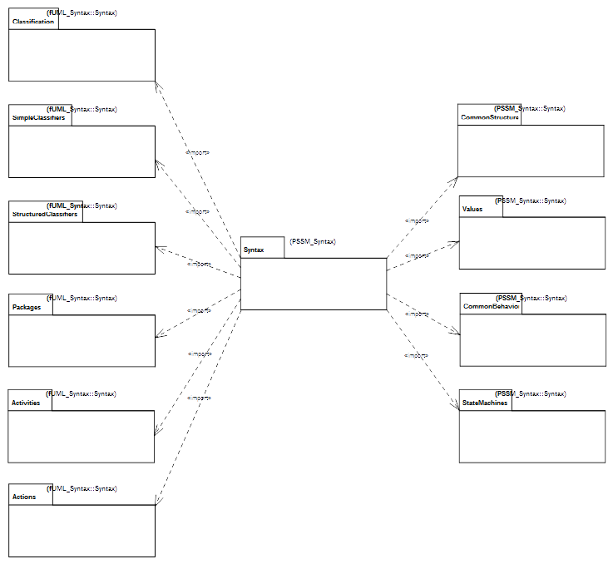
Figure 7.1 - PSSM Syntax Package
The constraints specified for PSSM are all those that are imported members of the PSSM_Syntax::Constraints package (see Figure 7.2). Each of these constraints has as its single constrained element the UML abstract syntax metaclass to which the constraint applies.
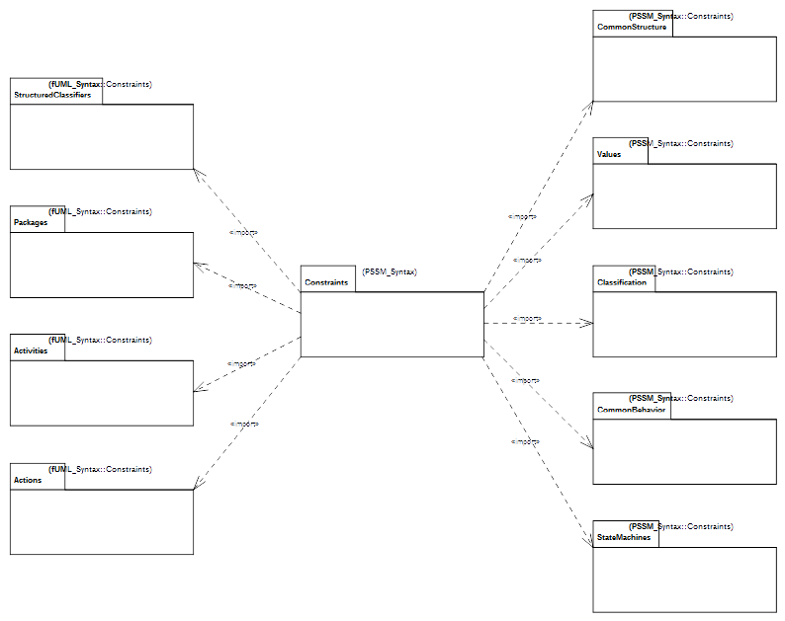Figure 7.2 - PSSM Constraints Package
The PSSM_Syntax::Constraints package includes (via package import) all the constraints from the fUML constraints packages for StructuredClassifiers, Packages, Activities and Actions (see Clause 7 of [fUML]). It also includes all the fUML constraints for CommonStructure, Values and CommonBehavior, but includes additional constraints for the additional metaclasses in the PSSM subset in those areas (see 7.2, 7.3, and 7.5, respectively). In addition, in one case (for Classification::Operation), a constraint from fUML is replaced in PSSM with a less restrictive constraint (see 7.4). Finally, additional constraints are included for the StateMachine abstract syntax specific to PSSM.

Common Structure

Overview
In addition to all the metaclasses included in the fUML subset CommonStructure package, PSSM includes the Constraint metaclass (see Figure 7.3). This metaclass is included in PSSM because the guard of a StateMachine Transition is given as a Constraint (as shown in Figure 7.7). There is also an additional syntactic constraint specified for Constraint, as shown in Figure 7.3 and formally defined in 7.2.2.
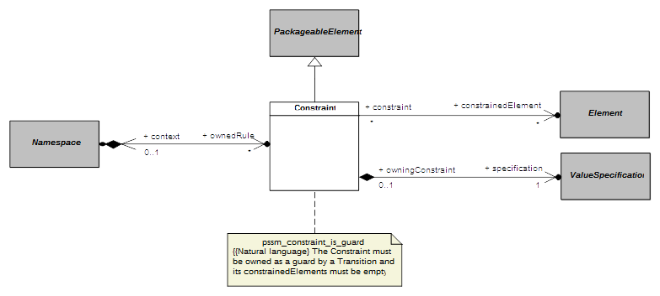Figure 7.3 - Constraints

Constraints

pssm_constraint_is_guard
context UML::CommonStructure::Constraint inv:
self.owner.oclIsKindOf(UML::StateMachines::Transition) and
self.constrainedElement->isEmpty()

Values

Overview
In addition to all the metaclasses included in the fUML subset Values package, PSSM includes the OpaqueExpression metaclass (see Figure 7.4). This metaclass is included in PSSM in order to provide a way to specify the specification of a Constraint (as shown in Figure 7.3). However, in order for such a specification to be precise, an OpaqueExpression is constrained to have a behavior that may be executed to provide the result value of the expression (as shown in Figure 7.4 and formally defined in 7.3.2).
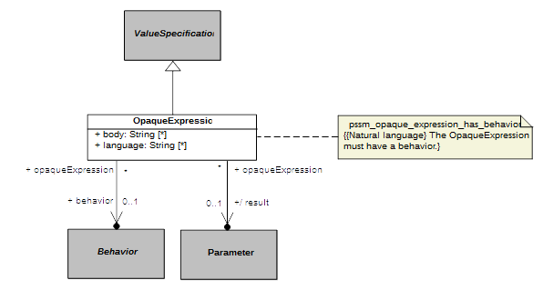Figure 7.4 - OpaqueExpressions

Constraints

pssm_opaque_expression_has_behavior
context UML::Values::OpaqueExpression inv:
self.behavior <> null

Classification

Overview
The PSSM subset includes all the metaclasses in the fUML subset Classification package and does not include any additional ones in this area. However, the fUML constraint zero_or_one_method requires that a concrete Operation have a single associated method. This constraint is too restrictive for PSSM, because PSSM allows an Operation to be handled via a CallEvent trigger on a StateMachine Transition, in which case the Operation cannot have a method (see 7.5). Therefore, the PSSM_Syntax::Constraints::Classification package imports all the constraints from the corresponding fUML package except for the zero_or_one_method constraint, which is replaced with the pssm_operation_has_at_most_one_method constraint (as shown in Figure 7.5 and formally defined in 7.4.2).
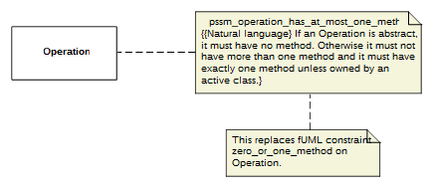Figure 7.5 - Operations

Constraints

pssm_operation_has_at_most_one_method
context UML::Classification::Operation inv:
if self.isAbstract then self.method->isEmpty()
else
self.method->size() <= 1 and
((self.class = null or not self.class.isActive) implies
self.method->size() = 1)
endif

Common Behavior

Overview
In addition to all the metaclasses included in the fUML subset CommonBehavior package, PSSM includes the CallEvent metaclass (see Figure 7.6). Including CallEvent in the PSSM subset provides the ability for an Operation of a Class in a PSSM conformant model to be handled by a CallEvent trigger on a Transition of a StateMachine acting as the classifierBehavior of that class (see 7.6.2), rather than be implemented by a method. Since the UML specification specifies that having a method on an Operation means all calls on the Operation are handled by executing that method (see [UML], 13.3.3.2), even if there may also be executing Behaviors with CallEvent Triggers for the Operation, Operations on CallEvents in PSSM are constrained not to have a method, in order to avoid confusion. This constraint is shown in Figure 7.6 and formally defined in 7.5.2.
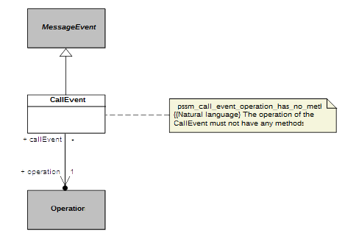Figure 7.6 - CallEvents

Constraints

pssm_call_event_operation_has_no_method
context UML::CommonBehavior::CallEvent inv:
self.operation.method->isEmpty()

State Machines

Overview
Not surprisingly, the largest extension to fUML provided by PSSM is in the area of StateMachines. Within this area, the PSSM subset includes abstract syntax for behavior StateMachines (see 7.6.2) and StateMachine redefinition (see 7.6.3). The formal PSSM subset does not include ProtocolStateMachines, they are discussed non-normatively in Annex A.

Behavior State Machines

Overview
A behavior StateMachine may be used in a PSSM-conformant model either stand-alone or as the classifierBehavior of an active Class. As shown in Figure 7.7, the PSSM subset includes the full UML abstract syntax for behavior StateMachines, except for the ConnectionPointReference metaclass. ConnectionPointReferences are used only in relation to submachine States, and such states are not allowed in a PSSM. Figure 7.7 shows various additional constraints on StateMachines required for PSSM, including the constraints on the usage of StateMachines and the prohibition on submachine States, all of which are formally defined in 7.6.2.2.
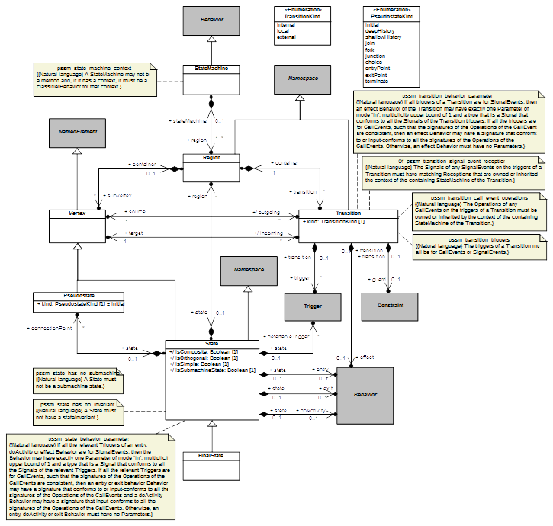Figure 7.7 - Behavior StateMachines

Constraints

pssm_state_machine_context
context UML::StateMachines::StateMachine inv:
self.specification = null and
self.context <> null implies self.context.classifierBehavior = self

pssm_state_has_no_submachine
context UML::StateMachines::State inv:
not self.isSubmachineState

pssm_state_has_no_invariant
context UML::StateMachines::State inv:
self.stateInvariant = null

pssm_state_behavior_parameters
context UML::StateMachines::State inv:
-- TBD

pssm_transition_triggers
context UML::StateMachines::Transition inv:
self.trigger.event->forAll(
oclIsKindOf(UML::CommonBehavior::CallEvent) or
oclIsKindOf(UML::CommonBehavior::SignalEvent)
)

pssm_transition_call_event_operations
context UML::StateMachines::Transition inv:
let stateMachine = self.containingStateMachine() in
let context =
if stateMachine.context = null then stateMachine
else stateMachine.context
endif in
context.allFeatures()->includesAll(
self.trigger->select(oclIsKindOf(UML::CommonBehavior::CallEvent)).
oclAsType(UML::CommonBehavior::CallEvent).operation
)

pssm_transition_signal_event_receptions
context UML::StateMachines::Transition inv:
let stateMachine = self.containingStateMachine() in
let context =
if stateMachine.context = null then stateMachine
else stateMachine.context
endif in
context.allFeatures()->select(oclIsKindOf(UML::SimpleClassifiers::Reception)).
oclAsType(UML::SimpleClassifiers::Reception).signal->includesAll(
self.trigger->select(oclIsKindOf(UML::CommonBehavior::SignalEvent)).
oclAsType(UML::CommonBehavior::SignalEvent).signal
)

pssm_transition_behavior_parameters
context UML::StateMachines::Transition inv:
-- TBD

State Machine Redefinition

Overview
The capability for StateMachine redefinition actually does not require any other metaclasses than those already included for behavior StateMachines. However, for clarity, the diagram for StateMachine redefinition from the UML specification is repeated here, showing the additional meta-associations involved (Figure 7.8). This diagram also shows the additional constraint (formally defined in 7.6.3.2) required for the PSSM semantics, which only support the ability of a StateMachine to extend at most one other StateMachine.
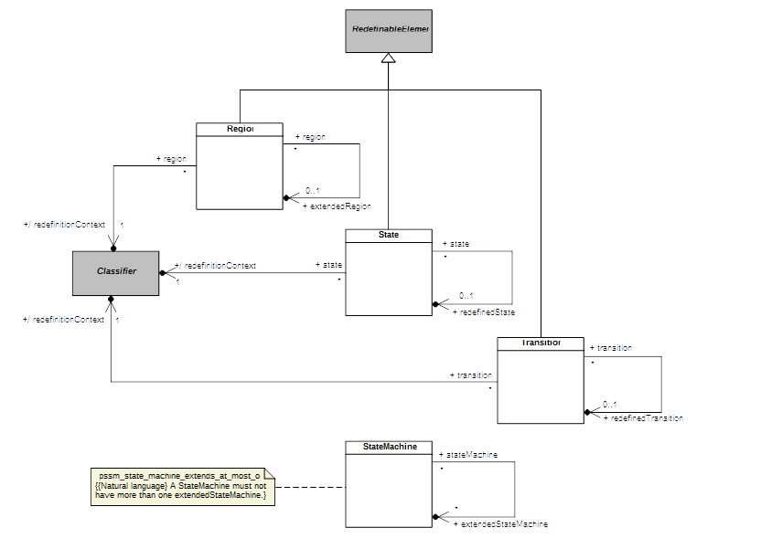Figure 7.8 - StateMachine Redefinition

Constraints

pssm_state_machine_extends_at_most_one
context UML::StateMachines::StateMachine inv:
self.extendedStateMachine->size() <= 1

Execution Model

Overview

Loci

Overview

Class Descriptions

Values

Overview

Expressions

Overview

Class Descriptions

Structured Classifiers

Overview

Classes

State Machines

Overview

Behavior State Machines

State Machine Redefinition

Test Suite

Overview
The PSSM specification is delivered with a test suite. This test suite is designed as a UML model. It captures a set of tests cases that when executed enables us to assess the semantics that is captured within the semantic model for UML state machines that is presented in Clause 8.

UML Semantics Requirements
The definition of the test suite is strongly coupled to the semantics requirements that were identified within the UML chapter related to state machines semantics Indeed each test case verify (or not) one particular requirement. A requirement takes the form of textual description of particular part of the semantics related to state machines. A test case is defined as an executable UML model that assesses this particular part of the semantics. Each time a test will be presented in 9.3, its related requirement will also be reminded.

Test Suite Organization
The test suite is separated into two parts. The first one defines the abstract architecture of a test case. This architecture is specialized (in the UML sense) for each test case. A detailed presentation of this part of the test suite model is given in 9.2.
The second part of the test suite defines a set of packages where each package refers to a particular test category. As an example a test category in the test suite captures all tests cases related to transition semantics. Each test case in this category asserts a specific part (identified in the requirements) of the transition semantics.

Test Coverage and Limits
The purpose of having a strong coupling between the semantics requirements for state machines is to be able (as in usual software development) to identify quickly and precisely what is covered by the semantic model in terms of semantics and what is currently not covered. Statistics and limitations about current coverage of UML state machines semantics are presented in section 9.4. .

Utilities
One objective of the PSSM test suite is to define a base architecture to simplify the definition of executable tests cases. This architecture (structure and behavior) is presented in 9.2.1. The communications that take place between the different elements of the architecture are presented in 9.2.2. Finally, 9.2.3 explains the process of generating a trace that capture information about the state machine execution. This trace is used to compare the execution expected for the state machine against the trace actually generated at execution time.

Architecture
This subclause presents the architecture that was defined to describe test cases to assess PSSM semantic model. In 9.2.1.1, concepts provided by UTP (UML Testing Profile) that are reused in the context of the test suite architecture are identified. In 9.2.1.2, the structure and the behavior of a base semantic test are presented. Finally, 9.2.1.3 identifies the structure of the semantic test container as well its behavior.

Relation with UML testing profile
The UML testing profile was built to provide “a standardized language based on OMG's Unified Modeling Language for designing, visualizing, specifying, analyzing, constructing, and documenting the artifacts commonly used in and required for various testing approaches, in particular model-based testing (MBT) approaches” [UTP].
The base architecture of the PSSM test suite is inspired by concepts identified by the UML testing profile. These concepts are:
- TestComponent: “Test components are part of the test environment and are used to communicate with the system under test (SUT) and other test components. The main function of test components is to drive a test case by stimulating the system under test through its provided interfaces and to evaluate whether the actual responses of the system under test comply with the expected ones.” (see subclause 8.2.2.2 of [UTP] to read the complete description of this concept).
- TestCase: “A test case is a behavioral feature or behavior specifying tests. A test case specifies how a set of test components interact with an SUT to realize a test objective. Test cases are owned by test contexts, and therefore have access to all parts of the test configuration, other global variables (e.g., data pools, etc.) or further behavioral features (e.g., auxiliary methods). A test case always returns a verdict.” (see subclause 9.2.2.4 of [UTP] to read the complete description of this concept).
- TestContext: “A test context acts as a grouping mechanism for a set of test cases. The composite structure of a test context is referred to as test configuration. The classifier behavior of a test context may be used for test control” (see subclause 8.2.2.3 of [UTP] to read the complete description of this concept).
The next subclause shows how these concepts are used in the context of the definition of the abstract architecture of a test.

Base Semantic Test
Figure 9.1 illustrates the architecture of an abstract semantic test.

Tester
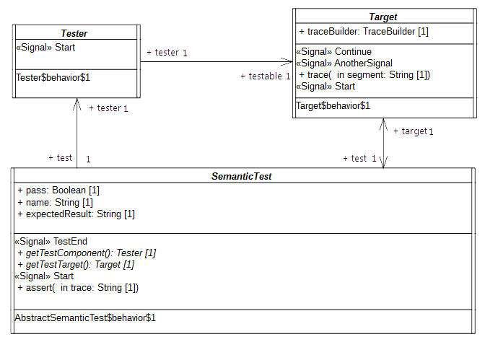Figure 9.1 - Architecture of an abstract semantic test

Description
The tester is an abstract active class which encodes in its classifier behavior the stimulation sequence (i.e, a set of events) that will be sent to the target (i.e., the system under test).
Note that this role matches to what is intended for a TestComponent in UTP. This class has the stereotype “TestComponent” applied.

Association Ends
- testable: Target [1] – The SUT (System Under Test) to which the stimulation sequence is sent.
- test: SemanticTest [1] – The test case which controls the tester.

Receptions
- Start – A tester can receive Start signal

Classifier Behavior
The classifier behavior of the abstract tester is empty. Specializations are intended to provide a new classifier behavior which will encode the user defined stimulation sequence.

Target

Description
The target defines the system under test. Specializations of this class have to provide their classifier behaviors specified as a state machine.
The target receives the stimulation sequence produced by the tester. The dispatching of the events will enable transitions of the state machine playing the role of a classifier behavior to be triggered.
All along its execution the state machine generates an execution trace. This trace is stored by the target and finally provided as the result of the execution to the test which controls the target.

Attributes
- traceBuilder: TraceBuilder [1] – Each test target owns a trace builder. It enables the classifier behavior of a target to build a trace all along its execution.

Association Ends
- test: SemanticTest [1] - The test case which controls the target.

Operations
- trace(in segment: String[1]) – The operation enables the addition of “segment” (i.e., a new part) to the execution trace. It can be called at any time in the classifier behavior of the target to capture information relative to the executed state machine.

Receptions
- Start – The target is able to receive Start signals
- Continue – The target is able to receive Continue signals
- AnotherSignal – The target is able to receive AnotherSignal signals.

Classifier Behavior
The classifier behavior of the abstract Target is empty. All specializations are intended to provide a new classifier behavior which will be the state machine whose execution is performed by the execution model defined for PSSM.

SemanticTest

Descriptions
A SemanticTest is the main artifact of a semantic test case. It is in charge of instantiating and controlling the tester and the target (i.e. the SUT). When the execution of the SUT is done then the execution trace that was produced is provided to the semantic test case for analysis. If the trace matches one of the expected trace for the executed state machine the test pass otherwise it fails.
The classifier behavior of a semantic test has the TestCase stereotype applied.

Attributes
- name: String [1] – The name of the test case name.
- pass: Boolean [1] – The current status (pass or fail) of the test.
- expectedResult: String [1] – The execution trace that is expected for SUT.

Operations
- getTestComponent(): Tester – Abstract operation which returns an instance of the tester controlled by the semantic test whose classifier has been started. This operation is intended to be redefined by specializations of SemanticTest.
- getTestTarget(): Target – Abstract operation which returns an instance of the target controlled by the semantic test whose classifier has been started. This operation is intended to be redefined by specializations of SemanticTest.
- assert(in trace: String[1]) – This operation updates the value of the attribute “pass” by comparing the trace given as a parameter to the expected execution trace known by the semantic test.

Receptions
- Start – The semantic test is able to receive Start signals.
- TestEnd – The semantic test is able to receive TestEnd signals.

Classifier Behavior
The classifier behavior of a semantic test is defined as UML activity (which conforms to the fUML subset). It is presented in Figure 9.2.
The principle of the behavior is the following:
- When the classifier behavior starts it blocks waiting for the dispatching of a Start signal
- On the reception of the Start signal it creates and instantiates both a the tester and the target.
  - The links (instances of associations) are created.
  - The tester and the target receive a Start signal.
  - The semantic test finally blocks again waiting for the dispatching of a TestEnd signal.
- When the TestEnd signal is received then it computes the verdict of the test and notifies the test suite that controls it.
Note that specializations of a semantic test are not intended to override the dynamic that is captured in this classifier behavior.

Semantic Test and Test Suite
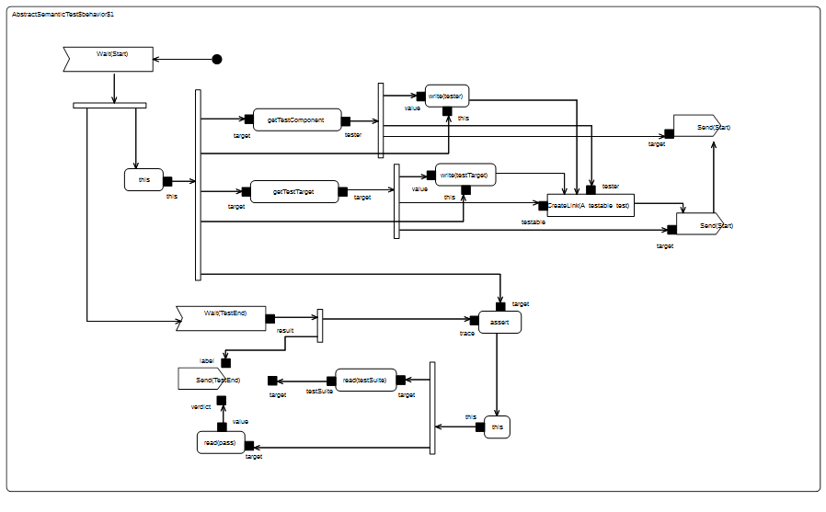Figure 9.2 - SemanticTest classifier behavior

SemanticTestSuite
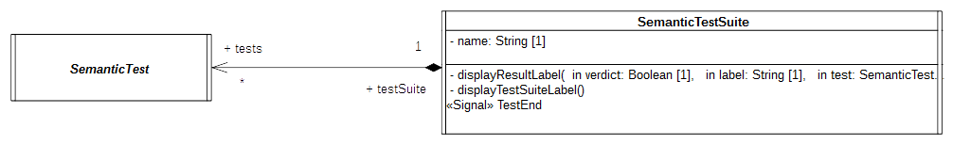Figure 9.3 - Semantic Test and Test Suite

Description
A SemanticTestSuite owns a set of SemanticTest. The execution of these tests is orchestrated by the test suite itself. Tests are executed one by one. At the end of each test the verdict is retrieved by the test suite that is charge of displaying the results. This is active class and is not intended to be specialized.
One can notice that it matches the concept of TestContext proposed by UTP. This class has the stereotype TestContext applied.

Attributes
- Name: String [1] – The name of the test suite.

Association Ends
- tests: SemanticTest [*] - the set of semantic tests that is handled by the semantic test suite.

Receptions
- TestEnd – The SemanticTestSuite class is able to received TestEnd signals.

Operations
- displayResultLabel(in verdict: Boolean [1], in label: String[1], in test: SemanticTest [1]) – A convenience operation to display the test result on an output stream.
- displayTestSuiteLabel() - A convenience operation to display the name of the name of the suite on an output stream.

Classifier Behavior
The classifier behavior of the suite encodes a sequential execution of the test known by the test suite. Each time a test (that was started by the test suite) terminates then the test suite gets notified. As soon as the notification (i.e., a TestEnd signal) is dispatched then the test result is displayed in the output stream chosen by the user. The classifier behavior of the semantic test suite is presented in Figure 9.4.

Protocol
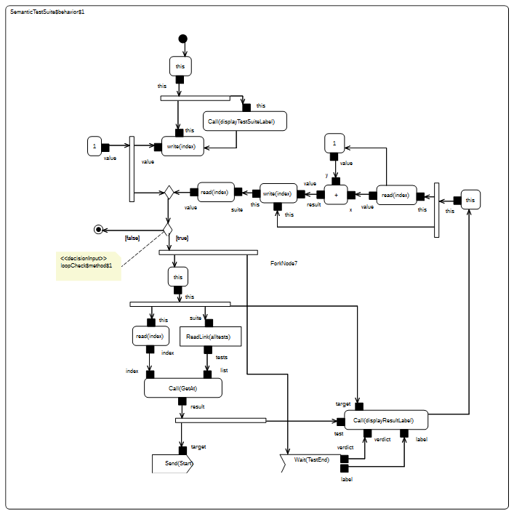Figure 9.4 - SemanticTestSuite classifier behavior
The Protocol package of the test suite has two subpackages: Messages and Events.
- Messages contains all signals used to communicate between the different active classes (see the model below).
namespace StateMachine_TestSuite::Util::Protocol;
package Messages {
/* -- Synchronization --*/
public signal Start {}
public signal End {
public trace: String;
}
public signal TestEnd {
public verdict: Boolean;
public label: String[0..1];
}
/* -- Synchronization --*/
/* -- Stimulations --*/
public signal Continue {}
public signal AnotherSignal {}
public signal Pending {}
/* -- Stimulations --*/
}
- Events contains the signal events (for the signals located in Messages) that can be directly used by triggers.
The following subclauses present the different signals and their usages in the context of the test suite.

Synchronization
These signals are used to synchronize executions of different active objects.

Start
The Start signal is used for to two purposes in the test suite context. First it enables the test suite to start the execution of a specific semantic test. Second it enables the test to start both its tester and its target. The modeling constraint for the SemanticTest, the Testert and the Target is that they must all register an accepter for the Start signal at the beginning of the execution of their classifier behaviors. Note that Start signal does not encapsulate data (since it has no attributes).

End
The End signal enables the Target to provide its controller (i.e., the SemanticTest) with a notification containing its execution trace. The semantic test takes advantage of this notification to compute the test verdict.

Attributes
- trace: String [1] – The execution trace generated by the state machine which plays the role of a classifier behavior for the Target.

TestEnd
The TestEnd signal enables a semantic test to notify its test suite that it has completed. This notification encapsulates two information: the test verdict as well as a label indicating in case of a fail the differences between the expected trace and the trace actually produced during the execution.

Attributes
- verdict: Boolean [1] – The verdict of test that is two say pass or fail encoded as Boolean values.
- label: String [0..1] – If the test failed the label presents the difference between the trace that was expected and the one actually produced during the execution.

Stimulation sequence
These signals (i.e., Continue, Pending and AnotherSignal) are used by the tester to stimulate the target (i.e. the system under test). None of these signals encapsulate data.

Tracing
At runtime the target is intended to produce an execution trace. This trace will be used to compute the test verdict by comparing the trace expected by the semantic test against the one actually generated by the target. The production of this trace relies on a small utility class TraceBuilder.
namespace StateMachine_TestSuite::Util::Tracing;
class TraceBuilder {
/*Record the trace as simple String*/
public trace: String;
/*Construction and destruction */
@Create
public TraceBuilder();
@Destroy
public destroy();
/*Add a new segment in the trace*/
public addSegment(in segment: String);
}
The execution information (state entered, behavior executed, etc.) which must be part of the trace are up to the designer of the test. To add a new information in the trace the designer must call the trace operation provided by the target. This latter will delegate to the trace builder. Such call to the trace operation must take place while the state machine is currently running. Consequently there four places at which the calls to trace might occur:
- The entry behavior of a state
- The doActivity behavior of a state
- The exit behavior of a state
- The effect behavior of a transition

Tests
This subclause presents the different test cases that are currently included in the PSSM test suite. The tests cases are grouped into categories. Each category is related to a dedicated part of the semantics.

Behaviors

Overview
Tests presented in this subclause assesses that semantics associated with state behaviors (i.e., entry, doActivity and exit) conform to what is specified in UML.

Test Behavior 001
Behavior001 – (UML 2.5 section 14.2.3.4.3)
A State may have an associated entry Behavior. This Behavior, if defined, is executed whenever the State is entered through an external Transition.

Test Architecture
Each test included in the test suite specializes the base test architecture presented in section 9.2.1.2. Figure 9.5 illustrates such specialization. The main point here is that Target class presented in section 9.2.1.2.2. is extended in order to provide a specific test target. This latter defines a new classifier behavior which is the state-machine that is going to be stimulated. One can also notice that SemanticTest is also extended. This enables the test to provide redefined version of operations getTestComponent and getTestTarget. These two operation are used to instantiate (and hence start classifier behaviors) both the tester (see section 9.2.1.2.1) and the test target (see section 9.2.1.2.2).
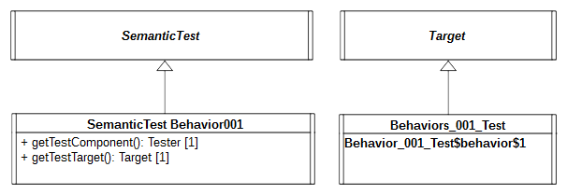Figure 9.5 - Behavior 001 Test Architecture

Tested state-machine
The state-machine that plays the role of a classifier behavior for the class Behaviors_001_Test is presented in Figure 9.6. The entry behavior associated to the state S1 of this state-machine is intended to be executed when the state is entered. When executed this the behavior will add in the execution trace a message S1(entry). If the message is not part of the trace then the test is considered as failed.
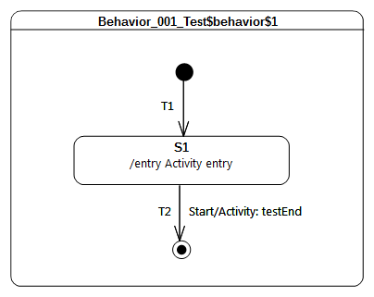Figure 9.6 - Behaviors_001_Test Classifier behavior
The behavior which is associated as an entry to to the state S1 is presented as an activity in Figure 9.7.
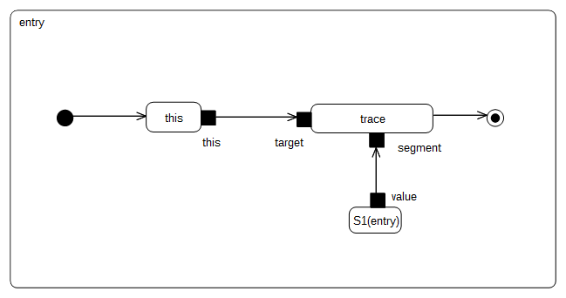Figure 9.7 - S1 entry behavior

Test execution
Received event occurrence(s)
  - Start – received when in configuration S1
Generated trace
- S1(entry)
RTC steps
Step | Event pool | State machine configuration | Fired transition(s)
1 | [] | [] - Initial RTC step | [T1]
2 | [Start, CE(S1)] | [S1] | []
3 | [Start] | [S1] | [T2]

Test Behavior 002
Behavior002 – (UML 2.5 section 14.2.3.4.3)
A State may also have an associated exit Behavior, which, if defined, is executed whenever the State is exited.

Tested state-machine
The state-machine that is executed for this test is presented in Figure 9.8.
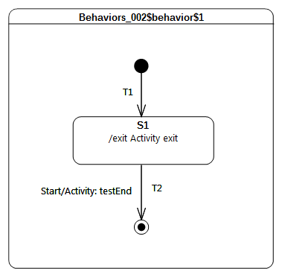Figure 9.8 - Behaviors 002 Test Classifier behavior

Test execution
Received event occurrence(s)
- Start – received when in configuration S1
Generated trace
- S1(exit)
RTC steps
Step | Event pool | State machine configuration | Fired transition(s)
1 | [] | [] - Initial RTC step | [T1]
2 | [Start, CE(S1)] | [S1] | []
3 | [Start] | [S1] | [T2]

Test Behavior 003 – A
Behavior003 – (UML 2.5 section 14.2.3.4.3)
A State may also have an associated doActivity Behavior. This Behavior commences execution when the State is entered (but only after the State entry Behavior has completed) and executes concurrently with any other Behaviors that may be associated with the State, until it completes (in which case a completion event is generated) or the State is exited, in which case execution of the doActivity Behavior is aborted.
In this test the focus is on validating the assertion that if a doActivity is currently executed by a state and this latter is exited then the doActivity is aborted. Other part of the requirement presented above will be asserted in section 9.3.1.5.

Tested state-machine
The state-machine that is executed for this test is presented in Figure 9.9.
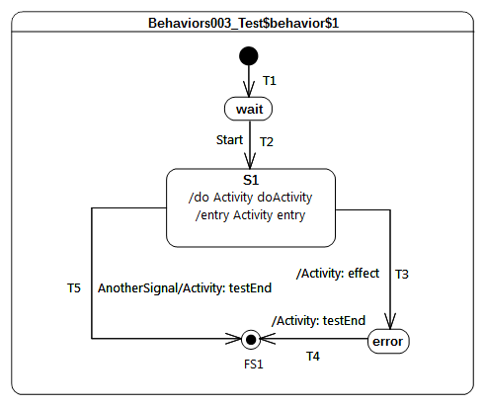Figure 9.9 - Behaviors 003 Classifier behavior
The doActivity behavior which is executed when the entry of S1 finished is presented in Figure 9.10. When started this behavior completes the execution trace with the message S1(doActivityPartI) and blocks until the reception of a Continue signal. Only if this signal triggers the continuation of the doActivity then the execution trace will be completed with the message S1(doActivityPartII).
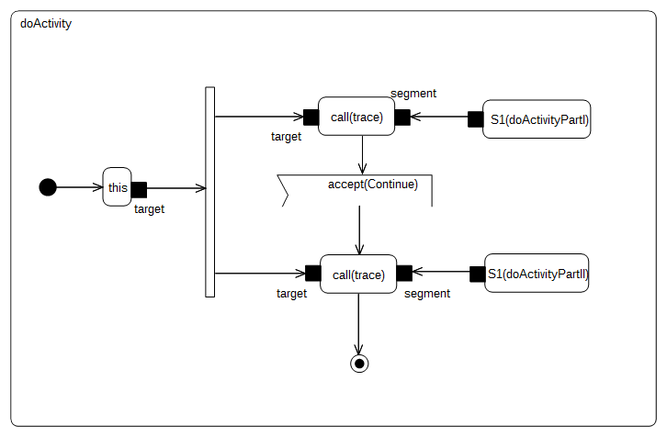Figure 9.10 - S1 doActivity behavior

Test executions
Received event occurrence(s)
- Start – received when in configuration wait
- AnotherSignal – received when in configuration S1
Generated trace
- S1(entry)::S1(doActivityPartI)
Note. The dispatching of the event AnotherSignal triggered transition T5. The triggering of this latter implies that S1 is exited and hence its running doActivity is aborted. The state-machine terminates its execution by reaching the final state.
RTC steps

Step | Event pool | State machine configuration | Fired transition(s)
1 | [] | [] - Initial RTC step | [T1]
2 | [Start, CE(wait)] | [wait] | []
3 | [Start] | [wait] | [T2]
4 | [AnotherSignal] | [S1] | [T5]

Test Behavior 003 – B
Behavior003 – (UML 2.5 section 14.2.3.4.3)
A State may also have an associated doActivity Behavior. This Behavior commences execution when the State is entered (but only after the State entry Behavior has completed) and executes concurrently with any other Behaviors that may be associated with the State, until it completes (in which case a completion event is generated) or the State is exited, in which case execution of the doActivity Behavior is aborted.
This test focuses on validating the assertion that when the doActivity completes then if the state is in a situation where it is ready to complete it generates a completion event. For this test the doActivity that is related to S1 is the same than the one presented in Figure 9.10.

Tested state-machine
The state-machine that is executed for this test is presented in Figure 9.11.

Test execution
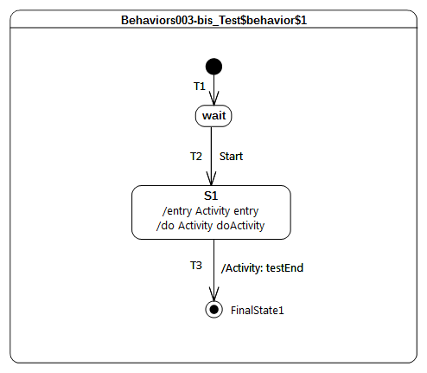Figure 9.11 - Behavior 003 bis Classifier behavior
Received event occurrence(s)
- Start – received when in configuration wait
- Continue – received when in configuration S1
Generated trace
- S1(entry)::S1(doActivityPartI)::S1(doActivityPartII)
Note. In this test case the only for the state-machine to terminate its execution is to traverse the completion transition T3 using the completion event generated by S1. The completion event requires to be generated that the doActivity behavior started by S1 completes. Here when Continue gets dispatched it cannot be accepted by the state-machine indeed there is no transition that has a trigger to react to this event. However it can be accepted by the doActivity behavior which is currently blocked waiting for a Continue event. The acceptance of this event leads the doActivity to complete which implies that upon the completion state S1 generates a completion event.
RTC steps

Step | Event pool | State machine configuration | Fired transition(s)
1 | [] | [] - Initial RTC step | [T1]
2 | [Start, CE(wait)] | [wait] | []
3 | [Start] | [wait] | [T2]
4 | [Continue] | [S1] | [] - RTC step in the doActivity
5 | [CE(S1)] | [S1] | [T3]

Test Behavior 004
Behavior004 – (UML 2.5 section 14.2.3.4.3)
The execution of a doActivity Behavior of a State is not affected by the firing of an internal Transition of that State.

Tested state-machine
The state-machine that is executed for this test is presented in Figure 9.12. It is important to consider that event if it does not appear on the diagram a self internal transition T3 exists for S1. This transition can be triggered on an AnotherSignal event and has an effect behavior. For this test the doActivity that is related to S1 is the same than the one presented in Figure 9.10.
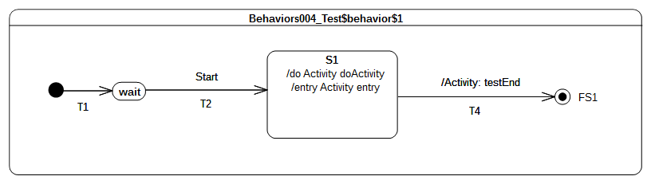Figure 9.12 - Behavior 004 Classifier Behavior

Test execution
Received event occurrence(s)
- Start – received when in configuration wait
- AnotherSignal – received when in configuration S1
- Continue – received when in configuration S1
Generated trace
- S1(entry)::S1(doActivityPartI)::T3(effect)::S1(doActivityPartII)
Note, When in configuration S1, T3 is triggered by the dispatching of AnotherSignal. This triggering has no impact on the doActivity behavior which is currently running. Indeed the behavior is still blocked waiting for Continue event occurrence. When this event is received the doActivity consumes it and completes its execution.
RTC steps

Step | Event pool | State machine configuration | Fired transition(s)
1 | [] | [] - Initial RTC step | [T1]
2 | [Start, CE(wait)] | [wait] | []
3 | [Start] | [wait] | [T2]
4 | [Continue, AnotherSignal] | [S1] | [T3]
5 | [Continue] | [S1] | [] - RTC step in the doActivity
6 | [CE(S1)] | [S1] | [T4]

Transitions

Transition 001
Transition 001 (UML 2.5 section 14.2.3.8)
It may have an associated effect Behavior, which is executed when the Transition is traversed.

Tested state-machine
The state-machine that is executed for that test is presented in Figure 9.13.
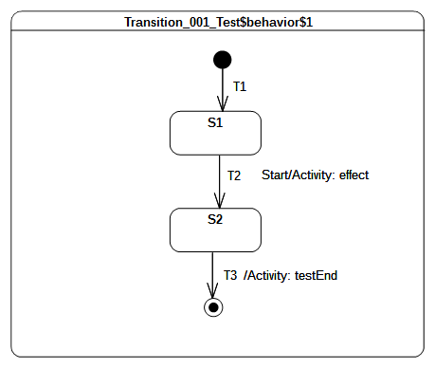Figure 9.13 - Transition 001 Classifier Behavior

Test executions
Received event occurrence(s)
- Start – received when in configuration S1.
Generated trace
- T2(effect)
Note, When Start is dispatched it triggers T2 whose execution includes the message T2(effect) to the execution trace.
RTC steps

Step | Event pool | State machine configuration | Fired transition(s)
1 | [] | [] - Initial RTC step | [T1]
2 | [Start, CE(S1)] | [S1] | []
3 | [Start] | [S1] | [T2]
4 | [CE(S2)] | [S2] | [T3]

Transition 007
Transition 007 (UML 2.5 section 14.2.3.8)
A Transition may own a set of Triggers, each of which specifies an Event whose occurrence, when dispatched, may trigger traversal of the Transition.

Tested state-machine
The state-machine that is executed for that test is presented in Figure 9.14.

Test executions
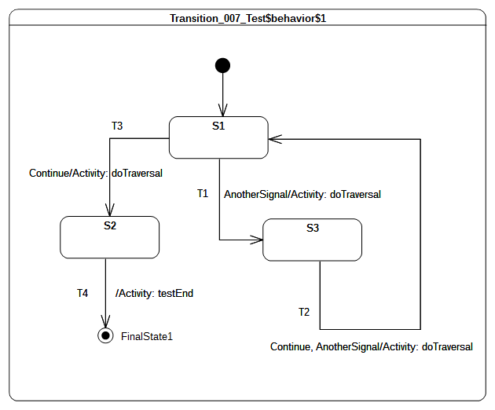Figure 9.14 - Transition 007 Classifier behavior
Received event occurrence(s)
- AnotherSignal – received when in configuration S1.
- Continue – received when in configuration S3.
- Continue – received when in configuration S1.
Generated trace
- T1(effect)::T2(effect)::T3(effect)
Note. When AnotherSignal is dispatched the transition T1 is triggered. This is due to the fact that T1 declares a trigger for a the signal AnotherSignal. The state-machine moves then in the configuration S3. There is no difference when there are multiple multiple triggered declared for a transition (see T2 in Figure 9.26). If the dispatched event occurrence matches at least one of the trigger then the transition is traversed. Continue triggers T2.
RTC steps

Step | Event pool | State machine configuration | Fired transition(s)
1 | [] | [] - Initial RTC step | [InitialTransition]
2 | [AnotherSignal, CE(S1)] | [S1] | []
3 | [AnotherSignal] | [S1] | [T1]
4 | [Continue, CE(S3)] | [S3] | []
5 | [Continue] | [S3] | [T2]
6 | [Continue, CE(S1)] | [S1] | []
7 | [Continue] | [S1] | [T3]
8 | [CE(S2)] | [S2] | [T4]

Transition 010
Transition 010 (UML 2.5 section 14.2.3.8.1)
kind = internal is a special case of a local Transition that is a self-transition (i.e., with the same source and target States), such that the State is never exited (and, thus, not re-entered), which means that no exit or entry Behaviors are executed when this Transition is executed.

Tested state-machine
The state-machine that is executed for that test is presented in Figure 9.15. Even if it does not appear on the diagram it is important to note that it exists a self internal transition IT for S1. This transition can be triggered when an occurrence of AnotherSignal is dispatched.

Test executions
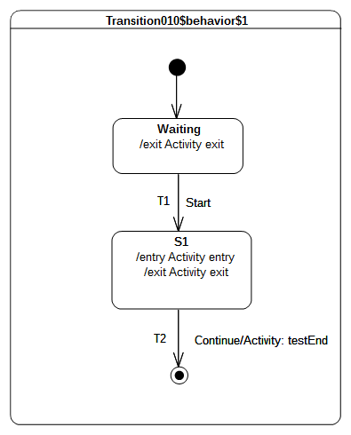Figure 9.15 - Transition 010 Classifier behavior
Received event occurrence(s)
- Start - received when in configuration waiting.
- AnotherSignal – received when in configuration S1.
- AnotherSignal – received when in configuration S1.
- Continue – received when in configuration S1.
Generated trace
- waiting(exit)::S1(entry)::IT(effect)::IT(effect)::S1(exit)
Note. The trace demonstrates here that S1 is not exited and re-entered when the transition IT is traversed. In the trace one can observe that IT(effect) appears twice. This illustrates the fact that this transition is triggered for each dispatching of an occurrence of AnotherSignal. The dispatching of Continue event occurrence implies that T2 is traversed and the state-machine execution completes by reaching the final state.
RTC steps

Step | Event pool | State machine configuration | Fired transition(s)
1 | [] | [] - Initial RTC step | [InitialTransition]
2 | [Start, CE(waiting)] | [waiting] | []
3 | [Start] | [waiting] | [T1]
4 | [AnotherSignal, AnotherSignal, CE(S1)] | [S1] | []
5 | [AnotherSignal, AnotherSignal] | [S1] | [IT]
6 | [Continue, AnotherSignal] | [S1] | [IT]
7 | [Continue] | [S1] | [T2]

Transition 011 – A
Transition 011 (UML 2.5 section 14.2.3.8.1)
kind = local is the opposite of external, meaning that the Transition does not exit its containing State (and, hence, the exit Behavior of the containing State will not be executed)

Tested state-machine
The state-machine that is executed for that test is presented in Figure 9.16.
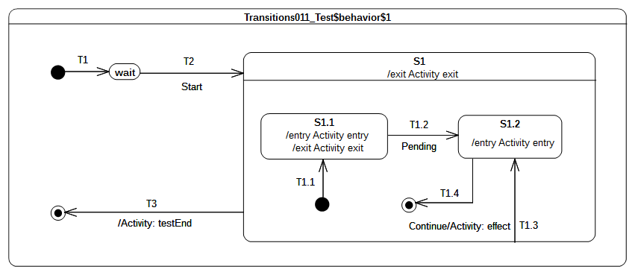Figure 9.16 - Transition 011 A Classifier behavior

Test executions
Received event occurrence(s)
- Start – received when in configuration wait.
- Continue – received when in configuration S1[S1.1].
Generated trace
- S1.1(entry)::S1.1(exit)::T1.3(effect)::S1.2(entry)
Note. When T1.3 is triggered by the event occurrence Continue the state-machine is in the configuration S1[S1.1]. The traversal of T1.3 implies that S1.1 is exited, the effect behavior is executed and finally S1.2 is entered. At the end of the entry behavior a completion event is generated for S1.2. This latter is used to trigger T1.4 in the next RTC step.
RTC steps

Step | Event pool | State machine configuration | Fired transition(s)
1 | [] | [] - Initial RTC step | [T1]
2 | [Start, CE(wait)] | [wait] | []
3 | [Start] | [wait] | [T2(T1.1)]
4 | [Continue, CE(S1.1)] | [S1[S1.1]] | []
5 | [Continue] | [S1[S1.1]] | [T1.3]
6 | [CE(S1.2)] | [S1[S1.2]] | [T1.4]
7 | [CE(S1)] | [S1] | [T3]

Transition 011 – B
Transition 011 (UML 2.5 section 14.2.3.8.1)
kind = local is the opposite of external, meaning that the Transition does not exit its containing State (and, hence, the exit Behavior of the containing State will not be executed)

Tested state-machine
The state-machine that is executed for that test is presented in Figure 9.17.
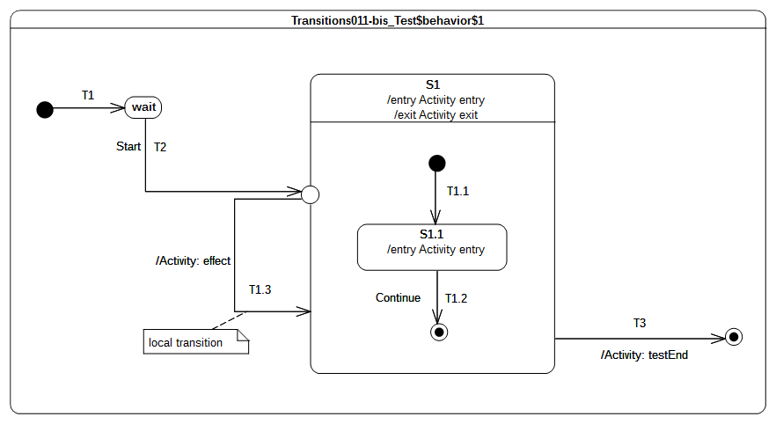Figure 9.17 - Transition 011 B Classifier behavior

Test executions
Received event occurrence(s)
- Start – received when in configuration wait.
- Continue – received when in configuration S1.
Generated trace
- S1(entry)::S1.1(entry)::T1.3(effect)
Notes. When the entry point is reached, S1 is entered and its unique region is entered. The execution of the region starts using the initial pseudostate. Next the continuation transition T1.1 is traversed and finally S1.1 is entered. At this point the RTC step initiated by the dispatching of the Start event occurrence is not ended. Indeed the continuation transition T1.3 outgoing from the entry point is traversed. Since S1 is already active it is not re-entered. This point is the end of the current RTC step. When Continue event occurrence is dispatched it triggers T1.2 which leads to the region completion and hence to the completion of S1. The completion event for S1 is used to trigger T3 which leads to the completion of the state-machine execution.
RTC steps

Step | Event pool | State machine configuration | Fired transition(s)
1 | [] | [] - Initial RTC step | [T1]
2 | [Start, CE(wait)] | [wait] | []
3 | [Start] | [wait] | [T2(T1.1, T1.3)]
4 | [Continue, CE(S1.1)] | [S1[S1.1]] | []
5 | [Continue] | [S1[S1.1]] | [T1.2]
6 | [CE(S1)] | [S1] | [T3]

Transition 011 – C
Transition 001
kind = external means that the Transition exits its source Vertex. If the Vertex is a State, then executing this Transition will result in the execution of any associated exit Behavior of that State.

Tested state-machine
The state-machine that is executed for that test is presented in Figure 9.18.

Test executions
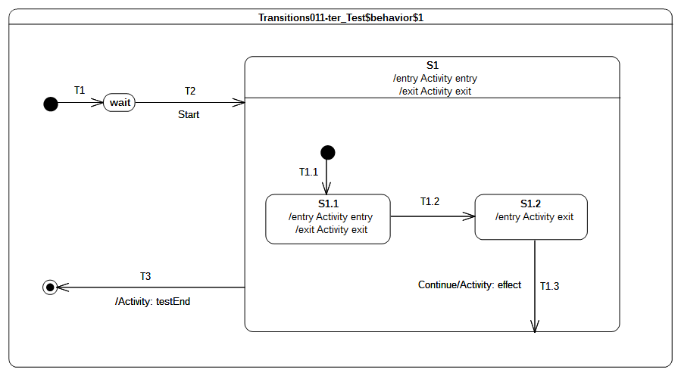Figure9.18: Transition 011C Classifier behavior
Received event occurrence(s)
- Start – received when in configuration wait.
- Continue – received when in configuration S1[S1.2].
Generated trace
- S1(entry)::S1.1(entry)::S1.1(exit)::S1.2(exit)::T1.3(effect)::S1(exit)
Note. When T1.3 is triggered (dispatching of Continue) S1.2 is exited and the effect behavior is executed. However S1 is not re-entered (it is already active) but the region which contains the last exited state is completed. The completion of the region implies the generation of a completion event for S1. This completion event is used to trigger T3.
RTC steps
Step | Event pool | State machine configuration | Fired transition(s)
1 | [] | [] - Initial RTC step | [T1]
2 | [Start, CE(wait)] | [wait] | []
3 | [Start] | [wait] | [T2(T1.1)]
4 | [CE(S1.1)] | [S1[S1.1]] | [T1.2]
5 | [Continue, CE(S1.2)] | [S1[S1.2]] | []
6 | [Continue] | [S1[S1.2]] | [T1.3]
7 | [CE(S1)] | [S1] | [T3]

Transition 011 – D
Transition 011 (UML 2.5 section 14.2.3.8.1)
kind = local is the opposite of external, meaning that the Transition does not exit its containing State (and, hence, the exit Behavior of the containing State will not be executed)

Tested state-machine
The state-machine that is executed for that test is presented in Figure 9.19.
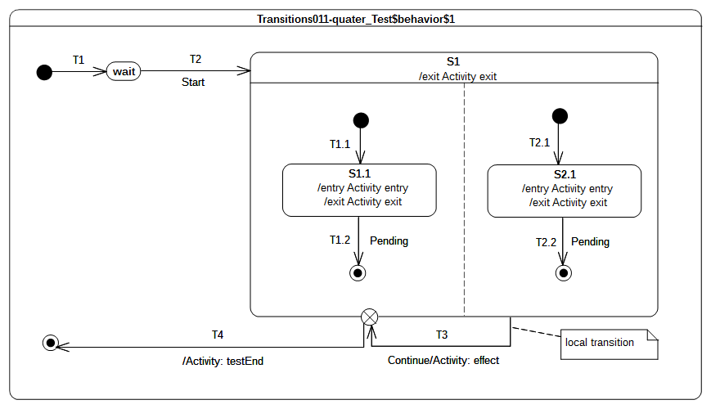Figure 9.19 - Transition 011 D Classifier behavior

Test executions
Received event occurrence(s)
- Start – received when in configuration wait.
- Continue – received when in configuration S1[S1.1, S2.1].
Generated trace
- S1.1(entry)::S2.1(entry)::T3(effect)::S1.1(exit)::S2.1(exit)::S1(exit)
Notes
- S1 has orthogonal regions therefore it is important to notice that the trace presented above is one possible execution path. Alternative execution paths are possible.
- When the state-machine configuration is S1[S1.1, S2.1] the event occurrence Continue is dispatched. This implies the trigerring of the local transition T3. The source state is not exited, the effect behavior is executed and finally the exit point is reached. Hence S1.1 and S2.1 are exited immediately followed by S1. The continuation transition fires and leads to the completion of the state-machine execution.
RTC steps

Step | Event pool | State machine configuration | Fired transition(s)
1 | [] | [] - Initial RTC step | [T1]
2 | [Start, CE(wait)] | [wait] | []
3 | [Start] | [wait] | [T2(T1.1, T2.1)]
4 | [Continue, CE(S2.1), CE(1.1)] | [S1[S1.1, S2.1]] | []
5 | [Continue, CE(S2.1)] | [S1[S1.1, S2.1]] | []
6 | [Continue] | [S1[S1.1, S2.1]] | [T3(T4)]

Transition 011 – E
Transition 001 (UML 2.5 section 14.2.3.8.1)
kind = local is the opposite of external, meaning that the Transition does not exit its containing State (and, hence, the exit Behavior of the containing State will not be executed)

Tested state-machine
The state-machine that is executed for that test is presented in Figure 9.20.
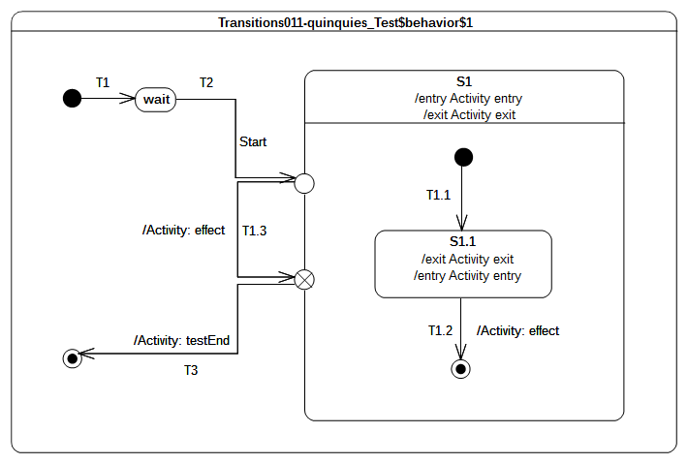Figure 9.20 - Transition 011 E Classifier behavior

Test executions
Received event occurrence(s)
- Start – received when in configuration wait.
Generated trace
- S1(entry)::S1.1(entry)::T1.3(effect)::S1.1(exit)::S1(exit)
Note. When the entry point is reached S1 is entered and the region is entered using the default approach (i.e. an initial is searched to start the execution). Hence S1.1 is entered via the transition T1.1. The RTC to completion initiated by the dispatching of Start event occurrence is not ended. The continuation transition T1.3 is traversed and its effect behavior is executed. At the point where the exit point is reached then S1.1 is exited as well as S1. The continuation transition T3 is traversed and leads to the completion of the state-machine execution. Transition T1.2 is never traversed in this test case and so S1 regions never completes.
RTC steps
Step | Event pool | State machine configuration | Fired transition(s)
1 | [] | [] - Initial RTC step | [T1]
2 | [Start, CE(wait)] | [wait] | []
3 | [Start] | [wait] | [T2(T1.1, T1.3, T3)]

Transition 015
Transition 015 (UML 2.5 section 14.2.3.8.3)
In case of simple States, a completion event is generated when the associated entry and doActivity Behaviors have completed executing

Tested state-machine
The state-machine that is executed for that test is presented in Figure 9.21. The doActivity which related to S1 state is exactly the same than the one presented in Figure 9.10.

Test executions
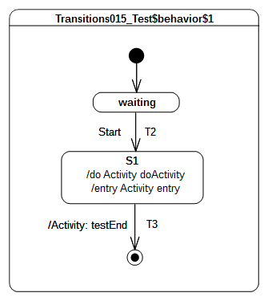Figure 9.21 - Transition 015 Classifier behavior
Received event occurrence(s)
- Start – received when in configuration waiting.
Generated trace
- S1(entry)::S1(doActivity)
Note. When S1 is entered (RTC step started by disptaching Start) its entry behavior is executed. As soon as the entry terminated its execution the doActivity is started asynchronously. When this doActivity behavior completes its execution a completion event is generated by S1 (its entry and doActivity are now terminated). This completion event is used to trigger T3.
RTC steps
Step | Event pool | State machine configuration | Fired transition(s)
1 | [] | [] - Initial RTC step | [InitialTransiton]
2 | [Start, CE(waiting)] | [waiting] | []
3 | [Start] | [waiting] | [T2]
4 | [CE(S1)] | [S1] | [T3]

Transition 016
Transition 016 (UML 2.5 section 14.2.3.8.3)
If no such Behaviors are defined, the completion event is generated upon entry into the State

Tested state-machine
The state-machine that is executed for that test is presented in Figure 9.22.

Test executions
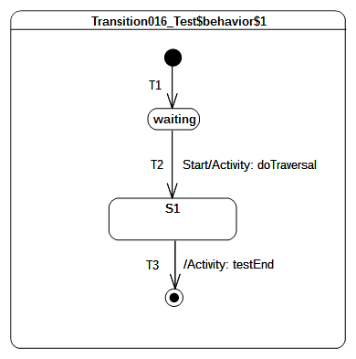Figure 9.22 - Transition 016 Classifier behavior
Received event occurrence(s)
- Start – received when in configuration waiting.
Generated trace
- T2(effect)
Note. When Start is dispatched T2 is triggered. Hence the effect behavior of T2 is executed and S1 is entered. In this test case S1 has no entry or doActivity, the completion event is therefore generated when it is entered.
RTC steps
Step | Event pool | State machine configuration | Fired transition(s)
1 | [] | [] - Initial RTC step | [InitialTransiton]
2 | [Start, CE(waiting)] | [waiting] | []
3 | [Start] | [waiting] | [T2]
4 | [CE(S1.1)] | [S1] | [T3]

Transition 017
Transition 017 (UML 2.5 section 14.2.3.8.3)
For composite States, a completion event is generated under the following circumstances: All internal activities (e.g., entry and doActivity Behaviors) have completed execution, and all its orthogonal Regions have reached a FinalState

Tested state-machine
The state-machine that is executed for that test is presented in Figure 9.23.

Test executions
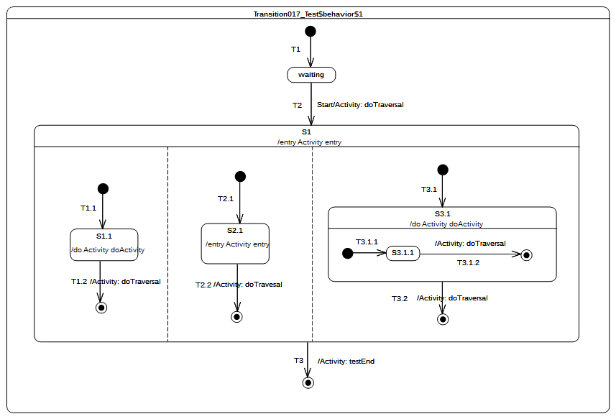Figure 9.23 - Transition 017 Classifier behavior
Received event occurrence(s)
- Start – received when in configuration waiting.
Generated trace
- T2(effect)::S1(entry)::S2.1(entry)::T2.2(effect)::T3.1.2(effect)::S1.1(doActivity)::T1.2(effect)::S3.1(doActivity):: T3.2(effect)
Notes
- S1 has orthogonal regions hence the execution trace that is presented above is one possible trace. It exists also alternative execution traces.
- The test case that is presented in Figure 9.23 mainly relies on completion event semantics. When Start is dispatched then T2 fires and implies the entrance of S1. Each region of S1 is entered concurrently using the default entry approach. Under the assumption that completion events for states S1.1, S2.1 and S3.1.1 are generated in this order: CE(S2.1), CE(S3.1.1) CE(S1.1); the further execution steps will occur in the following order:
- T2.2 is triggered and leads to the completion of the second region of S1. No completion event is generated.
- T3.1.2 is triggered and leads to the completion of the region owned by S3.1. A completion event is generated for this state.
- T1.2 is triggered and leads to the completion of the first region of S1. No completion event is generated
- T3.2 is triggered and leads to the completion of the last active region of S1. A completion event is generated for S1.
- T3 is triggered by the completion event generated by S1.
RTC steps
Step | Event pool | State machine configuration | Fired transition(s)
1 | [] | [] - Initial RTC step | [T1]
2 | [Start, CE(waiting)] | [waiting] | []
3 | [Start] | [waiting] | [T2(T1.1, T2.1, T3.1(T3.1.1))]
4 | [CE(S1.1), CE(S3.1.1), CE(S2.1)] | [S1[S1.1, S2.1, S3.1[S3.1.1]]] | [T2.2]
5 | [CE(S1.1), CE(S3.1.1)] | [S1[S1.1, S3.1[S3.1.1]]] | [T3.1.2]
6 | [CE(3.1), CE(S1.1)] | [S1[S3.1[S3.1.1]]] | [T1.2]
7 | [CE(3.1)] | [S1[S3.1]] | [T3.2]
8 | [CE(S1.1)] | [S1] | [T3]

Transition 019
Transition 019 (UML 2.5 section 14.2.3.8.3)
If two or more completion events corresponding to multiple orthogonal Regions occur simultaneously (i.e., as a result of the same Event occurrence), the order in which such completion occurrences are processed is not defined (p.329)

Tested state-machine
The state-machine that is executed for that test is presented in Figure 9.24.

Test executions
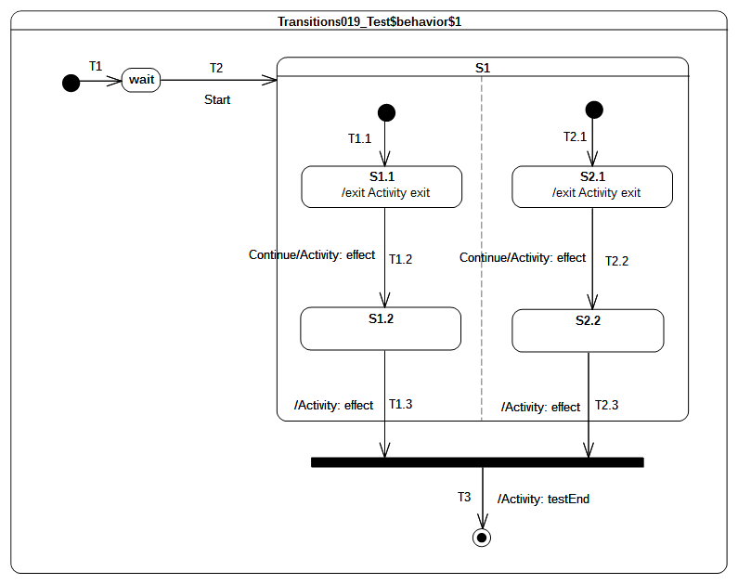Figure 9.24 - Transition 019 Classifier behavior
Received event occurrence(s)
- Start – received when in configuration wait.
- Continue – received when in configuration S1[S1.1, S2.1].
Generated trace
- S1.1(exit)::T1.2(effect)::S2.1(exit)::T2.2(effect)::T1.3(effect)::T2.3(effect)
Notes
- The execution trace that is presented above is one possibility. Other valid execution traces exists for this test case.
- At the end of the RTC step initiated by the dispatching of Start event occurrence, the state machine is in the following configuration: S1[S1.1, S2.1]. The dispatching of Continue event occurrence implies a simultaneous triggering of both T1.2 and T2.2. Hence thanks to same event occurrence two completion are respectively generated by S1.2 and S2.2. The order in which these completion event will be dispatched is the order in which they were placed in the event pool. Under the assumption that CE(S1.2) is first then T1.3 will be fired first. CE(2.1) will be triggered next and the join node prerequisites will be satisfied.
RTC steps
Step | Event pool | State machine configuration | Fired transition(s)
1 | [] | [] - Initial RTC step | [T1]
2 | [Start, CE(wait)] | [wait] | []
3 | [Start] | [wait] | [T2(T1.1, T2.1)]
4 | [Continue, CE(S1.1), CE(S2.1)] | [S1[S1.1, S2.1]] | []
5 | [Continue, CE(S1.1)] | [S1[S1.1, S2.1]] | []
6 | [Continue] | [S1[S1.1, S2.1]] | [T1.2, T2.2]
7 | [CE(S2.2), CE(S1.2)] | [S1[S1.2, S2.2]] | [T1.3]
8 | [CE(S2.2)] | [S1[S2.2]] | [T1.3(T3)]

Transition 020
Transition 020 (UML 2.5 section 14.2.3.8.3)
Completion events have dispatching priority. That is, they are dispatched ahead of any pending Event occurrences in the event pool.

Tested state-machine
The state-machine that is executed for that test is presented in Figure 9.25.

Test executions
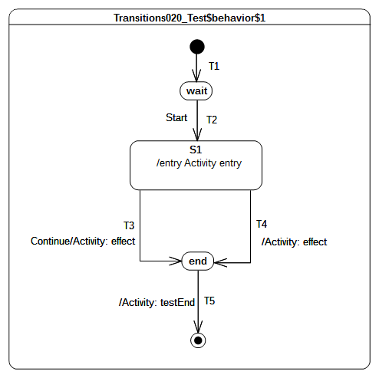Figure 9.25 - Transition 020 Classifier behavior
Received event occurrence(s)
- Start – received when in configuration wait.
- Continue – received when in configuration S1.
Generated trace
- S1(entry)::T4(effect)
Note. When Start is dispatched the transition T2 is triggered. This brings the state-machine in the configuration S1. The entry of S1 implies the execution of the entry behavior. Upon the termination of the execution of this behavior S1 is ready to generate a completion event. This latter is placed at the head of the event pool. Hence it acquires the priority over regular event(s) already present in the pool. To conclude when the next RTC step will be begin by the dispatching of the completion event generated for S1. This event will trigger the transition T4. Continue event occurrence will never get dispatched.
RTC steps
Step | Event pool | State machine configuration | Fired transition(s)
1 | [] | [] - Initial RTC step | [T1]
2 | [Start, CE(wait)] | [wait] | []
3 | [Start] | [wait] | [T2]
4 | [Continue, CE(S1.1)] | [S1] | [T4]
5 | [Continue, CE(end)] | [end] | [T5]

Transition 022
Transition 022 (UML 2.5 section 14.2.3.8)
It may have an associated effect Behavior, which is executed when the Transition is traversed.

Tested state-machine
The state-machine that is executed for that test is presented in Figure 9.26.
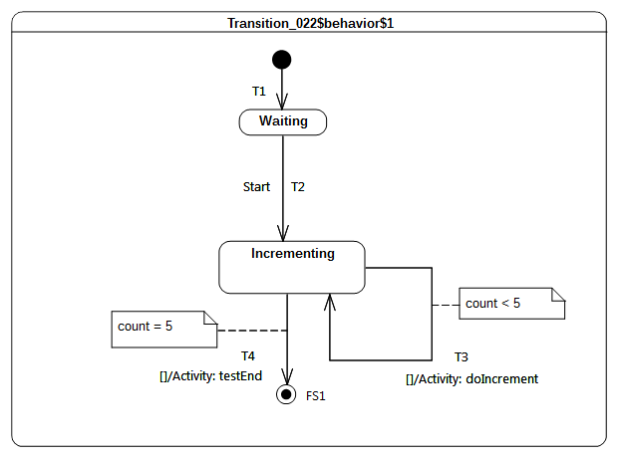Figure 9.26 - Transition 022 Classifier behavior

Test executions
Received event occurrence(s)
- Start – received when in configuration waiting.
Generated trace
- T3(effect)::T3(effect)::T3(effect)::T3(effect)::T3(effect)
Note. the principle of the test is to increment the value of a property of the class that has the sate-machine presented in Figure 9.26 has a classifier behavior. The value of the property is incremented until it reaches the value 5. The state-machine that implements this behavior uses guarded transitions (see T3 and T4). When the event occurrence Start is dispatched then T2 fires and Incrementing is entered. The completion event generated for that state is used to trigger either T4 or T3 based on their guard evaluations.
RTC steps
Step | Event pool | State machine configuration | Fired transition(s)
1 | [] | [] - Initial RTC step | [T1]
2 | [Start, CE(wait)] | [wait] | []
3 | [Start] | [wait] | [T2]
4 | [CE(Incrementing)] | [Incrementing] | [T3]
5 | [CE(Incrementing)] | [Incrementing] | [T3]
6 | CE(Incrementing) | [Incrementing] | [T3]
7 | CE(Incrementing) | [Incrementing] | [T3]
8 | CE(Incrementing) | [Incrementing] | [T3]
9 | CE(Incrementing) | [Incrementing] | [T4]

Event

Overview
Test cases presented in subclause demonstrate the coverage provided by the execution model regarding the dispatching and the acceptance of events occurrence in state-machines context.

Event 001
Event 001 (UML 2.5 section 14.2.3.9.1)
Upon creation, a StateMachine will perform its initialization during which it executes an initial compound transition prompted by the creation, after which it enters a wait point. In case of StateMachine Behaviors, a wait point is represented by a stable state configuration. It remains thus until an Event stored in its event pool is dispatched

Tested state-machine
The state-machine that is executed for that test is presented in Figure 9.27.
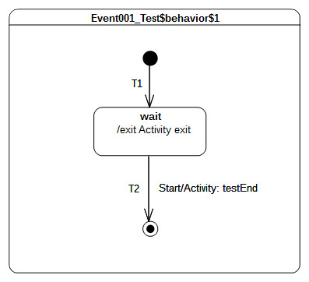Figure 9.27 - Event 001 Classifier behavior

Test executions
Received event occurrence(s)
- Start – received when in configuration wait.
Generated trace
- wait(exit)
Note. The state-machine execution starts using the initial pseudo state. The initial RTC step implies that the continuation transition T1 is traversed and the state wait is entered. At the end of this RTC step the state-machine execution enters a wait point. It is only able to leave when a Start event occurrence is dispatched from the event pool.
RTC steps
Step | Event pool | State machine configuration | Fired transition(s)
1 | [] | [] - Initial RTC step | [T1]
2 | [Start, CE(wait)] | [wait] | []
3 | [Start] | [wait] | [T2]

Event 002
Event 002 (UML 2.5 section 14.2.3.9.1)
This Event is evaluated and, if it matches a valid Trigger of the StateMachine and there is at least one enabled Transition that can be triggered by that Event occurrence, a single StateMachine step is executed.

Tested state-machine
The state-machine that is executed for that test is presented in Figure 9.28.

Test executions
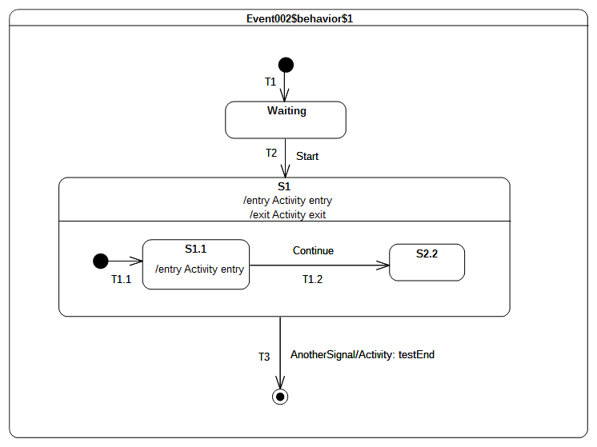Figure 9.28 - Event 002 Classifier behavior
Received event occurrence(s)
- Start – received when in configuration waiting.
- AnotherSignal received when in configuration S1[S1.1].
Generated trace
- S1(entry)::S1.1(entry)::S1(exit)
Note. At the point where AnotherSignal event occurrence is dispatched the executed state-machine is in configuration S1[S1.1]. This implies that when T3 is triggered then S1.1 is exited, immediately followed by S1. The state-machine execution completes by reaching the final state. This illustrates the realization of a RTC to completion step initiated by the dispatching of an event occurrence.
RTC steps
Step | Event pool | State machine configuration | Fired transition(s)
1 | [] | [] - Initial RTC step | [T1]
2 | [Start, CE(wait)] | [wait] | []
3 | [Start] | [wait] | [T2(T1.1)]
4 | [AnotherSignal, CE(S1.1)] | [S1[S1.1]] | []
5 | [AnotherSignal] | [S1[S1.1]] | [T3]

Event 008
Event 008 (UML 2.5 section 14.2.3.9.1)
When an Event occurrence is detected and dispatched, it may result in one or more Transitions being enabled for firing. If no Transition is enabled and the corresponding Event type is not in any of the deferrableTriggers lists of the active state configuration, the dispatched Event occurrence is discarded and the run-to-completion step is completed trivially.

Tested state-machine
The state-machine that is executed for that test is presented in Figure 9.29.

Test executions
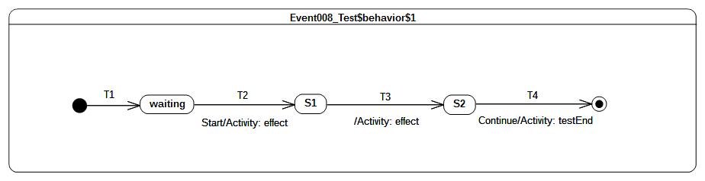Figure 9.29 - Event 008 Classifier behavior
Received event occurrence(s)
- Start – when received in configuration waiting.
- Continue – when received in configuration S2.
Generated trace
- T2(effect)::T3(effect)
Note. When the Start event occurrence is dispatched the state machine is in configuration waiting. The dispatching of this event implies that T2 is triggered and S1 is entered. As S1 is a simple state with no entry and doActivity behaviors then a completion event is generated for that state when entered. The dispatching of this completion events makesT3 to be triggered. Hence its effect behavior is executed and S2 is entered. The completion event generated of S2 is lost. Indeed when there is no possibility to use it to trigger an outgoing transition for that state. The only way to exit S2 is to receive and dispatch a Continue event occurrence.
RTC steps
Step | Event pool | State machine configuration | Fired transition(s)
1 | [] | [] - Initial RTC step | [T1]
2 | [Start, CE(waiting)] | [waiting] | []
3 | [Start] | [waiting] | [T2]
4 | [CE(S1)] | [S1] | [T3]
5 | [Continue, CE(S2)] | [S2] | []
6 | [Continue] | [S2] | [T4]

Event 009
Event 009 (UML 2.5 section 14.2.3.9.1)
It is possible that multiple Transitions (in different Regions) can be triggered by the same Event occurrence. The order in which these Transitions are executed is left undefined.

Tested state-machine
The state-machine that is executed for that test is presented in Figure 9.30.

Test executions
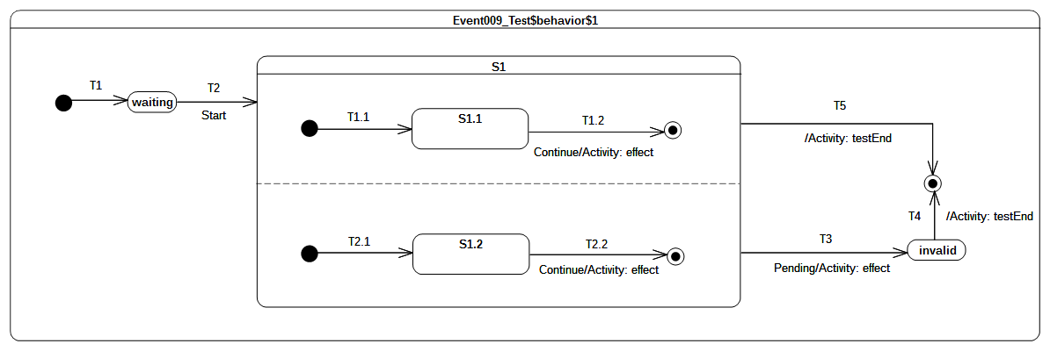Figure 9.30: Event 009 Classifier behavior
Received event occurrence(s)
- Start – received when in configuration waiting.
- Continue – received when in configuration S1[S1.1, S1.2].
- Pending – received when in configuration S1[S1.1, S1.2].
Generated trace
- T1.2(effect)::T2.2(effect)
Notes
- S1 contains orthogonal regions. Hence the trace presented above illustrates one possible execution.
- The Continue event occurrence is dispatched when the state-machine execution is in the configuration S1[S1.1, S1.2]. The dispatching of this event triggers simultaneously transitions T1.2 and T2.2 located in different orthogonal regions. This leads to the completion of S1 regions and so a completion event is generated for that state. This latter is used to trigger the completion transition T5. One can notice that in the case where Continue just triggered either T1.2 or T2.2 then S1 will not had the opportunity to complete. Hence T3 would have been triggered by the dispatching of Pending event occurrence and the expected execution trace would have been invalid.
RTC steps
Step | Event pool | State machine configuration | Fired transition(s)
1 | [] | [] - Initial RTC step | [T1]
2 | [Start, CE(waiting)] | [waiting] | []
3 | [Start] | [waiting] | [T2(T1.1, T2.1)]
4 | [Pending, Continue, CE(S1.2), CE(S1.1)] | [S1[S1.1, S1.2]] | []
5 | [Pending, Continue, CE(S1.2)] | [S1[S1.1, S1.2]] | []
6 | [Pending, Continue] | [S1[S1.1, S1.2]] | [T1.2, T2.2]
7 | [Pending, CE(S1)] | [S1] | [T5]

Event 010
Event 010 (UML 2.5 section 14.2.3.9.1)
It is possible for multiple mutually exclusive Transitions in a given Region to be enabled for firing by the same Event occurrence. In those cases, only one is selected and executed.

Tested state-machine
The state-machine that is executed for that test is presented in Figure 9.31.

Test executions
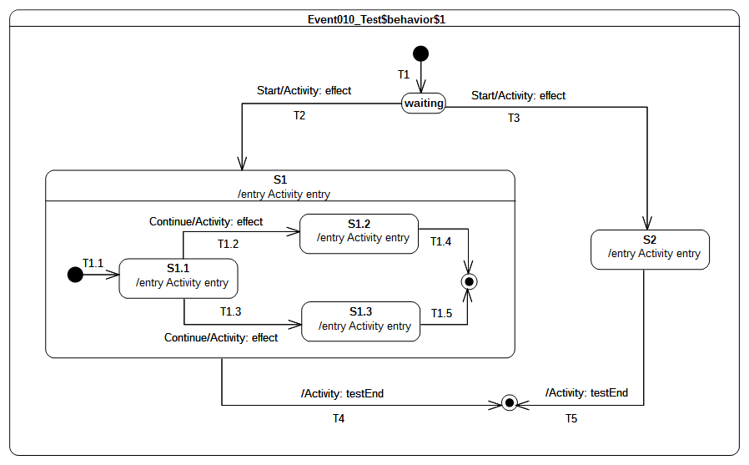Figure 9.31 - Event 010 Classifier behavior
Received event occurrence(s)
- Start – received when in configuration waiting.
- Continue – received when in configuration S1[S1.1].
Generated trace
- T1.2(effect)::S1(entry)::S1.1(entry)::T1.2(effect)::S1.2(entry).
Notes
- One can notice that the execution would have been completely different if a different semantic strategy was used to resolve conflicts.
- This test case highlights the resolution of transition conflicts at runtime. The first conflict that is encountered happens at the time the event occurrence Start is accepted. Indeed many transitions (i.e., T2 and T3) originating from the same state (i.e., waiting) can be triggered using this event occurrence. One of them is chosen using a semantic strategy. Under the assumption that in the case of this execution we always chose the first one in the list of conflicting transition then T2 fires. A similar scenario happens when the state-machine execution is in the configuration S1[S1.1]. The rule is not different when this happens in a nested context. Hence T1.2 is chosen using the semantic strategy to be triggered using the Continue event occurrence.
RTC steps
Step | Event pool | State machine configuration | Fired transition(s)
1 | [] | [] - Initial RTC step | [T1]
2 | [Start, CE(waiting)] | [waiting] | []
3 | [Start] | [waiting] | [T2(T1.1)]
4 | [Continue, CE(S1.1)] | [S1[S1.1]] | []
5 | [Continue] | [S1[S1.1]] | [T1.2]
6 | [CE(S1.2)] | [S1[S1.2]] | [T1.4]
7 | [CE(S1)] | [S1] | [T4]

Event 015
Event 015 (UML 2.5 section 14.2.3.9.3)
It is possible for more than one Transition to be enabled within a StateMachine. If that happens, then such Transitions may be in conflict with each other. For example, consider the case of two Transitions originating from the same State, triggered by the same event, but with different guards. If that event occurs and both guard conditions are true, then at most one of those Transition can fire in a given run-to-completion step.

Tested state-machine
The state-machine that is executed for that test is presented in Figure 9.32.

Test executions
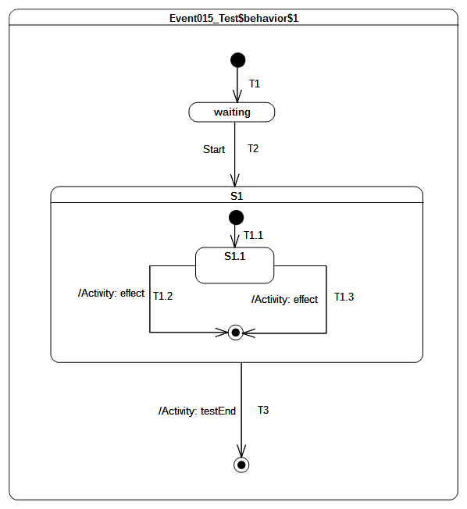Figure 9.32 - Event 015 Classifier behavior
Received event occurrence(s)
- Start – received when in configuration waiting.
Generated trace
- T1.2(effect)
Notes
- One can notice that the execution would have been different if a different semantic strategy was used to resolve conflicts.
- This test case is similar to the one presented in section 9.3.3.6. Nevertheless it illustrates the situation in which the conflicting situation occurs when a completion event for S1.1 is accepted. The two completion transitions T1.2 and T1.3 are both triggerable using the completion event. Here again the conflict is resolved using a semantic strategy to choose which transition is actually triggered.
RTC steps
Step | Event pool | State machine configuration | Fired transition(s)
1 | [] | [] - Initial RTC step | [T1]
2 | [Start, CE(waiting)] | [waiting] | []
3 | [Start] | [waiting] | [T2(T1.1)]
4 | [CE(S1.1)] | [S1[S1.1]] | [T1.2]
5 | [CE(S1)] | [S1] | T3

Event 016 – A
Event 016 (UML 2.5 section 14.2.3.9.4)
In situations where there are conflicting Transitions, the selection of which Transitions will fire is based in part on an implicit priority. These priorities resolve some but not all Transition conflicts, as they only define a partial ordering. The priorities of conflicting Transitions are based on their relative position in the state hierarchy. By definition, a Transition originating from a substate has higher priority than a conflicting Transition originating from any of its containing States. The priority of a Transition is defined based on its source State.

Tested state-machine
The state-machine that is executed for that test is presented in Figure 9.33.

Test executions
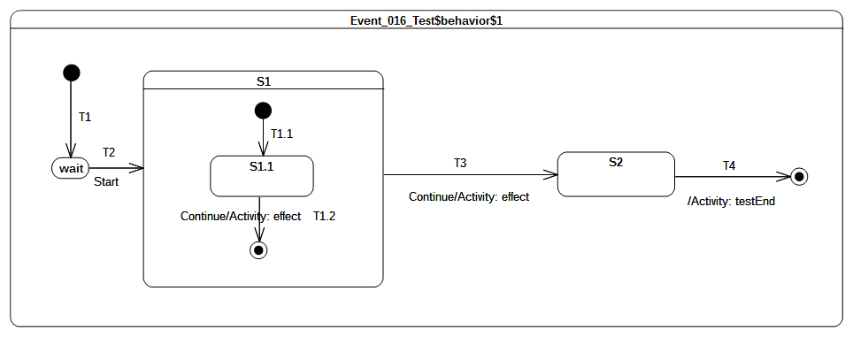Figure 9.33 - Event 016 Classifier behavior
Received event occurrence(s)
- Start – received when in configuration wait.
- Continue – received when in configuration S1[S1.1].
- Continue – received when in configuration S1.
Generated trace
- T1.2(effect)::T3(effect)
Note. This test case illustrates the consideration for transition priorities when an event is accepted. When the RTC step accepting Continue the event occurrence starts the state-machine is in the configuration S1[S1.1]. At this point to transitions seems to be triggered using the same. The resolution of this potential conflict is realized by analyzing transition priorities. As S1.1 is the innermost state in the configuration, transitions originating from this latter have the highest priority. Hence T1.2 is triggered.
RTC steps
Step | Event pool | State machine configuration | Fired transition(s)
1 | [] | [] - Initial RTC step | [T1]
2 | [Start, CE(wait)] | [wait] | []
3 | [Start] | [wait] | [T2(T1.1)]
4 | [Continue, CE(S1.1)] | [S1[S1.1]] | []
5 | [Continue] | [S1[S1.1]] | [T1.2]
6 | [Continue, CE(S1)] | [S1] | []
7 | [Continue] | [S1] | [T3]
8 | [CE(S2)] | [S2] | [T4]

Event 016 – B
Event 016 (UML 2.5 section 14.2.3.9.4)
In situations where there are conflicting Transitions, the selection of which Transitions will fire is based in part on an implicit priority. These priorities resolve some but not all Transition conflicts, as they only define a partial ordering. The priorities of conflicting Transitions are based on their relative position in the state hierarchy. By definition, a Transition originating from a substate has higher priority than a conflicting Transition originating from any of its containing States. The priority of a Transition is defined based on its source State.

Tested state-machine
The state-machine that is executed for that test is presented in Figure 9.34.
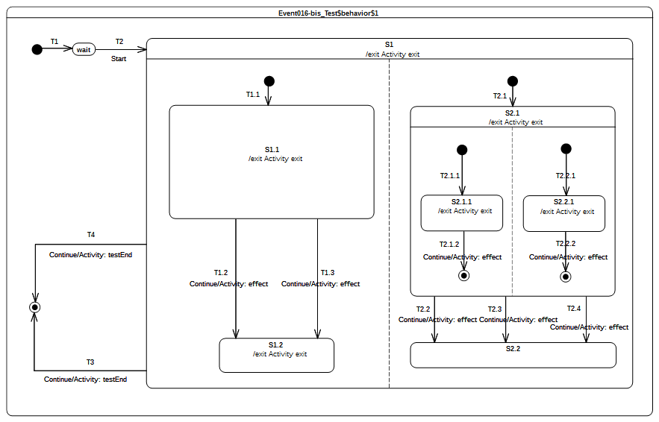Figure 9.34 - Event 016-bis Classifier behavior

Test executions
Received event occurrence(s)

- Start – received when in configuration wait.
- Continue – received when in configuration S1[S1.1, S2.1[S2.1.1, S2.2.1]].
- Continue – received when in configuration S1[S1.1, S2.1].
- Continue – received when in configuration S1[S1.2, S2.2].
Generated trace

- S2.1.1(exit)::T2.1.2(effect)::S2.2.1(exit)::T2.2.2(effect)::S1.1(exit)::T1.2(effect)::S2.1(exit)::T2.2(effect)::S1.2(exit)::S1(exit)
- Notes. The purpose of this test is to combine conflicting transitions and orthogonal regions to assess that joint usage of both parts of the state-machine semantics still conform to what is specified in UML. In this test case the execution goes as follows. The RTC step initiated by the acceptance of the Start event occurrence brought the state-machine to the configuration S1[S1.1, S2.1[S2.1.1, S2.2.1]]]. Completions events generated during this RTC step (respectively for states S1.1, S2.1.1 and S2.2.1) when dispatched do not trigger any transition. The next RTC step that actually leads to transition triggering is the one initiated by the acceptance of the Continue event occurrence. During this step the execution model shows that both T2.1.2 and T2.2.2 are fired using the same event occurrence. This is not sufficient in the context of this step. Indeed T1.2 or T1.3 should also have been fired.
- Remarks. While the trace that is produced is correct, the content of each step is not correct (see RTC step N°7). This error indicates that in its current version the execution model does not fire (using the same event occurrence) transitions located in different regions if these regions are located at different level of nesting. Fire transitions will be those with the highest priority. This limitation will be fixed in further refinement of the execution model. For the moment this test case must be considered as being failed. The first table below detail the execution that is currently realized by the execution model. The second table propose the execution that shall be realized.
RTC steps

Step | Event pool | State machine configuration | Fired transition(s)
1 | [] | [] - Initial RTC step | [T1]
2 | [Start, CE(wait)] | [wait] | []
3 | [Start] | [wait] | [T2(T1.1, T2.1(T2.1.1, T2.2.1))]
4 | [Continue, CE(2.2.1), CE(S2.1.1), CE(S1.1)] | [S1[S1.1, S2.1[S2.1.1, S2.2.1]]] | []
5 | [Continue, CE(2.2.1), CE(S2.1.1)] | [S1[S1.1, S2.1[S2.1.1, S2.2.1]]] | []
6 | [Continue, CE(2.2.1)] | [S1[S1.1, S2.1[S2.1.1, S2.2.1]]] | []
7 | [Continue] | [S1[S1.1, S2.1[S2.1.1, S2.2.1]]] | [T2.1.2, T2.2.2]
8 | [Continue, CE(S2.1)] | [S1[S1.1, S2.1]] | []
9 | [Continue] | [S1[S1.1, S2.1]] | [T1.2, T2.2]
10 | [Continue, CE(S2.2), CE(S1.2)] | [S1[S1.2, S2.2]] | []
11 | [Continue, CE(S2.2)] | [S1[S1.2, S2.2]] | []
12 | [Continue] | [S1[S1.2, S2.2]] | [T3]

Step | Event pool | State machine configuration | Fired transition(s)
1 | [] | [] - Initial RTC step | [T1]
2 | [Start, CE(wait)] | [wait] | []
3 | [Start] | [wait] | [T2(T1.1, T2.1(T2.1.1, T2.2.1))]
4 | [Continue, CE(2.2.1), CE(S2.1.1), CE(S1.1)] | [S1[S1.1, S2.1[S2.1.1, S2.2.1]]] | []
5 | [Continue, CE(2.2.1), CE(S2.1.1)] | [S1[S1.1, S2.1[S2.1.1, S2.2.1]]] | []
6 | [Continue, CE(2.2.1)] | [S1[S1.1, S2.1[S2.1.1, S2.2.1]]] | []
7 | [Continue] | [S1[S1.1, S2.1[S2.1.1, S2.2.1]]] | [T1.2, T2.1.2, T2.2.2]
8 | [Continue, CE(S2.1), CE(S1.2)] | [S1[S1.2, S2.1]] | []
9 | [Continue, CE(S2.1)] | [S1[S1.2, S2.1]] | []
10 | [Continue] | [S1[S1.2, S2.1]] | [T2.2]
11 | [Continue, CE(S2.2)] | [S1[S1.2, S2.2]] | []
12 | [Continue] | [S1[S1.2, S2.2]] | [T3]

Event 018
Event 018 (UML 2.5 section 14.2.3.9.6)
Once a Transition is enabled and is selected to fire, the following steps are carried out in order: 1. Starting with the main source State, the States that contain the main source State are exited according to the rules of State exit (or, composite State exit if the main source State is nested) as described earlier. 2. The series of State exits continues until the first Region that contains, directly or indirectly, both the main source and main target states is reached. The Region that contains both the main source and main target states is called their least common ancestor. At that point, the effect Behavior of the Transition that connects the sub-configuration of source States to the sub-configuration of target States is executed. (A “sub-configuration” here refers to that subset of a full state configuration contained within the least common ancestor Region.) 3. The configuration of States containing the main target State is entered, starting with the outermost State in the least common ancestor Region that contains the main target State. The execution of Behaviors follows the rules of State entry (or composite State entry) described earlier.

Tested state-machine
The state-machine that is executed for that test is presented in Figure 9.35.

Test executions
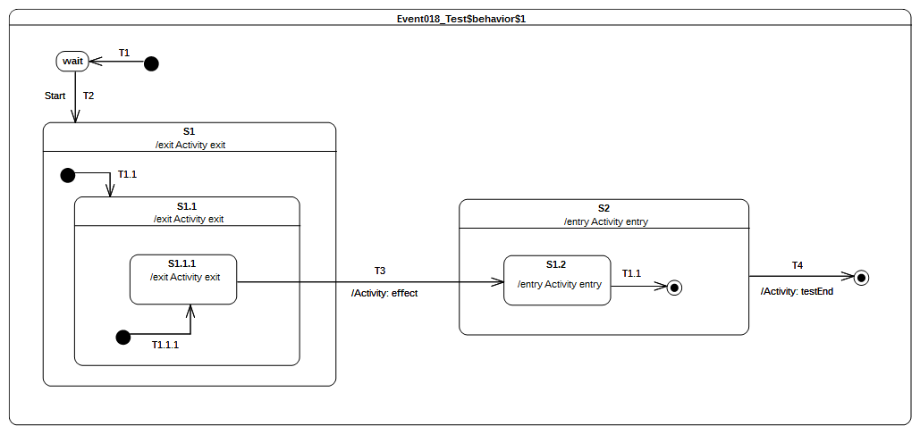Figure 9.35 - Event 018 Classifier behavior
Received event occurrence(s)
- Start – received when in configuration wait.
Generated trace
- S1.1.1(exit)::S1.1(exit)::S1(exit)::T3(effect)::S2(entry)::S1.2(entry)
Note. The interesting point of that test case is to consider the situation in which transition T3 is triggered by the acceptance of the completion event generated for S1.1.1. The configuration of the state-machine is at this time S1[S1.1[S1.1.1]]. When T3 is traversed it provokes the following set of actions:
- S1.1.1, S1.1 and S1 are exited (in this order).
- The effect behavior of the transition is executed.
- S2 and S2.1 are entered (in this order).
RTC steps
Step | Event pool | State machine configuration | Fired transition(s)
1 | [] | [] - Initial RTC step | [T1]
2 | [Start, CE(wait)] | [wait] | []
3 | [Start] | [wait] | [T2(T1.1(T1.1.1))]
4 | [CE(S1.1.1)] | [S1[S1.1[S1.1.1]]] | [T3]
5 | [CE(S1.2)] | [S2[S1.2]] | [T1.1]
6 | [CE(S2)] | [S2] | [T4]

Entering

Overview
Test cases presented in subclause demonstrate the coverage provided by the execution model regarding entry semantics of composite states.

Entering 004
Entering 004 (UML 2.5 section 14.2.3.4.5)
If no initial Pseudostate is defined, there is no single approach defined. One alternative is to treat such a model as ill formed. A second alternative is to treat the composite State as a simple State, terminating the traversal on that State despite its internal parts.

Tested state-machine
The state-machine that is executed for that test is presented in Figure 9.36.
Test executions
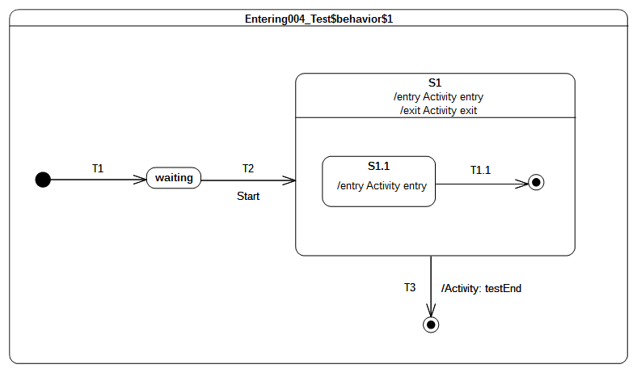Figure 9.36 - Entering 004 Classifier behavior
Received event occurrence(s)
- Start – received when in configuration waiting.
Generated trace
- S1(entry)::S1(exit)
Note. The model here is ill-formed, nevertheless the execution model supports its execution. To do so S1 is treated as being a simple state. Hence when S1 is entered it completes right after the termination of its entry behavior. This completion event is used to trigger the transition T3 which leads to the completion of the state-machine execution.
RTC steps

Step | Event pool | State machine configuration | Fired transition(s)
1 | [] | [] - Initial RTC step | [T1]
2 | [Start, CE(waiting)] | [waiting] | []
3 | [Start] | [waiting] | [T2]
4 | [CE(S1)] | [S1] | [T3]

Entering 005
Entering 005 (UML 2.5 section 14.2.3.4.5)
If the incoming Transition or its continuations terminate on a directly contained substate of the composite State, then that substate becomes active and its entry Behavior is executed after the execution of the entry Behavior of the containing composite State. This rule applies recursively if the Transition terminates on an indirect (deeply nested) substate.

Tested state-machine
The state-machine that is executed for that test is presented in Figure 9.37.

Test executions
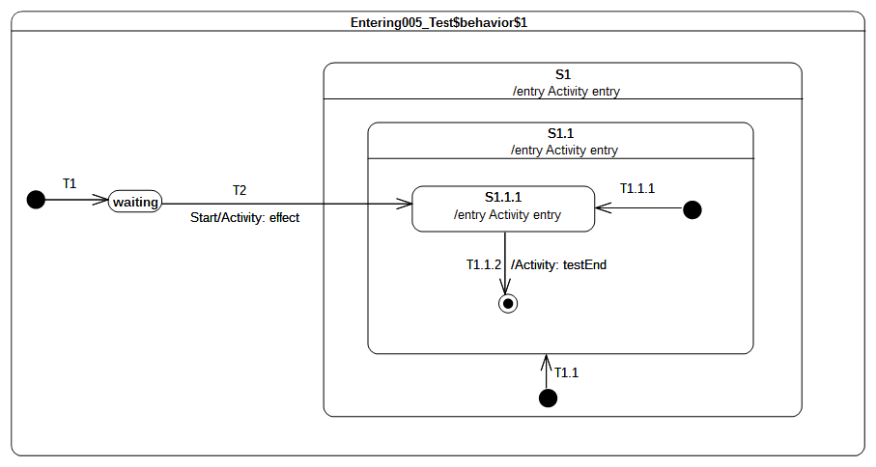Figure 9.37 - Entering 005 Classifier behavior
Received event occurrence(s)
- Start – received when in configuration waiting.
Generated trace
- T2(effect)::S1(entry)::S1.1(entry)::S1.1.1(entry)
Note. This test case illustrates the entry of the deeply nested state S1.1.1. Here when T2 is triggered, its effect behavior is executed and lead to the entrance (in this order) of S1, S1.1, and S1.1.1. S1 and S1.1 are composite state whose unique region is entered explicitly (i.e. if it exists an initial pseudo-state then this latter is not used).
RTC steps
Step | Event pool | State machine configuration | Fired transition(s)
1 | [] | [] - Initial RTC step | [T1]
2 | [Start, CE(waiting)] | [waiting] | []
3 | [Start] | [waiting] | [T2]
4 | [CE(S1.1.1)] | [S1[S1.1[S1.1.1]]] | [T1.1.2]
5 | [CE(S1.1)] | [S1[S1.1]] | []

Entering 009
Entering 009 (UML 2.5 section 14.2.3.4.5)
If a Transition enters a composite State through an entryPoint Pseudostate, then the effect Behavior associated with the outgoing Transition originating from the entry point and penetrating into the State (but after the entry Behavior of the composite State has been executed)

Tested state-machine
The state-machine that is executed for that test is presented in Figure 9.38.

Test executions
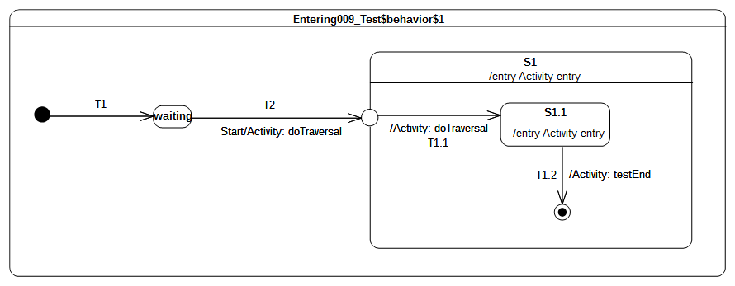Figure 9.38 - Entering 009 Classifier behavior
Received event occurrence(s)
- Start – received when in configuration waiting.
Generated trace
- T2(effect)::S1(entry)::T1.1(effect)::S1.1(entry)
Note. This test case illustrates the entrance of a composite state through an entry point. Here when the entry point is reached it leads to entrance of S1 and so the execution of its entry behavior. S1 one region is entered explicitly by T1.1, this continuation transition is traversed as soon as S1 was entered. It leads to the entrance of S1.1. This latter completes when its entry behavior was executed. The completion event is used to trigger the transition T1.2.
RTC steps
Step | Event pool | State machine configuration | Fired transition(s)
1 | [] | [] - Initial RTC step | [T1]
2 | [Start, CE(waiting)] | [waiting] | []
3 | [Start] | [waiting] | [T2(T1.1)]
4 | [CE(S1.1)] | [S1[S1.1]] | [T1.2]
5 | [CE(S1)] | [S1] | []

Entering 010
Entering 010 (UML 2.5 section 14.2.3.4.5)
If the composite State is also an orthogonal State with multiple Regions, each of its Regions is also entered, either by default or explicitly.

Tested state-machine
The state-machine that is executed for that test is presented in Figure 9.39.

Test executions
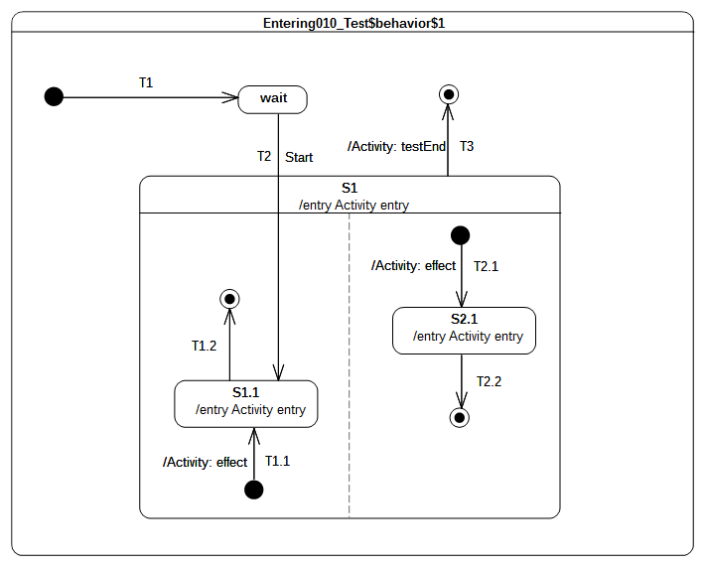Figure 9.39 - Entering 010 Classifier behavior
Received event occurrence(s)
- Start – received when in configuration wait.
Generated trace
- S1(entry)::T2.1(effect)::S2.1(entry)::S1.1(entry)
Note. This test case presents the entry of a composite state with orthogonal regions. Here one region is entered explicitly and the other is entered by default. This entry occurs in the RTC step initiated by the acceptance of the Start event occurrence. First S1 is entered, this leads to the default entry of the right side region. Next the left hand side region is entered explicitly (the initial pseudo state and its continuation transition are not used). Hence the state S1.1 is entered. One can notice that this describes on possible execution. Indeed the concurrency expressed in S1 can lead to obtain other valid execution traces. Nevertheless rules for default and explicit entry of regions remain unchanged.
RTC steps
Step | Event pool | State machine configuration | Fired transition(s)
1 | [] | [] - Initial RTC step | [T1]
2 | [Start, CE(wait)] | [wait] | []
3 | [Start] | [waiting] | [T2(T1.1, T2.1)]
4 | [CE(S1.1), CE(2.1)] | [S1[S1.1, S2.1]] | [T2.2]
5 | [CE(S1.1)] | [S1[S1.1]] | [T1.2]
6 | [CE(S1)] | [S1] | [T3]

Entering 011
Entering 011 (UML 2.5 section 14.2.3.4.5)
If the Transition terminates on the edge of the composite State (i.e., without entering the State), then all the Regions are entered using the default entry rule above.

Tested state-machine
The state-machine that is executed for that test is presented in Figure 9.40.
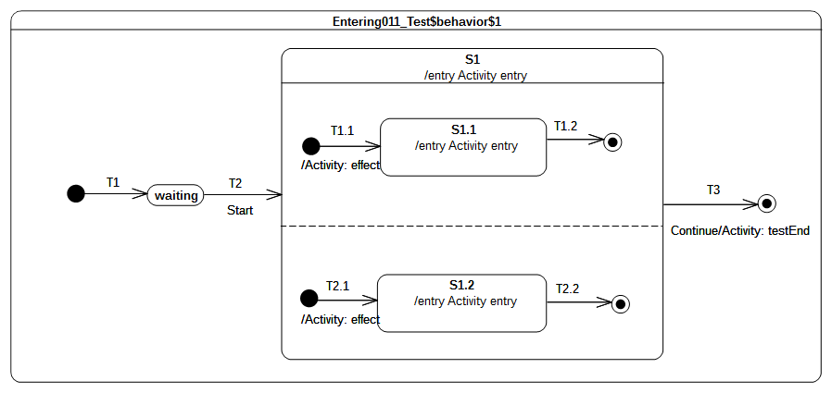Figure 9.40 - Entering 011 Classifier behavior

Test executions
Received event occurrence(s)
- Start – received when in configuration waiting.
Generated trace
- S1(entry)::T2.1(effect)::S1.2(entry)::T1.1(effect)::S1.1(entry)
Note. This test case presents the situation were all regions of a composite state are entered using the default entry rule. The RTC step that was initiated by the acceptance of the Start event occurrence leads to enter S1 which means that when its entry behavior was executed all region are started concurrently. The execution of each region starts using the available initial pseudo-state. S1 completes when both of its region completed. This occurs when completion events generated by S1.1 and S1.2 have been dispatched. S1 completion event is then used to trigger the transition T3.
RTC steps
Step | Event pool | State machine configuration | Fired transition(s)
1 | [] | [] - Initial RTC step | [T1]
2 | [Start, CE(waiting)] | [waiting] | []
3 | [Start] | [waiting] | [T2(T1.1, T2.1)]
4 | [CE(1.2), CE(S1.1)] | [S1[S1.1, S2.1]] | [T1.2]
5 | [CE(1.2)] | [S1[S2.1]] | [T2.2]
6 | [CE(S1)] | [S1] | [T3]

Exiting

Overview
Tests presented in this subclause assesses that semantics associated with state exiting rules conform to what is specified in UML.

Exiting 001
Exiting 001 (UML 2.5 section 14.2.3.4.6)
When exiting a State, regardless of whether it is simple or composite, the final step involved in the exit, after all other Behaviors associated with the exit are completed, is the execution of the exit Behavior of that State.

Tested state-machine
The state-machine that is executed for that test is presented in Figure 9.41.
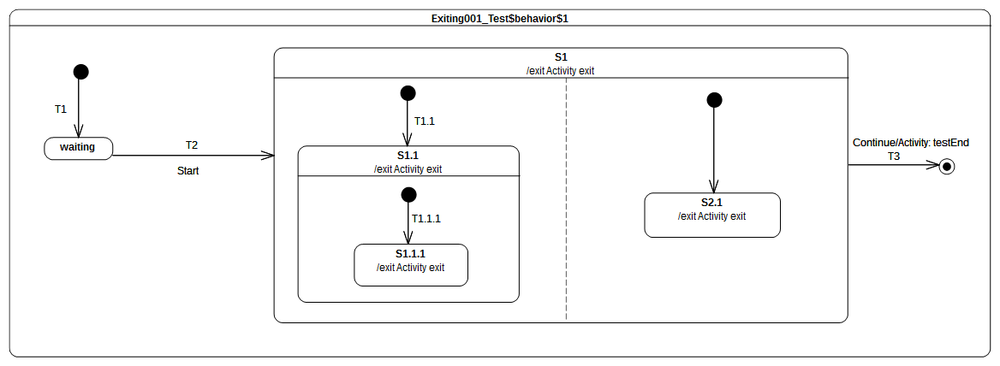Figure 9.41: Exiting 001 Classifier behavior

Test executions
Received event occurrence(s)
- Start – received when in configuration waiting.
- Continue – received when in configuration S1[S1.1[S1.1.1], S2.1].
Generated trace
- S1.1.1(exit)::S1.1(exit)::S2.1(exit)::S1(exit)
- Notes. This test illustrates the exit sequence of a composite state with orthogonal regions. At the point where Continue event occurrence is accepted it triggers transition T3. The first action implied by the traversal of T3 is that S1 needs to be exited. To be exited S1 requires first that all active states in all regions controlled by this state have been exited. The exit sequence starts for each region with the innermost active state. Hence if we consider the left hand side S1.1.1 is exited first and immediately followed by S1.1. Concurrently S2.1 is exited in the right hand side region. The exit sequence is concluded by the execution of the exit behavior of S1. Finally the effect behavior of T3 is executed and the state-machine execution completes.
RTC steps
Step | Event pool | State machine configuration | Fired transition(s)
1 | [] | [] - Initial RTC step | [T1]
2 | [Start, CE(waiting)] | [waiting] | []
3 | [Start] | [waiting] | [T2(T1.1(T1.1.1), T2.1)]
4 | [Continue, CE(S2.1), CE(S1.1.1)] | [S1[S1.1[S1.1.1], S2.1]] | []
5 | [Continue, CE(S2.1)] | [S1[S1.1[S1.1.1], S2.1]] | []
6 | [Continue] | [S1[S1.1[S1.1.1], S2.1]] | [T3]

Exiting 002
Exiting 002 (UML 2.5 section 14.2.3.4.6)
If the State has a doActivity Behavior that is still executing when the State is exited, that Behavior is aborted before the exit Behavior commences execution.

Tested state-machine
The state-machine that is executed for that test is presented in Figure 9.42. The doActivity behavior of S1 has exactly the same behavior that the one presented in Figure 9.1 except that instead of waiting for Continue event occurrence it waits for an AnotherSignal event occurrence.
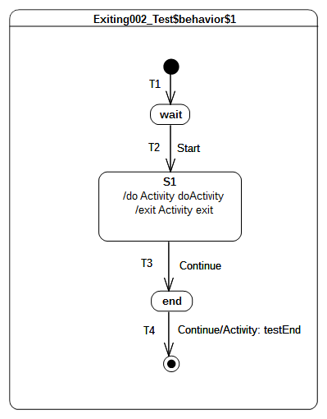Figure 9.42: Exiting 002 Classifier behavior
The exit behavior is specified as shown in Figure 9.43. It contributes to the trace production by adding a the fragment 'S1(exit)' and sends a signal AnotherSignal to the current context object executing this behavior
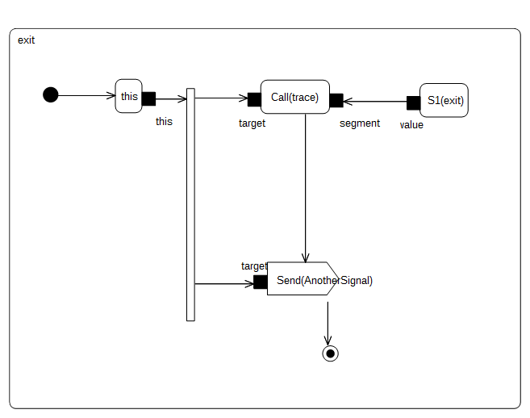Figure 9.43: S1 exit behavior

Test executions
Received event occurrence(s)
- Start – received when in configuration wait.
- Continue – received when in configuration S1.
- AnotherSignal – received when in configuration S1.
- Continue – received when in configuration end.
Generated trace
- S1(doActivityPartI)::S1(exit)
- Note. The purpose of this test is to demonstrate that the doActivity behavior (if it is still running) is aborted before the exit behavior of is actually executed. In this test case the doActivity behavior is started asynchronously after S1 was entered. It is the very last action that takes place during the RTC step initiated by the acceptance of the Start event occurrence.
- When the Continue event occurrence is dispatched the doActivity behavior is still running. Indeed it waits for an AnotherSignal occurrence. However S1 is now forced to be exited using the transition T3 (due to the acceptance of the Continue event occurrence). Hence its doActivity behavior is aborted and its exit behavior is executed. To verify that doActivity was effectively aborted before the execution the exit, the exit behavior of S1 sends an AnotherSignal occurrence to the context object. If the doActivity was not aborted then it would have used this event occurrence to continue its execution and it would have completed the execution trace with the message S1(doActivityPartII).
RTC steps

Step | Event pool | State machine configuration | Fired transition(s)
1 | [] | [] - Initial RTC step | [T1]
2 | [Start, CE(wait)] | [wait] | []
3 | [Start] | [wait] | [T2]
4 | [AnotherSignal, Continue] | [S1] | [T3]
5 | [Continue, AnotherSignal, CE(end)] | [end] | []
6 | [Continue, AnotherSignal] | [end] | []
7 | [Continue] | [end] | [T4]

Exiting 003

Exiting 003 (UML 2.5 section 14.2.3.4.6)
When exiting from a composite State, exit commences with the innermost State in the active state configuration. This means that exit Behaviors are executed in sequence starting with the innermost active State.

Tested state-machine
The state-machine that is executed for that test is presented in Figure 9.44.
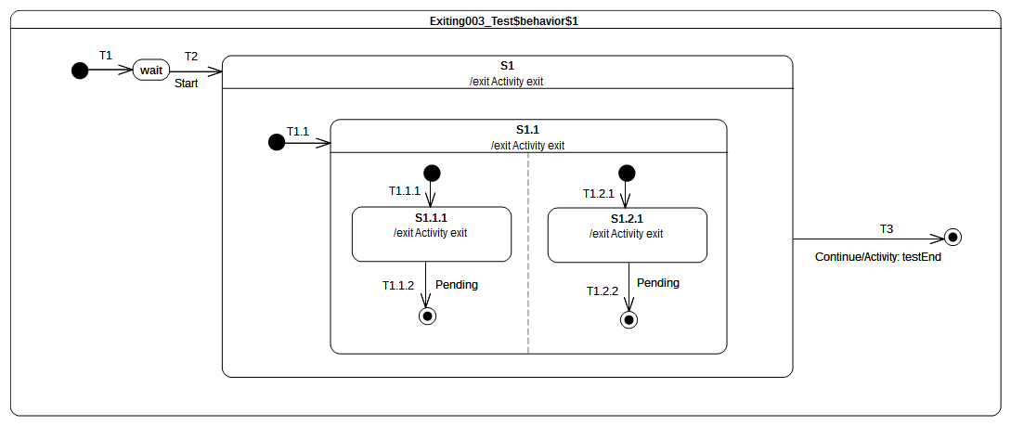Figure 9.44: Exiting 003 Classifier behavior

Test executions
Received event occurrence(s)
- Start – received when in configuration wait.
- Continue – received when in configuration S1[S1.1[S1.1.1, S1.2.1]].
Generated trace
- S1.1.1(exit)::S1.2.1(exit)::S1.1(exit)::S1(exit)
- Notes. The purpose of this test is to demonstrate that when a composite state is exited, the exit behaviors that are executed first are those owned by the innermost active state(s). Here when the Continue event occurrence is accepted the state-machine is in configuration S1[S1.1[S1.1.1, S1.2.1]]. This means that to conforms to UML state-machine semantics our execution model must start the exit sequence of S1 by first exiting S1.1.1 and S1.2.1. Next S1.1 is exited and finally this is S1 turn.
RTC steps
Step | Event pool | State machine configuration | Fired transition(s)
1 | [] | [] - Initial RTC step | [T1]
2 | [Start, CE(wait)] | [wait] | []
3 | [Start] | [wait] | [T2(T1.1(T1.1.1, T1.2.1))]
4 | [Continue, CE(S1.2.1), CE(S1.1.1)] | [S1[S1.1[S1.1.1, S1.2.1]]] | []
5 | [Continue, CE(S1.2.1)] | [S1[S1.1[S1.1.1, S1.2.1]]] | []
6 | [Continue] | [S1[S1.1[S1.1.1, S1.2.1]]] | [T3]

Exiting 004

Exiting 004 (UML 2.5 section 14.2.3.4.6)
If the exit occurs through an exitPoint Pseudostate, then the exit Behavior of the State is executed after the effect Behavior of the Transition terminating on the exit point.
- Tested state-machine
The state-machine that is executed for that test is presented in Figure 9.45.
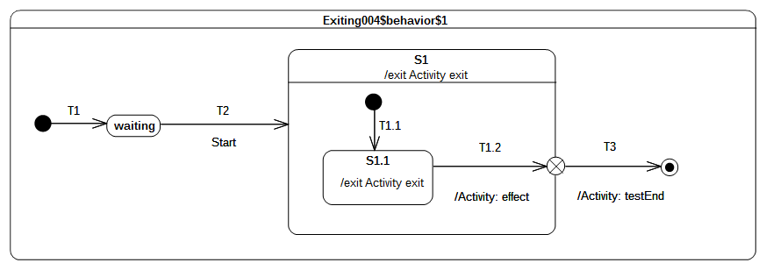Figure 9.45: Exiting 004 Classifier behavior

Test executions
Received event occurrence(s)
- Start – received when in configuration wait.
Generated trace
- S1.1(exit)::T1.2(effect)::S1(exit)
- Notes. The purpose of this state is to validate that when a composite state is left using an exit point then the effect behavior of the transition entering this pseudo-state is executed before the exit behavior of the state. At the point where the state-machine is in configuration S1[S1.1] the completion event generated for S1.1 is dispatched and accepted. This initiates an RTC step during which S1.1 is exited, the effect behavior is of T1.2 is executed, S1 is exited and finally the continuation transition T3 is traversed.
RTC steps
Step | Event pool | State machine configuration | Fired transition(s)
1 | [] | [] - Initial RTC step | [T1]
2 | [Start, CE(waiting)] | [waiting] | []
3 | [Start] | [waiting] | [T2(T1.1)]
4 | [CE(S1.1)] | [S1[S1.1]] | [T1.2(T3)]

Exiting 005

Exiting 005 (UML 2.5 section 14.2.3.4.6)
When exiting from an orthogonal State, each of its Regions is exited. After that, the exit Behavior of the State is executed.
- Tested state-machine
The state-machine that is executed for that test is presented in Figure 9.46.
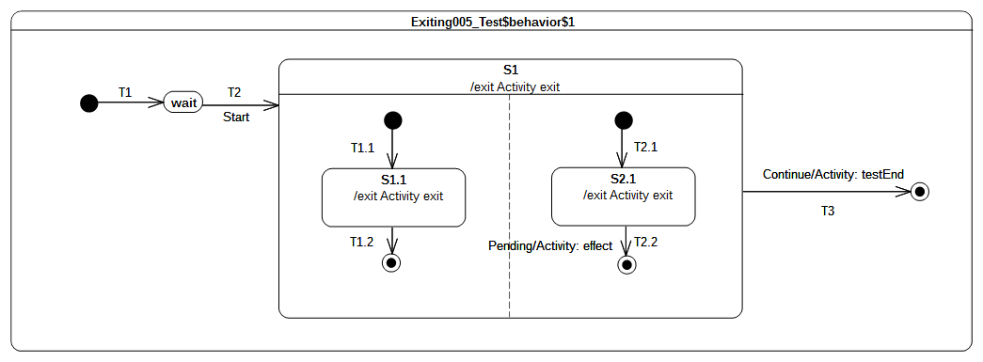Figure 9.46: Exiting 005 Classifier behavior

Test executions
Received event occurrence(s)
- Start – received when in configuration wait.
- Continue – received when in configuration S1[S1.1].
Generated trace
- S1.1(exit)::S2.1(exit)::S1(exit)
- Notes. Here the purpose of the test is to ensure that when exiting S1 which has orthogonal regions, the exit behaviors of S1.1 and S2.1 are executed before the exit behavior of S1. When the Continue event occurrence the state-machine is in the configuration S1[S1.1] (the left hand side region has already completed due to the acceptance of the S1.1 completion event). Hence the transition T3 is triggered and the exit sequence starts by the execution of S2.1 exit behavior followed by the one of S1.
RTC steps
Step | Event pool | State machine configuration | Fired transition(s)
1 | [] | [] - Initial RTC step | [T1]
2 | [Start, CE(waiting)] | [waiting] | []
3 | [Start] | [waiting] | [T2(T1.1, T2.1)]
4 | [Continue, CE(S2.1), CE(S1.1)] | [S1[S1.1, S2.1]] | [T1.2]
5 | [Continue, CE(S2.1)] | [S1[S2.1]] | []
6 | [Continue] | [S1] | [T3]

Exit

Overview
Tests presented in this subclause assesses that semantics associated with exit points conform to what is specified in UML.

Exit 001
Exit 001 (UML 2.5 section 14.2.3.7)
Transitions terminating on an exit point within any Region of the composite State implies exiting of this composite (with execution of its associated exit Behavior)
Tested state-machine
The state-machine that is executed for that test is presented in Figure 9.47.

Test executions
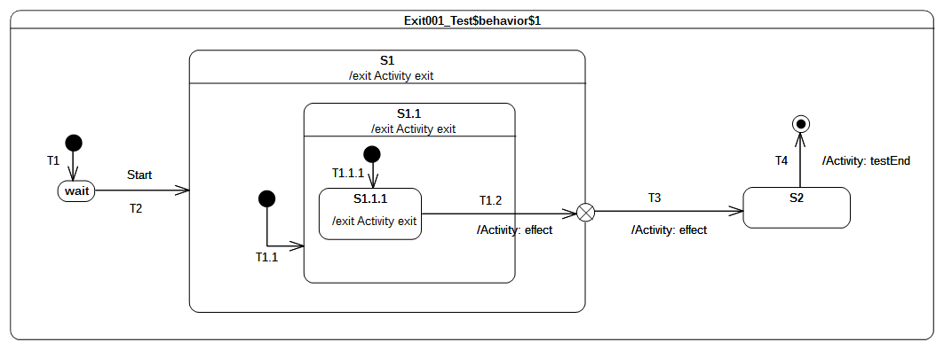Figure 9.47: Exit 001 Classifier behavior
Received event occurrence(s)
- Start – received when in configuration wait.
Generated trace
- S1.1.1(exit)::S1.1(exit)::T1.2(effect)::S1(exit)::T3(effect)
- Note. The purpose of this test case is to demonstrate the support of exit point pseudo to exit a composite state. The completion event generated by S1.1.1 is dispatched and accepted when the state-machine is in configuration S1[S1.1[S1.1.1]]. At this point T1.2 is triggered. When traversed this transition implies first that S1.1.1 is exited as well as S1.1. Next its effect behavior is executed and finally the exit point placed on S1 is reached. The semantics of the exit point requires S1 to be exited and the continuation T3 to be traversed.
RTC Steps
Step | Event pool | State machine configuration | Fired transition(s)
1 | [] | [] - Initial RTC step | [T1]
2 | [Start, CE(wait)] | [wait] | []
3 | [Start] | [wait] | [T2(T1.1(T1.1.1))]
4 | [CE(S1.1.1)] | [S1[S1.1[S1.1.1]]] | [T1.2(T3)]
5 | [CE(S2)] | [S2] | [T4]

Exit 002
Exit 002 (UML 2.5 section 14.2.3.7)
If multiple Transitions from orthogonal Regions within the State terminate on this Pseudostate, then it acts like a join Psuedostate
Tested state-machine
The state-machine that is executed for that test is presented in Figure 9.48.
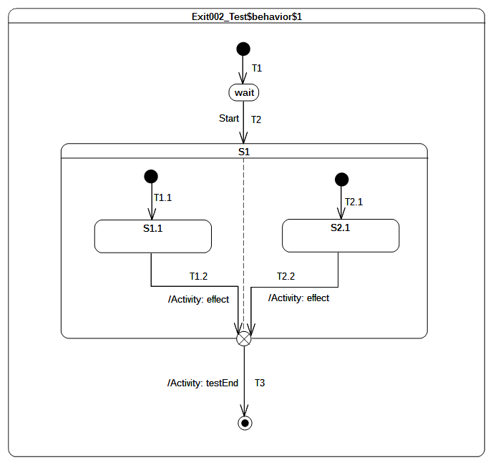Figure 9.48: Exit 002 Classifier behavior

Test executions
Received event occurrence(s)
- Start – received when in configuration wait.
Generated trace
- T1.2(effect)::T2.2(effect)
- Note. The purpose of this test is to demonstrate that if multiple transitions originating from states located in different orthogonal regions terminate on an exit pseudo state then this latter acts (in addition to original semantics) as a join pseudo state.
- When the completion event generated by S1.1 is dispatched and accepted by the state-machine then T1.2 is triggered and traversed. This is the first time that the exit point is reached. It cannot be traversed since its prerequisites are not satisfied (i.e., all of its incoming transition have not already been traversed). The next RTC step is is initiated by the acceptance of the S2.1 completion event. T2.2 is triggered hence the execution reaches the exit point for the second time. This latter is traversed and its continuation transition is traversed. The state-machine execution completes when the final state is reached.
RTC Steps
Step | Event pool | State machine configuration | Fired transition(s)
1 | [] | [] - Initial RTC step | [T1]
2 | [Start, CE(wait)] | [wait] | []
3 | [Start] | [wait] | [T2(T1.1, T2.1)]
4 | [CE(S2.1), CE(S1.1)] | [S1[S1.1, S2.1]] | [T1.2]
5 | [CE(S2.1)] | [S1[S2.1]] | [T2.2(T3)]

Exit 003
Exit 003
UML does not provide any constraint on the number of transitions that can originate from an exit point. Hence it means we can have more than one transition that is ready to be traversed. This situation may lead to a conflict.
Tested state-machine
The state-machine that is executed for that test is presented in Figure 9.49.

Test executions
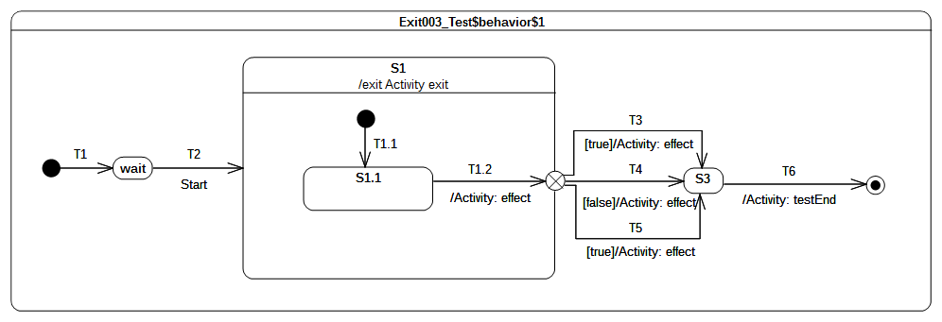Figure 9.49: Exit 003 Classifier behavior
Received event occurrence(s)
- Start – received when in configuration wait.
Generated trace
- T1.2(effect)::S1(exit)::T3(effect)
- Notes. The purpose of this test case is to ensure that in a situation where multiple transitions outgoing an exit point are ready to be traversed only one of them will actually be elected for firing. At some point of the execution (acceptance of S1.1 completion event) the exit point that is placed on S1 is reached. The guard placed on transitions originating from this exit point are evaluated. The set of enabled transitions is now composed of T3 and T5. A semantic strategy is used to determine which transition is going to be traversed. Under the assumption that T3 is elected then it is traversed and S3 is entered. The completion event generated by S3 will be dispatched in the next RTC step and the state-machine will complete its execution.
RTC Steps
Step | Event pool | State machine configuration | Fired transition(s)
1 | [] | [] - Initial RTC step | [T1]
2 | [Start, CE(wait)] | [wait] | []
3 | [Start] | [wait] | [T2(T1.1)]
4 | [CE(S1.1)] | [S1[S1.1]] | [T1.2(T3)]
5 | [CE(S3)] | [S3] | [T6]

Entry

Overview
Tests presented in this subclause assesses that semantics associated with entry points conform to what is specified in UML

Entry 002 - A
Entry 002
If the owning State has an associated entry Behavior, this Behavior is executed before any behavior associated with the outgoing Transition. If multiple Regions are involved, the entry point acts as a fork Pseudostate.

Tested state-machine
The state-machine that is executed for that test is presented in Figure 9.50.
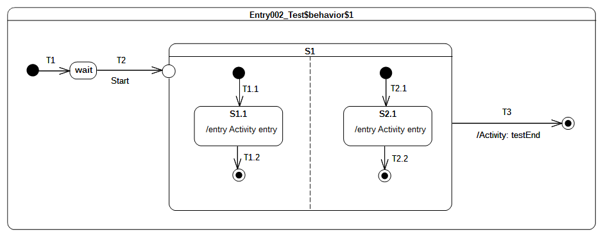Figure 9.50: Entry 002 A Classifier behavior

Test execution
Received event occurrence(s)
- Start – received when in configuration wait.
Generated trace
- S1.1(entry)::S2.1(entry)
- Notes. The fact that the entry behavior of the state owning the entry point is executed before the effect behavior of the transition outgoing the exit point was demonstrated in the test case presented in section 9.3.4.4. The purpose of this test is to demonstrate that if an entry point is placed on a composite state with orthogonal regions then this entry point behaves as a fork. When Start event occurrence is accepted by the state-machine then T2 is triggered. At the end of T2 traversal the entry point is reached which implies the entry of S1. Without any transitions originating from the pseudostate and penetrating into the state then all regions of S1 are entered using the default entry rule (i.e, each region starts is execution using the its initial pseudo state). Hence both continuation transitions T1.1 and T2.1 are traversed therefore states S1.1 and S2.1 execute their entry behaviors. At the end of each entry behavior execution a completion event is generated. This is is the end of the RTC step initiated by Start event occurrence dispatching. The two next RTC steps are related to the dispatching and the acceptance of this completion events. As soon as both regions have completed a completion event is generated for S1. The last RTC step consist in accepting this completion event to trigger T3 and completing the state-machine execution when the final state is reached.
RTC steps
Step | Event pool | State machine configuration | Fired transition(s)
1 | [] | [] - Initial RTC step | [T1]
2 | [Start, CE(wait)] | [wait] | []
3 | [Start] | [wait] | [T2(T1.1, T2.1)]
4 | [CE(S2.1), CE(S1.1)] | [S1[S1.1, S2.1]] | [T1.2]
5 | [CE(S2.1)] | [S1[S2.1]] | [T2.2]
6 | [CE(S1)] | [S1] | [T3]

Entry 002 – B

Tested state-machine
The state-machine that is executed for that test is presented in Figure 9.51.
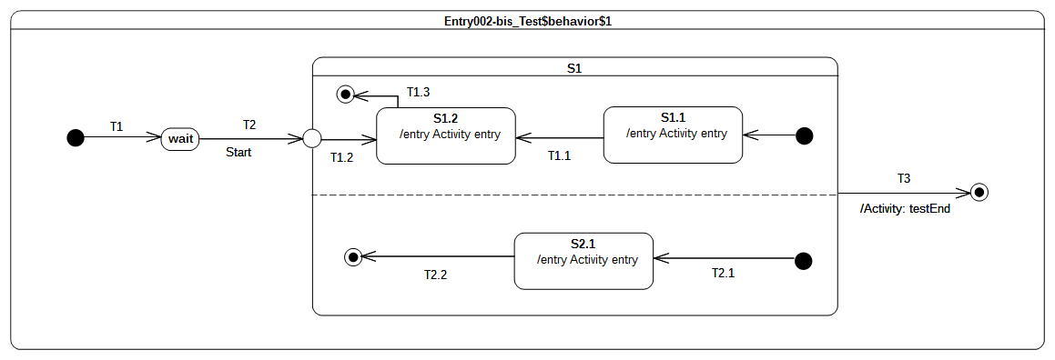Figure 9.51: Entry 002 B Classifier behavior

Test execution
Received event occurrence(s)
- Start – received when in configuration wait.
Generated trace
- S2.1(entry)::S1.2(entry)
- Notes. Test case presented in section 9.3.7.4 demonstrates that when a transition outgoing from entry point and penetrating a composite state is traversed then the region containing the targeted state is entered explicitly (i.e., without using the initial pseudo-state). The purpose of this test is to demonstrate that if orthogonal regions exist in that composite state then these latter are entered using the default approach while the first one (i.e., the one containing the target vertex) is entered explicitly. As we can see on the generated execution trace S1.1(entry) message does not appear which indicates the entrance of the upper region of S1 was realized explicitly. In addition, S2.1(entry) is part of the trace and this indicates the other region of S1 was entered using the default entry approach.
RTC Steps
Step | Event pool | State machine configuration | Fired transition(s)
1 | [] | [] - Initial RTC step | [T1]
2 | [Start, CE(wait)] | [wait] | []
3 | [Start] | [wait] | [T2(T2.1, T1.2)]
4 | [CE(S1.2), CE(S2.1)] | [S1[S1.2, S2.1]] | [T2.2]
5 | [CE(S1.2)] | [S1[S1.2]] | [T1.3]
6 | [CE(S1)] | [S1] | T3

Entry 002 – C
Entry 002
If the owning State has an associated entry Behavior, this Behavior is executed before any behavior associated with the outgoing Transition.

Tested state-machine
The state-machine that is executed for that test is presented in Figure 9.52.
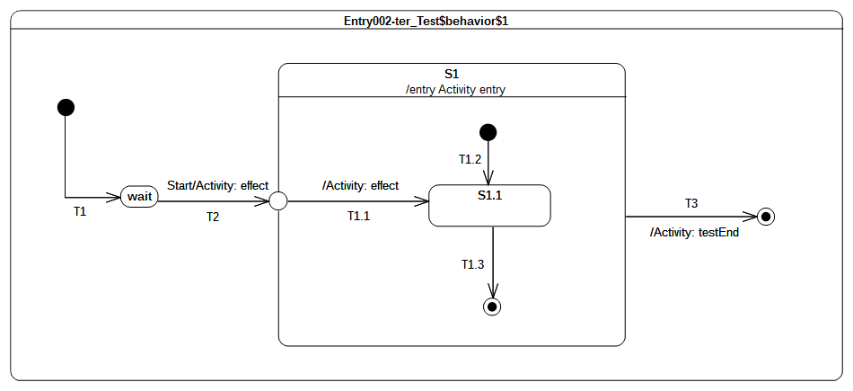Figure 9.52: Entry 002 C Classifier behavior

Test execution
Received event occurrence(s)
- Start – received when in configuration wait.
Generated trace
- T2(effect)::S1(entry)::T1.1(entry)
- Notes. The purpose of this test is to demonstrate that the entry behavior of the state owning the entry point is always executed before the effect behavior(s) of the transition(s) originating from this entry point. When the Start event occurrence is dispatched and accepted by the state-machine T2 is triggered and traversed. It traversal implies the execution of the effect behavior as well as the entrance of the entry point pseudo state. When the entry point is entered S1 is entered and so its entry behavior is executed. As soon as the previous actions have been done the continuation transition T1.1 can be traversed. Hence its effect behavior is executed and S1.1 is entered.
RTC Steps
Step | Event pool | State machine configuration | Fired transition(s)
1 | [] | [] - Initial RTC step | [T1]
2 | [Start, CE(wait)] | [wait] | []
3 | [Start] | [wait] | [T2(T1.1)]
4 | [CE(S1.1)] | [S1[S1.1]] | [T1.3]
5 | [CE(S1)] | [S1] | [T3]

Entry 002 – D

Tested state-machine
The state-machine that is executed for that test is presented in Figure 9.53.

Test execution
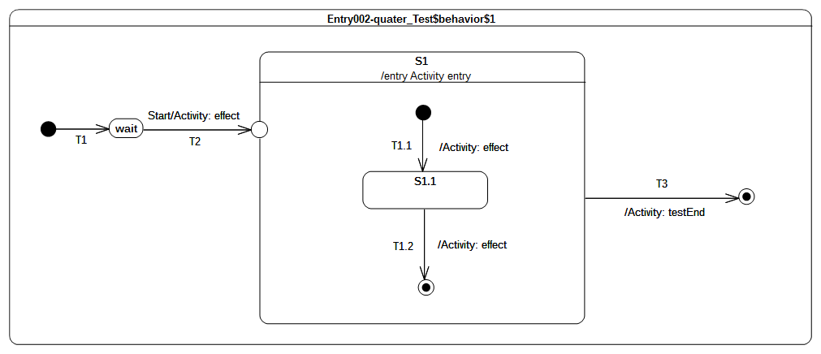Figure 9.53: Entry 002 D Classifier behavior
Received event occurrence(s)
- Start – received when in configuration wait.
Generated trace
- T2(effect)::S1(entry)::T1.1(effect)::T1.2(effect)
- Notes. The purpose of this test is to consolidate what was shown in previous test-cases presented in section 9.3.7. It demonstrates that if the composite has a single region and is entered through an entry with no outgoing transitions then the region is entered using the default entry approach. When the Start event occurrence is dispatched and accepted by the state-machine then T2 is triggered and traversed. Its traversal is materialized in the trace with the message T2(effect). Next S1 is entered and its entry behavior is executed (see message S1(entry) in the trace). Finally we can see the region is entered using the default approach since the execution of T1.1 effect behavior adds in the trace the message T1.1(effect).
RTC Steps

Step | Event pool | State machine configuration | Fired transition(s)
1 | [] | [] - Initial RTC step | [T1]
2 | [Start, CE(wait)] | [wait] | []
3 | [Start] | [wait] | [T2(T1.1)]
4 | [CE(S1.1)] | [S1[S1.1]] | [T1.2]
5 | [CE(S1)] | [S1] | [T3]

Entry 002 – E

Tested state-machine
The state-machine that is executed for that test is presented in Figure 9.54.

Test execution
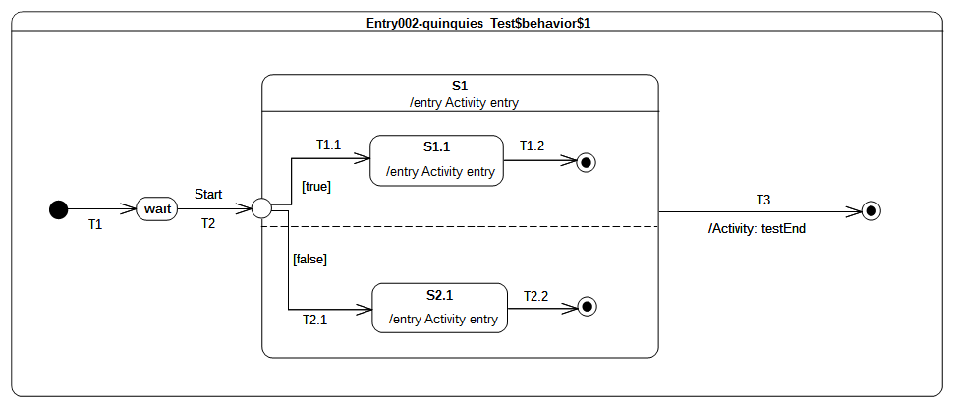Figure 9.54: Entry 002 E Classifier behavior
Received event occurrence(s)
- Start – received when in configuration wait.
Generated trace
- S1(entry)::S1.1(entry)
- Notes. The purpose of this test is to consolidate what was shown in previous test-cases presented in section 9.3.7. It demonstrates impact of guard evaluation for transitions originating from an entry point on regions execution. When the Start event occurrence is dispatched T2 is traversed and the entry point is entered. Hence S1 entry behavior is executed and guards of continuation transition T1.1 and T1.2 are evaluated. Only T1.1 guards evaluates to true. This implies that only the upper region of S1 is entered. The other region is ignored since it could not be entered either using the default or the explicit entry. This ends the RTC step that was initiated by the acceptance of the Start event occurrence. The next RTC step is initiated by the acceptance of the completion event generated by S1.1. This event is used to trigger T1.2 whose traversal leads to the completion of the region and so to the completion of S1. The last RTC step consists in accepting the completion event generated for S1. This latter triggers T3 and enables the state-machine to reach the final state.
RTC Steps
Step | Event pool | State machine configuration | Fired transition(s)
1 | [] | [] - Initial RTC step | [T1]
2 | [Start, CE(wait)] | [wait] | []
3 | [Start] | [wait] | [T2(T1.1)]
4 | [CE(S1.1)] | [S1[S1.1]] | [T1.2]
5 | [CE(S1)] | [S1] | [T3]

Choice

Overview
Tests presented in this subclause assesses that semantics associated with choice pseudo-state conform to what is specified in UML

Choice 001
Choice 001 (UML 2.5 section 14.2.3.7)
The guard Constraints on all outgoing Transitions are evaluated dynamically, when the compound transition traversal reaches this Pseudostate

Tested state-machine
The state-machine that is executed for that test is presented in Figure 9.55.
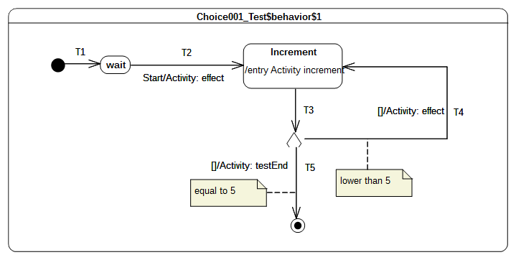Figure 9.55: Choice 001 Classifier behavior

Test execution
Received event occurrence(s)
- Start – received when in configuration wait.
Generated trace
- T4(effect)::T4(effect)::T4(effect)::T4(effect)
- Notes. The purpose of this test is to demonstrate how evaluation of guards of transition originating from a choice pseudo-state has an impact on the execution flow. When the Start event occurrence is dispatched and accepted by the state-machine T2 is triggered. The execution of its associated effect behavior implies the initialization of the value property of the class for which the state-machine plays the role of a classifier behavior. Increment state is entered and its entry behavior makes the value of property value to be incremented. Right after the termination of the entry behavior a completion event is generated for the state Increment. This is the end of the RTC step initiated by the acceptance of the Start event occurrence. The next RTC step is initiated by the acceptance of the completion event generated by the Increment state. This latter triggers T3 which is the incoming transition of the choice pseudo state. When the pseudo-state is reached all guards placed on outgoing transitions are evaluated. Only the guard placed on T4 evaluates to true hence this continuation transition is traversed which leads to re-enter the Increment state. The next for four RTC steps repeat this execution path. The fifth consists in traversing T5 whose guard now evaluates to true. When the final state is reach the state-machine completes its execution.
RTC Steps

Step | Event pool | State machine configuration | Fired transition(s)
1 | [] | [] - Initial RTC step | [T1]
2 | [Start, CE(wait)] | [wait] | []
3 | [Start] | [wait] | [T2]
4 | [CE(Increment)] | [Increment] | [T3(T4)]
5 | [CE(Increment)] | [Increment] | [T3(T4)]
6 | [CE(Increment)] | [Increment] | [T3(T4)]
7 | [CE(Increment)] | [Increment] | [T3(T4)]
8 | [CE(Increment)] | [Increment] | [T3(T5)]

Choice 002
Choice 002 (UML 2.5 section 14.2.3.7)
If more than one guard evaluates to true, one of the corresponding Transitions is selected. The algorithm for making this selection is not defined.

Tested state-machine
The state-machine that is executed for that test is presented in Figure 9.56.

Test execution
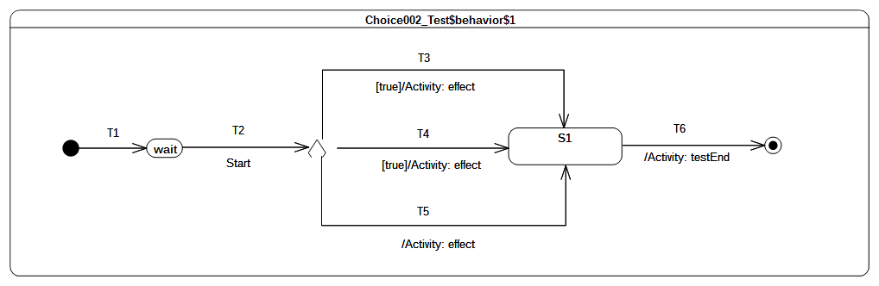Figure 9.56: Choice 002 Classifier behavior
Received event occurrence(s)
- Start – received when in configuration wait.
Generated trace
- T4(effect)
- Notes. The purpose of this test is to demonstrate that if many transitions originating from a choice pseudo state are enabled then at most one of them is elected to be traversed. When the Start event occurrence is dispatched and accepted by the state-machine T2 is triggered. The choice pseudo-state reached using this transition has outgoing transitions. Each guard of each transition is evaluated. The verdict is T3, T4 and T5 (a transition with no guard is considered to have a guard that evaluates to true) are all ready to be traversed. Hence a semantic strategy is used to elect the transition that will be fired. Under the assumption that a first choice strategy is used and the list of enabled transition is organized with the following order [T4, T5, T3] then T4 is elected to be traversed.
RTC Steps

Step | Event pool | State machine configuration | Fired transition(s)
1 | [] | [] - Initial RTC step | [T1]
2 | [Start, CE(wait)] | [wait] | []
3 | [Start] | [wait] | [T2(T4)]
4 | [CE(S1)] | [S1] | [T6]

Choice 003
Choice 003 (UML 2.5 section 14.2.3.7)
If none of the guards evaluates to true, then the model is considered ill formed. To avoid this, it is recommended to define one outgoing Transition with the predefined “else” guard for every choice Pseudostate.

Tested state-machine
The state-machine that is executed for that test is presented in Figure 9.57.

Test execution
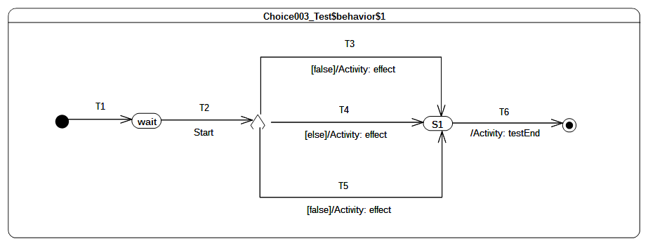Figure 9.57: Choice 003 Classifier behavior
Received event occurrence(s)
- Start – received when in configuration wait.
Generated trace
- T4(effect)
- Notes. The purpose of this test is to demonstrate that if a choice point has an else outgoing transition and all of other outgoing transitions have guards that evaluate to false, then the else transition is chosen and traversed. When the Start event occurrence is dispatched and accepted T2 is triggered and enables the state-machine to reach the choice point. At this point guards of transitions T3 and T5 are evaluated. None of them evaluates to true but it exists an else transition T4. This transition (i.e., T4) is traversed and S1 is entered. The completion event generated by S1 is is used to trigger T6 which leads to the completion of the state-machine execution.
RTC Steps

Step | Event pool | State machine configuration | Fired transition(s)
1 | [] | [] - Initial RTC step | [T1]
2 | [Start, CE(wait)] | [wait] | []
3 | [Start] | [wait] | [T2(T4)]
4 | [CE(S1)] | [S1] | [T6]

Standalone

Overview
This subclause demonstrates that PSSM execution model capture semantics related to standalone state-machines (see mandatory requirements in section 0.3). Standalone state-machines do not play the role of a classifier behavior of a Class.

Standalone 001

Tested state-machine
The state-machine that is executed for that test is presented in Figure 9.58. As a state-machine is a Class then it is legal for this state-machine to inherits from the Target abstract (see section 9.2.1.2.2). Hence the state-machine is the test target and has the possibility to receive any signals that the Target could receive. Note that the state-machine is active but does not have a classifier behavior.

Test execution
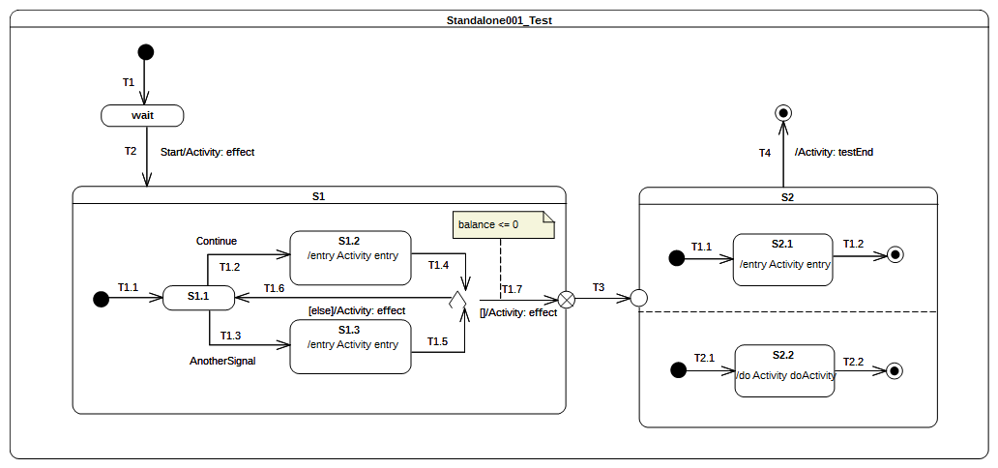Figure 9.58: Standalone 001
Received event occurrence(s)
- Start – received when in configuration wait.
- Continue – received when in configuration S1[S1.1].
- Continue – received when in configuration S1[S1.1].
Generated trace
- T2(effect)::S1.2(entry)::T1.6(effect)::S1.2(entry)::T1.7(effect)::S2.1(entry)::S2.2(doActivity)
- Notes. Start event occurrence is dispatched and accepted while the state-machine is in configuration wait. Hence T2 is triggered (see message T2(effect) in the trace) and S1 is entered using the default entry approach. S1 region starts executing through the initial pseudo state, T1.1 is traversed and S1.1 is entered. The next RTC step is initiated by the acceptance of Continue event occurrence which triggers T1.2 and whose tarversal makes S1.2 to be entered. The execution of S1.2 entry behavior updates a property balance owned by the state-machine. When this behavior has terminated its execution a completion event is generated for S1.2. The completion event is used to trigger T1.4. The state-machine reaches the choice point and evaluates T1.7 guard. The balance (initial value 150) is not lower than or equal to 0 hence the else transition T1.6 is traversed and a completion event is generated upon S1.1 entry. A second Continue event occurrence is dispatched and accepted hence the state-machine returns to S1.2 and a completion event is generated for that state. This time when T1.4 is triggered, the choice point is reached and T1.7 guard is true so it can be traversed. When the exit point is reached S1 is exited. The continuation transition T3 is traversed and S2 is entered through the entry point. Hence both orthogonal regions are entered using the default entry approach. S2.1 generates a completion event when this entry behavior terminated its execution, S2.2 generates a completion event when its doActivity has completed. Completion events generated by these states are used to trigger T1.2 and T2.2. When both completion events have been dispatched and accepted S2 can complete. The completion event will be used to trigger T4 and reach the final state that will complete the state-machine execution.
RTC Steps
Step | Event pool | State machine configuration | Fired transition(s)
1 | [] | [] - Initial RTC step | [T1]
2 | [Start, CE(wait)] | [wait] | []
3 | [Start] | [wait] | [T2(T1.1)]
4 | [Continue, CE(S1.1)] | [S1[S1.1]] | []
5 | [Continue] | [S1[S1.1]] | [T1.2]
6 | [CE(S1.2)] | [S1[S1.2]] | [T1.4(T1.6)]
7 | [Continue, CE(S1.1)] | [S1[S1.1]] | []
8 | [Continue] | [S1[S1.1]] | [T1.2]
9 | [CE(S1.2)] | [S1[S1.2]] | [T1.4(T1.7, T3, T1.1, T2.1))]
10 | [CE(2.1)] | [S2[S2.1, S2.2]] | [T1.2]
11 | [CE(S2.2)] | [S2[S2.2]] | [T2.2]
12 | [CE(S2)] | [S2] | [T4]

Fork

Overview
Test cases presented in this sub-clause assesses that Fork semantics conforms to what is specified in UML.

Fork 001
Fork 001 (UML 2.5 sections14.2.3.4.5 and 14.2.3.2)
If the Transition explicitly enters one or more Regions (in case of a fork), these Regions are entered explicitly and the others by default.
An explicit activation occurs when a Region is entered by a Transition terminating on one of the Region’s contained Vertices. When one Region of an orthogonal State is activated explicitly, this will result in the default activation of all of its orthogonal Regions, unless those Regions are also entered explicitly (multiple orthogonal Regions can be entered explicitly in parallel through Transitions originating from the same fork Pseudostate)

Tested state-machine
The state-machine that is executed for that test is presented in Figure 9.59.

Test execution
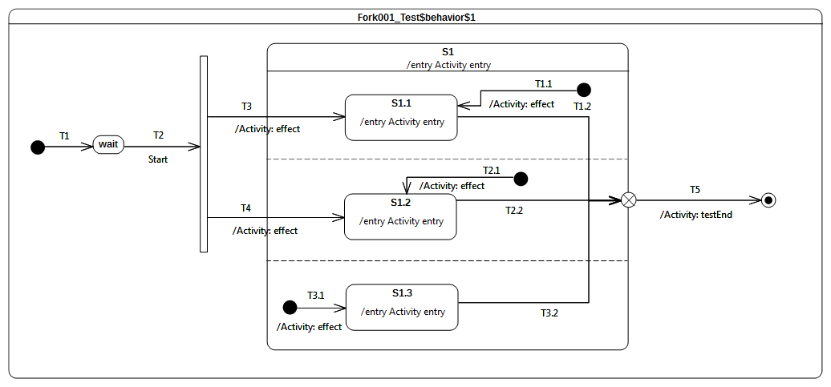Figure 9.59: Fork 001 Classifier behavior
Received event occurrence(s)
- Start – received when in configuration wait.
Generated trace
- T3(effect)::S1(entry)::T3.1(effect)::S1.3(entry)::S1.1(entry)::T4(effect)::S1.2(entry). It is very important to note that the trace generated by the execution is one possible trace among the set of possible traces.
- Notes. The purpose of this test is to demonstrate the support for the Fork pseudo-state semantics as well as the preservation of regions entry rules when this pseudo state is used. When the Start event occurrence is dispatched and accepted by the state-machine it triggers T2. Traversal of this transition brings the state-machine to the Fork pseudo state. Both outgoing transitions of that pseudo state are fired concurrently. However neither S1.1 or S1.2 are entered immediately. Indeed first S1 is entered, its entry behavior is executed and all regions that are not entered explicitly are started concurrently. This implies that the third region (i.e., the one containing S1.3) starts its execution using the initial pseudo state. Hence T3.1 is traversed and S1.3 is entered (a completion event is generated for that state when its entry behavior has finished). Finally both S1.1 and S1.2 are entered. This concludes the RTC step that was initiated by the acceptance of the Start event occurrence. The three completion events generated by S1.3, S1.1 and S2.1 will be used in next RTC steps to trigger T3.2, T1.2 and T2.2.
RTC Steps
Step | Event pool | State machine configuration | Fired transition(s)
1 | [] | [] - Initial RTC step | [T1]
2 | [Start, CE(wait)] | [wait] | []
3 | [Start] | [wait] | [T2(T3.1, T3, T4)]
4 | [CE(S1.2), CE(S1.1), CE(S1.3)] | [S1[S1.1, S1.2, S1.3]] | [T3.2]
5 | [CE(S1.2), CE(S1.1)] | [S1[S1.1, S1.2]] | [T1.2]
6 | [CE(S1.2)] | [S1[S1.2]] | [T2.2(T5)]

Fork 002

Tested state-machine
The state-machine that is executed for that test is presented in Figure 9.60.
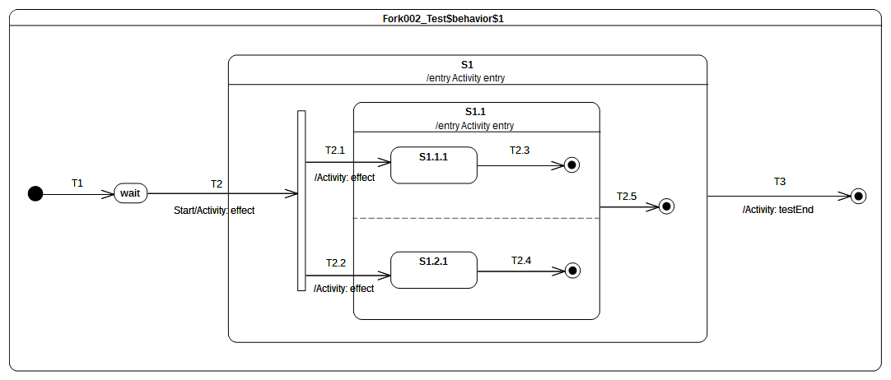Figure 9.60: Fork 002 Classifier behavior

Test execution
Received event occurrence(s)
- Start – received when in configuration wait.
Generated trace
- T2(effect)::S1(entry)::T2.1(effect)::S1.1(entry)::T2.2(effect). It is very important to note that the trace generated by the execution is one possible trace among the set of possible traces.
- Notes. The purpose of this test is to consolidate Fork semantics by evaluating that if used in a nested context the composite state explicit entry rule is preserved. When the Start event occurrence is dispatched and accepted by the state-machine then T2 is triggered and its effect behavior is executed. This brings the state-machine to the Fork pseudo state. As the Fork pseudo-state is located within a composite state that is not already active then this latter is entered first. Hence S1 entry behavior is executed. Next Fork pseudo-state outgoing transitions are traversed. The attempt to enter a state that is not already active leads to the entrance of that state and the execution of its entry behavior. Only at this time explicit entry of both regions of S1.1 can continue.
RTC Steps
Step | Event pool | State machine configuration | Fired transition(s)
1 | [] | [] - Initial RTC step | [T1]
2 | [Start, CE(wait)] | [wait] | []
3 | [Start] | [wait] | [T2(T2.1, T2.2)]
4 | [CE(1.2.1), CE(S1.1.1)] | S1[S1.1[S1.1.1, S1.2.1]] | [T2.3]
5 | [CE(1.2.1)] | S1[S1.1[ S1.2.1]] | [T2.4]
6 | [CE(S1.1)] | [S1[S1.1]] | [T2.5]
7 | [CE(S1)] | [S1] | [T3]

Join

Overview
Test cases presented in this sub-clause assesses that Join semantics conforms to what is specified in UML.

Join 001
Join 001 (UML 2.5 section 14.2.3.7)
All incoming Transitions have to complete before execution can continue through an outgoing Transition.

Tested state-machine
The state-machine that is executed for that test is presented in Figure 9.61.

Test execution
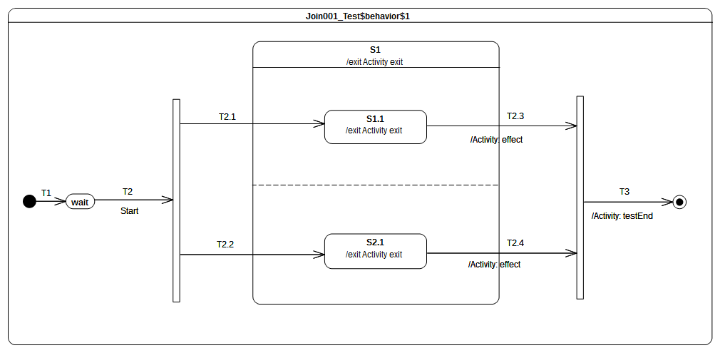Figure 9.61: Join 001 Classifier behavior
Received event occurrence(s)
- Start – received when in configuration wait.
Generated trace
- S1.1(exit)::T2.3(effect)::S2.1(exit)::S1(exit)::T2.4(effect)
- Notes. The purpose of this test is to demonstrate that the Join pseudo state can only be traversed when all incoming transitions have been traversed. Lets consider the situation where the state-machine is currently in configuration S1[S1.1, S2.1]. Two completion events (one for S1.1 and the other one for S2.1) are available at the pool. When the completion event generated by S1.1 is dispatched and accepted it triggers T2.3. Hence S1.1 is exited, the effect behavior of T2.3 is executed nevertheless S1 is not exited and the join pseudo state is not traversed. The next step consists in accepting S2.1 completion event. This means that T2.4 is triggered so S2.1 is exited and T2.4 is executed. In addition S1 is exited and join pseudo state is traversed. The continuation transition T3 is traversed. When the final state is reached the state-machine execution completes.
RTC Steps
Step | Event pool | State machine configuration | Fired transition(s)
1 | [] | [] - Initial RTC step | [T1]
2 | [Start, CE(wait)] | [wait] | []
3 | [Start] | [wait] | [T2(T2.1, T2.2)]
4 | [CE(S2.1), CE(S1.1)] | [S1[S1.1, S2.1]] | [T2.3]
5 | [CE(S2.1)] | [S1[S2.1]] | [T2.4(T3)]

Join 002

Tested state-machine
The state-machine that is executed for that test is presented in Figure 9.62.

Test execution
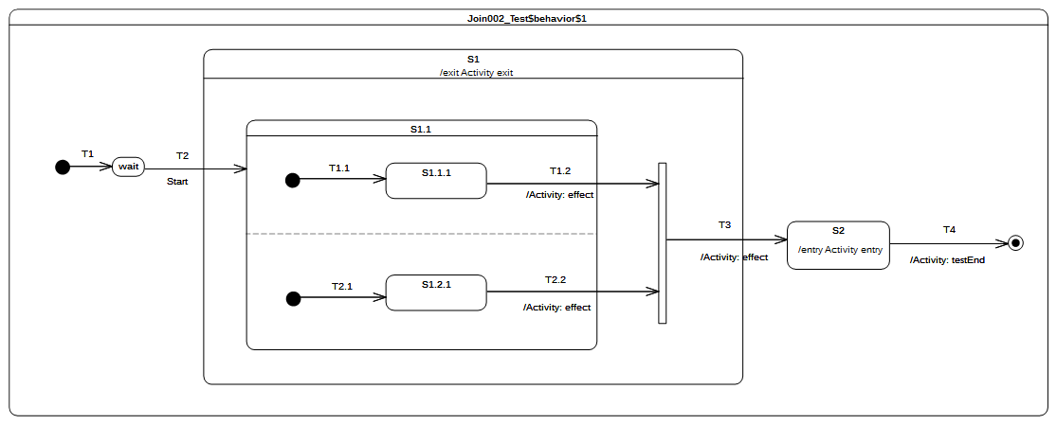Figure 9.62: Join 002 Classifier behavior
Received event occurrence(s)
- Start – received when in configuration wait.
Generated trace
- T2.2(effect)::T1.2(effect)::S1(exit)::T3(effect)::S2(entry)
- Notes. The purpose of this test is to consolidate Join semantics and demonstrate that if used in a nested context the exit rule of a composite state is still preserved. Lets consider the situation where the state-machine is in configuration S1[S1.1[S1.1.1]]. The completion event generated by S1.1.1 is dispatched and accepted. Hence T1.2 is traversed, its effect behavior is executed, S1.1 is exited and the join pseudo state is reached. All incoming transitions have been fired so the join pseudo-state can be traversed. When continuation transition T3 is traversed, S1 is exited, the effect behavior of the transition is executed and finally S2 is entered.
RTC Steps

Step | Event pool | State machine configuration | Fired transition(s)
1 | [] | [] - Initial RTC step | [T1]
2 | [Start, CE(wait)] | [wait] | []
3 | [Start] | [wait] | [T2(T1.1, T2.1)]
4 | [CE(S1.2.1), CE(S1.1.1)] | [S1[S1.1[S1.1.1, S1.2.1]]] | [T1.2]
5 | [CE(S1.2.1)] | [S1[S1.1[S1.2.1]]] | [T2.2(T3)]
6 | [CE(S2)] | [S2] | [T4]

Terminate

Overview
Test cases presented in this sub-clause assesses that Terminate semantics conforms to what is specified in UML.

Terminate 001
Terminate 001 (UML 2.5 section 14.2.3.7)
Entering a terminate Pseudostate implies that the execution of the StateMachine is terminated immediately. The StateMachine does not exit any States nor does it perform any exit Behaviors.

Tested state-machine
The state-machine that is executed for that test is presented in Figure 9.63.
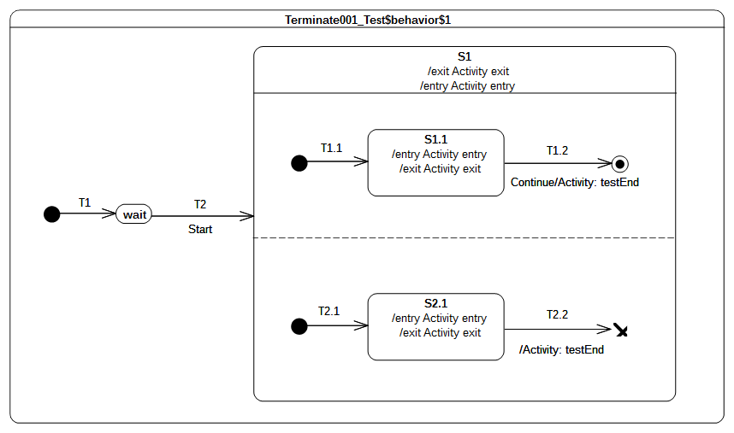Figure 9.63: Terminate 001 Classifier behavior

Test execution
Received event occurrence(s)
- Start – received when in configuration wait.
Generated trace
- S1(entry)::S1.1(entry)::S2.1(entry)::S2.1(exit)
- Notes. The purpose of this test is to demonstrate support for terminate semantics. Lets consider the situation where the state-machine is in configuration S1[S1.1, S2.1]. Two completion events are in the event pool, one of for S2.1 and the other one for S1.1. When S2.1 completion event is accepted it triggers T2.2. The traversal of this transition leads the state-machine to reach the terminate pseudo-state. To be conform to what UML specifies no state must be exited when the terminate pseudo-state is executed and the state-machine must terminate its execution. This behavior can be observed in the generated trace. Indeed neither S1.1 or S1 have executed their exit behaviors after the execution of the terminate pseudo-state.
RTC Steps

Step | Event pool | State machine configuration | Fired transition(s)
1 | [] | [] - Initial RTC step | [T1]
2 | [Start, CE(wait)] | [wait] | []
3 | [Start] | [wait] | [T2(T1.1, T2.1)]
4 | [CE(S2.1), CE(S1.1)] | [S1[S1.1, S2.1]] | []
5 | [CE(2.1)] | [S1[S1.1, S2.1]] | [T2.2]

Terminate 002

Terminate 002 (UML 2.5 section 14.2.3.7)
Any executing doActivity Behaviors are automatically aborted. Entering a terminate Pseudostate is equivalent to invoking a DestroyObjectAction.

Tested state-machine
The state-machine that is executed for that test is presented in Figure 9.64.

Test execution
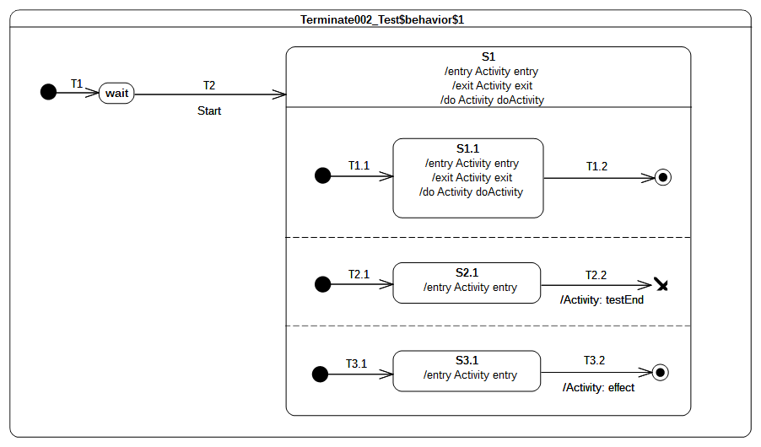Figure 9.64: Terminate 002 Classifier behavior
Received event occurrence(s)
- Start – received when in configuration wait.
Generated trace
- S1(entry)::S1.1(entry)::S2.1(entry)::S3.1(entry)
- Notes. The purpose of this test is to demonstrate that running doActivity behaviors are aborted if a terminate pseudo-state is reached. At the end of the RTC step initiated by the acceptance of the Start event occurrence the state-machine is in configuration S1[S1.1, S2.1, S3.1]. The doActivity behaviors of S1 and S1.1 have been invoked (it does not mean they have already started) and two completion events are available at the pool; one for S2.1 and the other one for S3.1. Under the assumption that the completion event generated by S2.1 is accepted first then T2.2 fires and the state-machine execution is terminated. Hence doActivity behaviors of S1 and S1.1 are aborted and no exit behavior is executed.
- Here it is very important to notice that it also exists alternative valid execution trace. Indeed S3.1 completion might be dispatched and accepted first so before the termination T3.2 would have been traversed and the message T3.2(effect) would have been incorporate to the trace. As another example it also possible to mention the case of the two doActivity behaviors that have been invoked. These behavior may have started their execution and so the messages S1(doActivityPartI) and S1.1(doActivityPartI) would have been incorportated into the trace.
RTC Steps

Step | Event pool | State machine configuration | Fired transition(s)
1 | [] | [] - Initial RTC step | [T1]
2 | [Start, CE(wait)] | [wait] | []
3 | [Start] | [wait] | [T2(T1.1, T2.1, T3.1)]
4 | [CE(S3.1), CE(S2.1), CE(S1.1)] | [S1[S1.1, S2.1, S3.1]] | [T1.2]
5 | [CE(S3.1), CE(S2.1)] | [S1[S2.1, S3.1]] | [T2.2]

Terminate 003

Tested state-machine
The state-machine that is executed for that test is presented in Figure 9.65.
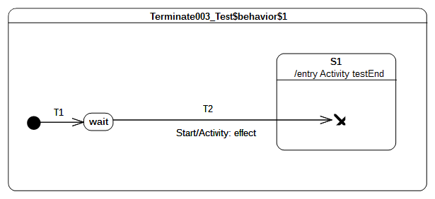Figure 9.65: Terminate 003 Classifier behavior

Test execution
Received event occurrence(s)
- Start – received when in configuration wait.
Generated trace
- T2(effect)
- Notes. The purpose of this test is to ensure that when a terminate pseudo state is used in a nested context the composite state entry rule is preserved. When the Start event occurrence is dispatched and accepted by the state-machine T2 is triggered. Hence wait is exited, the effect behavior of the transition is executed, S1 is entered and finally the terminate pseudo state is reached. The execution of this pseudo-state implies the termination of the state-machine. Note that if the entry behavior of S1 was not executed then the semantic test would not have been notified of the termination of the test target. Hence the test would not have been considered as being passed.
RTC Steps
Step | Event pool | State machine configuration | Fired transition(s)
1 | [] | [] - Initial RTC step | [T1]
2 | [Start, CE(wait)] | [wait] | []
3 | [Start] | [wait] | [T2]

Final

Overview
Test cases presented in this sub-clause assesses that final state semantics conforms to what is specified in UML.

Final 001
Final 001
FinalState is a special kind of State signifying that the enclosing Region has completed. Thus, a Transition to a FinalState represents the completion of the behaviors of the Region containing the FinalState.

Tested state-machine
The state-machine that is executed for that test is presented in Figure 9.66.
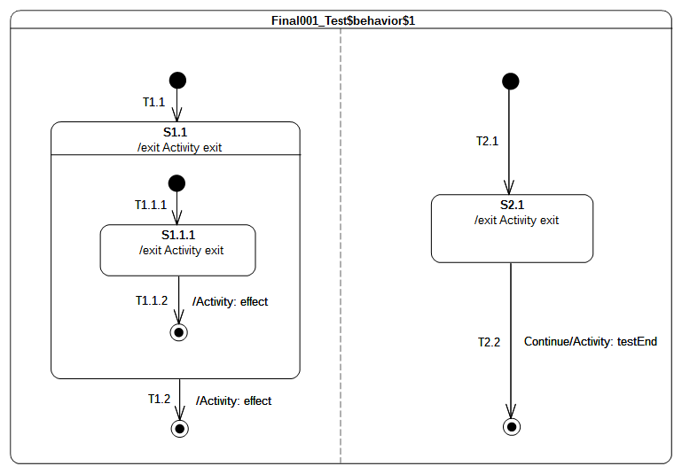Figure 9.66: Final 001 Classifier behavior

Test execution
Received event occurrence(s)
- Start – received when in configuration wait.
- Continue – received when in configuration [S1[S1.1.1], S2.1].
Generated trace
- S1.1.1(exit)::T1.1.2(effect)::S1.1(exit)::T1.2(effect)::S2.1(exit)
- Notes. The purpose of this test is to demonstrate support of Final state usage both at state-machine and composite state level. When the state-machine starts its execution both regions starts their executions concurrently. The initial RTC step ends up with the following configuration: [S1.1[S1.1.1], S2.1]. At this time there are two completion events placed in the pool. The completion events were generated by S2.1 and S1.1.1 when entered. Under the assumption that S2.1 completion event is at the head of the event pool then it is dispatched first. However it does not initiate a RTC step. Indeed S2.1 has no completion transition. The completion event is therefore lost. The next RTC step consists in dispatching and accepting S1.1.1 completion event. It triggers traversal of T1.1.2 and leads the state-machine to reach the final state located in S1.1 region. This region completes and a completion event is generated for S1.1. This completion event is dispatched and accepted in the next RTC step. It triggers T1.2 when the final state is reached, the left hand side region of the state-machine completes. When the Continue event occurrence is dispatched and accepted T2.2 is triggered. The state-machine execution completes when the target final state is reached.
RTC Steps

Step | Event pool | State machine configuration | Fired transition(s)
1 | [] | [] - Initial RTC step | [T1]
2 | [Start, CE(wait)] | [wait] | []
3 | [Start] | [wait] | [T1.1(T1.1.1), T2.1]
4 | [Continue, CE(S2.1), CE(S1.1.1)] | [S1.1[S1.1.1], S2.1] | [T1.1.2]
5 | [Continue, CE(S1.1), CE(S2.1)] | [S1.1, S2.1] | []
6 | [Continue, CE(S1.1)] | [S1.1, S2.1] | [T1.2]
7 | [Continue] | [S2.1] | [T2.2]

Deferred

Overview
Test cases presented in this sub-clause assesses that deferred event semantics conform to what is specified in UML.

Deferred 001
Deferred 001 (UML 2.5 section 14.2.3.4.4)
A State may specify a set of Event types that may be deferred in that State. This means that Event occurrences of those types will not be dispatched as long as that State remains active. Instead, these Event occurrences remain in the event pool until a state configuration is reached where these Event types are no longer deferred.

Tested state-machine
The state-machine that is executed for that test is presented in Figure 9.67.
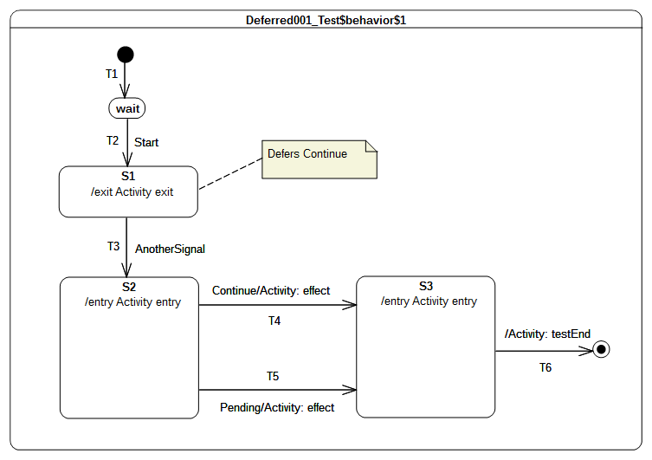Figure 9.67: Deferred 001 Classifier behavior

Test execution
Received event occurrence(s)
- Start – received when in configuration wait.
- Continue – received when in configuration S1.
- AnotherSignal – received when in configuration S1.
- Pending – received when in configuration S2.
Generated trace
- S1(exit)::S2(entry)::T4(effect)::S3(entry)
- Notes. The purpose of this test is to demonstrate support for deferred event in the context of simple states. Lets consider the situation where the state-machine is in configuration S1. S1 has no completion transition hence its completion event is lost while trying to be dispatched. Continue event occurrence is dispatched and can be accepted since it is indicated as being deferred in configuration S1. The acceptance of the event occurrence does not change the state-machine configuration. The next RTC step consists in dispatching and accepting AnotherSignal. This implies triggering of T3. S1 is exited hence the Continue event occurrence is no longer deferred and S2 is entered. At this point three event occurrences are available at the pool. The one at the head of the pool is the completion event for S2, the second one is the Continue event occurrence and the last one is the Pending event occurrence. The dispatching of the completion event does not trigger a new RTC step. Indeed S2 has no completion transition. The next event (i.e., the one which was originally deferred) to be dispatched matches the trigger declared in T4. Hence T4 is traversed, its effect behavior is executed and S3 is entered. As the completion event generated by S3 has the priority over the Pending event occurrence it is dispatched first. S3 completion transition is traversed and the state-machine execution completes when the final state is reached. Note that in this execution the Pending event occurrence is never dispatched. However If the Continue event occurrence was actually not deferred a different execution path would have been observed. Indeed T5 would have been traversed instead of T4.
RTC Steps
Step | Event pool | State machine configuration | Fired transition(s)
1 | [] | [] - Initial RTC step | [T1]
2 | [Start, CE(wait)] | [wait] | []
3 | [Start] | [wait] | [T2]
4 | [AnotherSignal, Continue, CE(S1)] | [S1] | []
5 | [AnotherSignal, Continue] | [S1] | []
6 | [AnotherSignal] | [S1] | [T3]
7 | [Pending, Continue] | [S2] | [T4]
8 | [Pending, CE(S3)] | [S3] | [T6]

Deferred 002
Deferred 002 (UML 2.5 section 14.2.3.4.4)
If a deferred Event type is used explicitly in a Trigger of a Transition whose source is the deferring State (i.e., a kind of override option).

Tested state-machine
The state-machine that is executed for that test is presented in Figure 9.68.
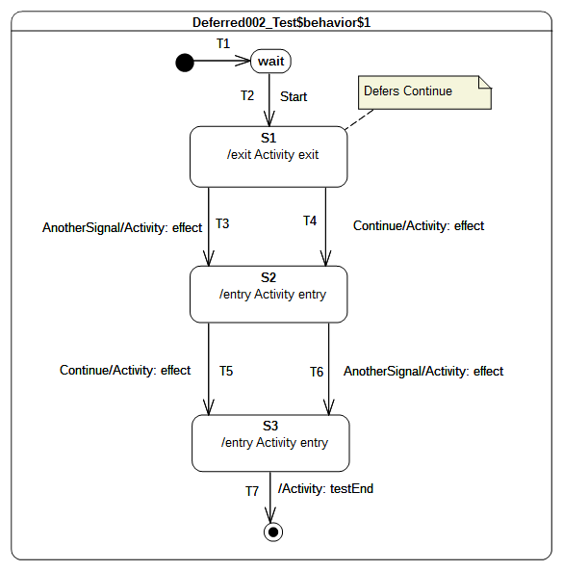Figure 9.68: Deferred 002 Classifier behavior

Test execution
Received event occurrence(s)
- Start – received when in configuration wait.
- Continue – received when in configuration S1.
- AnotherSignal – received when in configuration S1.
- Continue – received when in configuration S2.
Generated trace
- S1(exit)::T4(effect)::S2(entry)::T6(effect)::S3(entry)
- Notes. The purpose of this test is to demonstrate that in a specific situation an event that is declared as being deferred is finally not deferred. Lets consider the situation where the state-machine is in configuration S1 and the completion event of S1 was dispatched but did not trigger any RTC step. The event pool contain at this time two event occurrences. The first one is a Continue event occurrence while the second one is an AnotherSignal event occurrence. When the Continue event occurrence is accepted it is not deferred. Indeed a transition originating from the deferring state has a trigger which uses explicitly the Continue event type. This overrides the deferring constraint and the transition T4 is triggered. Hence S1 is left, the effect behavior of the transition is executed and S2 is entered. The completion event generated by this S2 will not trigger an RTC step since this state has no completion transition. The next RTC step consists in dispatching and accepting the AnotherSignal event occurrence. This implies that T6 is triggered, so S2 is exited, the effect behavior is executed and S3 is entered. The completion event of S3 is used to initiate the next RTC step which leads the state-machine to reach the final state and to complete its execution.
RTC Steps
Step | Event pool | State machine configuration | Fired transition(s)
1 | [] | [] - Initial RTC step | [T1]
2 | [Start, CE(wait)] | [wait] | []
3 | [Start] | [wait] | [T2]
4 | [AnotherSignal, Continue, CE(S1)] | [S1] | []
5 | [AnotherSignal, Continue] | [S1] | [T4]
6 | [Continue, AnotherSignal, CE(S2)] | [S2] | []
7 | [Continue, AnotherSignal] | [S2] | [T6]
8 | [Continue, CE(S3)] | [S3] | [T7]

Deferred 003
Deferred 003 (UML 2.5 section 14.2.3.4.4)
An Event may be deferred by a composite State or submachine States, in which case it remains deferred as long as the composite State remains in the active configuration.

Tested state-machine
The state-machine that is executed for that test is presented in Figure 9.69.

Test execution
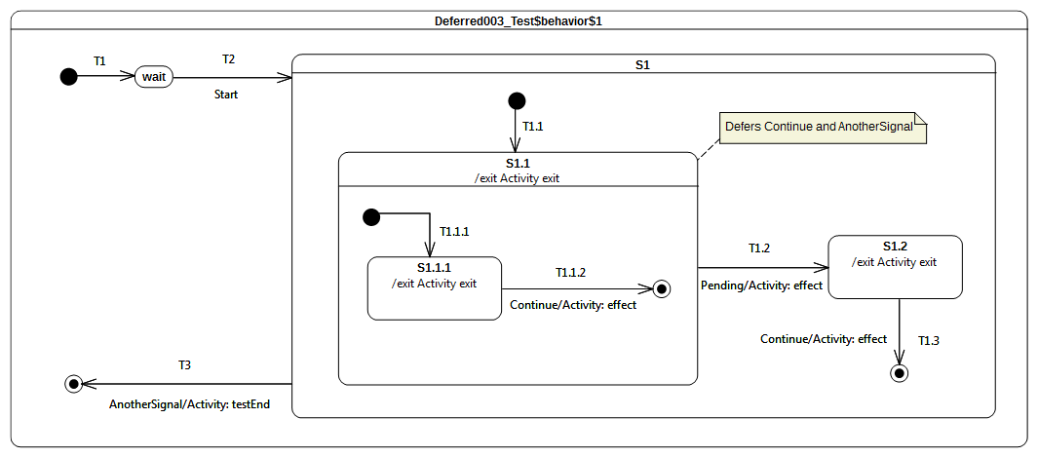Figure 9.69: Deferred 003 Classifier behavior
Received event occurrence(s)
- Start – received when in configuration wait.
- Continue – received when in configuration S1[S1.1[S1.1.1]].
- Continue – received when in configuration S1[S1.1].
- AnotherSignal – received when in configuration S1[S1.1].
- Pending – received when in configuration S1[S1.1].
Generated trace
- S1.1.1(exit)::T1.1.2(effect)::S1.1(exit)::T1.2(effect)::S1.2(exit)::T1.3(effect)
- Notes. The purpose of this test is to demonstrate the support for deferred event semantics when the deferred event type is declared by a composite state. Lets consider the situation where the state-machine is in the configuration S1[S1.1[S1.1.1]]. There are at this time two events occurrence ready to be dispatched: the first one is a completion event for a S1.1.1 and the second one is a Continue event occurrence. The completion event is lost since S1.1.1 has no completion transition. Continue event occurrence is dispatched and accepted. Indeed T1.1.2 is ready to be traversed using this event occurrence. This transition has priority over the deferring constraint added by S1.1 since it is located at a more nested level in the hierarchy. Hence T1.1.2 is triggered and S1.1.1 leaves the state-machine configuration and S1.1 region completes. The completion event generated by S1.1 cannot be used to trigger any transition therefore it is lost. The next RTC step consists in dispatching a new Continue event occurrence. This event occurrence is accepted and deferred due to the constraint required by S1.1. The next event occurrence to be dispatched and accepted is of type AnotherSignal. S1.1 also defers this type of event occurrences. Since the state-machine configuration did not change the event occurrence is deferred. To summarize at this point of the execution two events occurrences are deferred: one Continue event occurrence and one AnotherSignal event occurrence. The next RTC step is initiated by the acceptance of the Pending event occurrence. As T1.2 can be triggered using this event occurrence S1.1 is exited (the deferred events are released), the effect behavior of the transition is executed and S1.2 is entered. S1.2 completion event does not trigger a RTC step since it has no completion transitions. The continue event occurrence that was originally deferred is used to trigger T1.3 which leads S1 region to be completed. S1 completion event is lost. The final RTC step is initiated by the dispatching of AnotherSignal event occurrence. It triggers T3; the traversal of this transition enables the state-machine to reach the final state and so to complete its execution.
RTC Steps
Step | Event pool | State machine configuration | Fired transition(s)
1 | [] | [] - Initial RTC step | [T1]
2 | [Start, CE(wait)] | [wait] | []
3 | [Start] | [wait] | [T2(T1.1, T1.1.1)]
4 | [Continue, CE(S1.1.1)] | [S1[S1.1[S1.1.1]]] | []
5 | [Continue] | [S1[S1.1]] | [T1.1.2]
6 | [Pending, AnotherSignal, Continue, CE(S1.1)] | [S1[S1.1]] | []
7 | [Pending, AnotherSignal, Continue] | [S1[S1.1]] | []
8 | [Pending, AnotherSignal] | [S1[S1.1]] | []
9 | [Pending] | [S1[S1.1]] | [T1.2]
10 | [AnotherSignal, Continue, CE(S1.2)] | [S1.2] | []
11 | [AnotherSignal, Continue] | [S1.2] | [T1.3]
12 | [AnotherSignal, CE(S1)] | [S1] | []
13 | [AnotherSignal] | [S1] | [T3]

Deferred 004 – A

Tested state-machine
The state-machine that is executed for that test is presented in Figure 9.70.
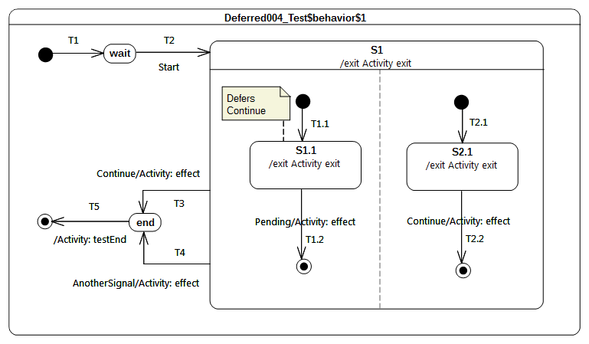Figure 9.70: Deferred 004 A Classifier behavior

Test execution
Received event occurrence(s)
- Start – received when in configuration wait.
- Continue – received when in configuration S1[S1.1, S2.1].
- Pending – received when in configuration S1[S1.1, 2.1].
- AnotherSignal – received when in configuration S1.
Generated trace
- S1.1(exit)::T1.2(effect)::S2.1(exit)::T2.2(effect)::S1(exit)::T4(effect)
- Notes. The purpose of this test is to assess deferred events semantics when used in the context of orthogonal regions. Lets consider the situation where the state-machine is in configuration S1[S1.1, S2.1]. After dispatching of completion events for S1.1 and S2.1 it remains one event occurrence in the pool that is ready to be dispatched: a Continue event occurrence. When the Continue event occurrence is dispatched and accepted by the state-machine it is deferred by S1.1. The current state-machine configuration remains S1[S1.1, S2.1]. The next RTC step is initiated by the acceptance of the Pending event occurrence. This latter starts by triggering T1.2. As S1.1 leaves the state-machine configuration the Continue event occurrence is now available at the pool. The left hand region completes. T2.2 is triggered by the RTC step initiated by the dispatching of the Continue event occurrence. This leads S1 to generate a completion event. The completion event is lost since S1 has no completion transition. S1 is exited when AnotherSignal event is dispatched.
- Remarks. UML specifies in section 14.2.3.4.4 that “if a deferred Event type is used explicitly in a Trigger of a Transition whose source is the deferring State (i.e., a kind of override option).”. In the situation presented in the test case S1.1 has no outgoing transition with a trigger using the Continue event type. Hence the S1.1 deferring constraint is not overridden. Nevertheless it also reasonable to think that the outgoing transition of S2.1 (i.e., T2.2) should have overridden S1.1 constraint. Hence in an alternative execution S2.1 is exited first and T2.2 is traversed. The generated execution trace would have been: S2.1(exit)::T2.2(effect)::S1.1(exit)::T1.2(effect)::S1(exit)::T4(effect). This part of the state-machine semantics is still under discussion.
RTC Steps
Step | Event pool | State machine configuration | Fired transition(s)
1 | [] | [] - Initial RTC step | [T1]
2 | [Start, CE(wait)] | [wait] | []
3 | [Start] | [wait] | [T2(T1.1, T2.1)]
4 | [Pending, Continue, CE(S2.1), CE(S1.1)] | [S1[S1.1, S2.1]] | []
5 | [Pending, Continue, CE(S2.1)] | [S1[S1.1, S2.1]] | []
6 | [Pending, Continue] | [S1[S1.1, S2.1]] | []
7 | [Pending] | [S1[S1.1, S2.1]] | [T1.2]
8 | [Continue] | [S1[S2.1]] | [T2.2]
9 | [AnotherSignal, CE(S1)] | [S1] | []
10 | [AnotherSignal] | [S1] | [T4]
11 | [CE(end)] | [end] | [T5]

Deferred 004 – B

Tested state-machine
The state-machine that is executed for that test is presented in Figure 9.71.
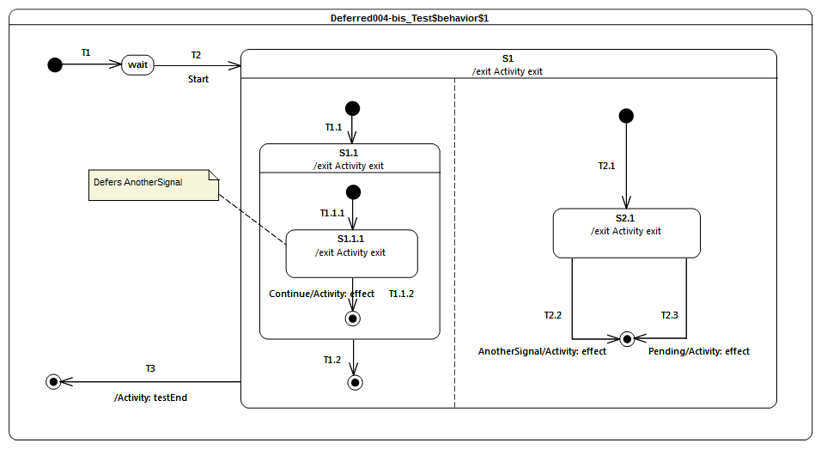Figure 9.71: Deferred 004 B Classifier behavior

Test execution
Received event occurrence(s)
- Start – received when in configuration wait.
- AnotherSignal – received when in configuration S1[S1.1[S1.1.1], S2.1].
- Continue – received when in configuration S1[S1.1[S1.1.1], S2.1].
- Pending – received when in configuration S1.
Generated trace
- S1.1.1(exit)::T1.1.2(effect)::S1.1(exit)::S2.1(exit)::T2.2(effect)::S1(exit)
- Notes. The purpose of this test is is to assess deferred events semantics when used in the context of orthogonal regions. Lets consider the situation where the state-machine is in configuration S1[S1.1[S1.1.1], S2.1]. After dispatching of completion events for S1.1.1 and S2.1 it remains two events occurrence in the pool: an AnotherSignal event occurrence and a Continue event occurrence. When accepted the AnotherSignal event occurrence is deferred by S1.1.1. The next RTC step is initiated by the acceptance of the Continue event occurrence. T1.1.2 is triggered, this implies that S1.1.1 leaves the state-machine configuration and so the event occurrence that was previously deferred become available. The unique region of S1.1 completes and so a completion event is generated for S1.1. In the next RTC step this completion event is dispatched and accepted. This implies that T1.2 is triggered which leads to the completion of the left region of S1. At this time one event occurrence (i.e., AnotherSignal) remains in the pool. When dispatched it triggers T2.2 which exits S2.1 and reaches final state that leads to the completion of S1 region.
- Remarks. Here again the semantics can be different regarding the interpretation of the overriding transition rule. Indeed If we consider that when AnotherSignal event occurrence is dispatched then the event is not deferred because T2.2 in the right region can fire then the execution trace is different.
RTC Steps
Step | Event pool | State machine configuration | Fired transition(s)
1 | [] | [] - Initial RTC step | [T1]
2 | [Start, CE(wait)] | [wait] | []
3 | [Start] | [wait] | [T2(T1.1(T1.1.1), T2.1)]
4 | [Continue, AnotherSignal, CE(S1.1.1)] | [S1[S1.1[S1.1.1], S2.1]] | []
5 | [Continue, AnotherSignal] | [S1[S1.1[S1.1.1], S2.1]] | []
6 | [Continue] | [S1[S1.1[S1.1.1], S2.1]] | [T1.1.2]
7 | [AnotherSignal, CE(S1.1)] | [S1[S1.1, S2.1]] | [T1.2]
8 | [AnotherSignal] | [S1[2.1]] | [T2.2]
9 | [Pending, CE(S1)] | [S1] | [T3]

Other Tests

Overview
This subclause reuse examples provided by the UML specification. It assesses that the intended execution semantics of each example is captured through the PSSM execution model.

Transition Execution Algorithm Test

Tested state-machine
The state-machine that is executed for that test is presented in Figure 9.72. The test case is proposed by the UML specification in Figure 14.2.
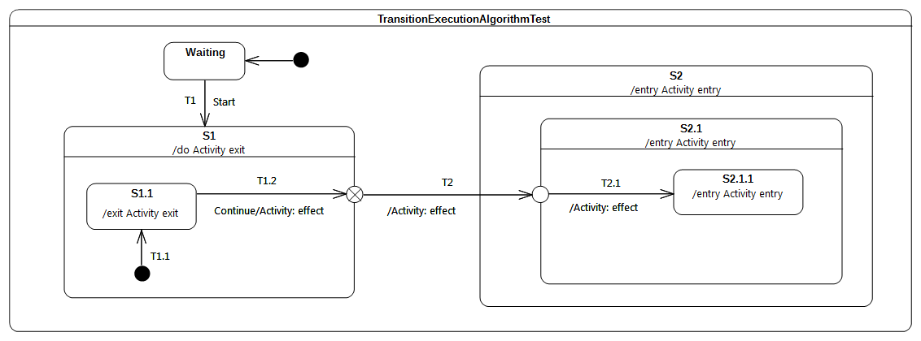“Figure 9.72: TransitionExecutionAlgorithmTest Classifier behavior

Test execution
Received event occurrence(s)
- Start – received when in configuration wait.
- Continue – received when in configuration S1[S1.1].
Generated trace
- S1.1(exit)::T1.2(effect)::S1(exit)::T2(effect)::S2(entry)::S2.1(entry)::T2.1(effect)
- Notes. Lets consider the situation with the state-machine is in configuration S1[S1.1]. There are two events available at the pool: the first one is the completion event for S1.1 and the second one is a Continue event occurrence. The completion event gets dispatched first. It does not initiate an RTC step since S1.1 has no completion transition and is therefore lost. When the completion event occurrence is dispatched it triggers T1.2. S1.1 is exited, T1.2 effect behavior is executed and the exit point placed on the edge of S1 is reached. This exit point implies exiting of S1 and the traversal of the continuation transition T2. This leads the state-machine to reach the entry point placed on the edge of S2.1. At this point S2 is entered first and the continuation transition T2.1 is traversed. This implies that at the end of the RTC step S2.1.1 is entered and its entry behavior is executed.
RTC Steps
Step | Event pool | State machine configuration | Fired transition(s)
1 | [] | [] - Initial RTC step | [IntialTransitin]
2 | [Start, CE(wait)] | [wait] | []
3 | [Start] | [wait] | [T1(T1.1)]
4 | [Continue, CE(S1.1)] | [S1[S1.1]] | []
5 | [Continue] | [S1[S1.1]] | [T1.2(T2, T2.1)]
6 | [CE(2.1.1)] | [S2[S2.1[S2.1.1]]] | []

Test Coverage and Limits

Overview
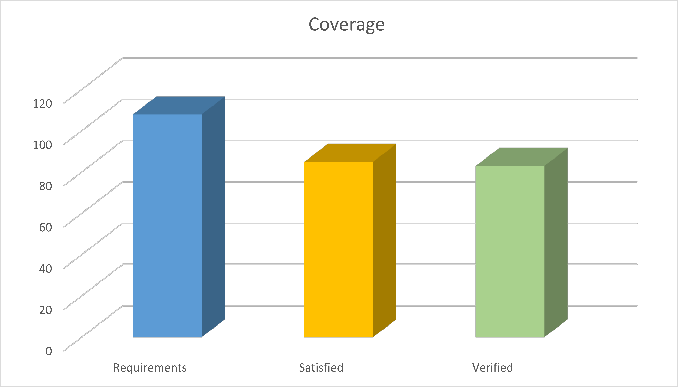Figure 9.73: PSSM Test Suite Coverage
- 108 semantic requirements have been identified in the section 14 of UML 2.5.
- 87 (about 81%) are considered as being satisfied (i.e., supported but not tested) by the execution model.
- 85 (about 79%) are both considered are satisfied and verified (i.e., they are tested) by the execution model.

Tests Report
The purpose of this sub-clause is to provide an overview of tests highlighting parts of the semantics that are not or may not be correctly captured by the execution model.
- Test Event 016 - B presented in section 9.3.3.9 provides the intended execution trace however the content of the RTC steps revealed an incomplete firing sequence when multiple transitions can be fired using the same event occurrence.
- Test Deferred 004 – A presented in section 9.3.14.5. It demonstrates handling of deferred event semantics in context of orthogonal regions. This test produces a valid execution trace however it is important to note that the assessed semantics is still discussed and will likely be refined in further revisions of this specification.
- Test Deferred 004 – B presented in section 9.3.14.6. It consolidates handling of deferred event semantics in context of orthogonal regions. This test produces a valid execution trace however it is important to note that the assessed semantics is still discussed and will likely be refined in further revisions of this specification.

Coverage
PSSM test suite includes 64 tests, 63 of them are successful and 1 is failed. There are no interferences with semantics proposed in PSCS. Indeed if PSSM is used in addition to PSCS the execution results of the PSCS test suite remain unchanged: all PSCS tests are successful.

Execution Model Limitations
The purpose of this sub-clause is to give an overview of the limitations of the current version of the execution model. It exists two categories of limitations. The first category is presented in section 9.4.4.1 and provides the list of syntactic elements whose semantics has not yet been formalized. The second category is presented in section 9.4.4.2 and highlights known limitations of the semantics encoded within the execution model.

Syntactic Elements
- Pseudo-states:
- Junction is not supported
- Shallow history is not supported
- Deep history is not supported
- State-machine redefinition is not supported.
- Passive state-machines are not supported
- State-machines used as a method of an operation are not supported
- State-machines cannot receive any other kind of events than signal events.
- Sub-machines are out of the PSSM scope and are therefore not supported.
- Protocol state-machines are not supported.

Limitations
- Transition traversal is done in “zero” time. This traversal is not a semantic variation into the proposed execution version model. This implies that it is not possible to have a different semantics for transition traversal especially for the purpose of including non-”zero” time interpretation.
- The usage of a state-machine as a doActivity behavior is not supported.
- Passing of data is not supported. That means if a signal that triggers a transition has values for its properties then this values cannot be accessed in:
- The guard of the transition
- The effect behavior of the transition
- The entry behavior of the target state
- The doActivity behavior of the target state
- Protocol State Machines
(informative)
  - Overview
ProtocolsStateMachines are intended to specify some constraints on sequences of interactions supported by an associated classifier behavior together with their expected outcomes.
According to the UML 2.5 specification, violation of a constraint specified by a ProtocolsStateMachine at run time shall result in an exception to be raised. However, since the fUML version upon which this specification is built does not support exceptions, it is not possible to define an executable semantics for ProtocolsStateMachines. Instead, the following section provides a precise interpretation of the UML semantics for ProtocolsStateMachines.
According to UML 2.5, this interpretation assumes the following restrictions:
- ProtocolConformance is excluded since the real conformance of one protocol to another depends the valid interaction sequences actually allowed be each of them and cannot simply be claimed.
- Protocols specify contracts constraining all the involved entities. ProtocolsStateMachines are given semantics only in the case where they control binary interactions. This specification constrains them to be associated with an Interface
- There can be more than one protocol defined for given Classifier. The precise semantics specified below assumes that only one protocol is controlling a given interaction. ProtocolsStateMachines are constrained to be associated with a Port, which identifies an interaction point where the protocol applies.
- Neither Operation::precondition nor Operation::postcondition are derived. Therefore, it is not possible to compute them according to the preconditions and the postconditions of enabled ProtocolTransitions they are associated with. Instead, this specification assumes that the constraints imply by an enabled ProtocolTransition is the result of a logical “and” between the preconditions and the postconditions, respectively, of both the protocol transition and its associated operation.
  - Abstract Syntax
Figure A.1 shows classes related to protocol state machines in the PSSM StateMachines package. The diagrams correspond to similar diagrams in the UML 2.5 Specification. The following feature has been excluded from the PSSM subset:
- ProtocolConformance: this class is excluded since it is a declarative statement that can be derived from the actual definition of the involved ProtocolStateMachine.
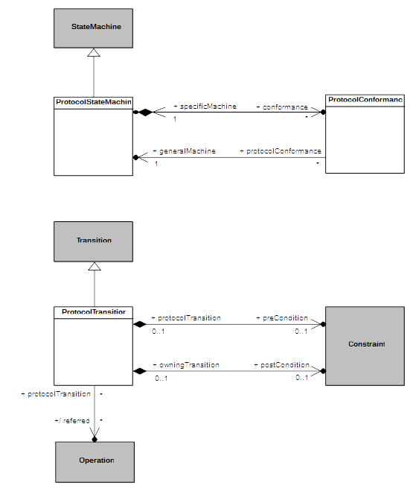Figure A.1 - ProtocolStateMachines
  - Semantics
    - Controlled Events
Interactions controlled by a ProtocolsStateMachine are restricted to event occurrences for which this state machine has at least one trigger defined. An occurrence of such a controlled event violates the protocol specified by a ProtocolsStateMachine if it is not explicitly allowed according to the current state of the protocol.
    - Protocol States Configuration
The initial state configuration of the protocol is defined according the initial Pseudostate of each active Region within the ProtocolsStateMachine. For each occurrence of an event controlled by the ProtocolsStateMachine which is not invalid, the corresponding ProtocolTransition is fired, which result in the target State to become the active protocol state.
    - Protocol Violation
A protocol violation shall result in an exception to be raised. It occurs in the following cases:
- An occurrence of a controlled event is received while it is invalid. That is: there is no enabled ProtocolTransition for that event for which the precondition is satisfied. In cases where that event is a CallEvent, this precondition is computed as a logical “and” between the ProtocolTransition::precondition and the CallEvent::operation::precondition.
- The postcondition of the protocol transition activated following the occurrence of a controlled event linked o the invocation of a BehavioralFeature is not met at when the execution of the corresponding method ends. In cases where that event is a CallEvent, this postcondition is computed as a logical “and” between the ProtocolTransition:: postcondition and the CallEvent::operation::postcondition.

The exact type and format of such a variable are of no concern here; implementers are free to chose their own.
To simplify the example, we assume here that there are no entry, exit, or do behaviors associated with any of the states.
See https://wiki.eclipse.org/Papyrus/UserGuide/ModelExecution

